Thermos dashboard Implementation Roadmap

This format is made to help tutors, study advisors, and other Thermos implementation partners make deliberate choices in the implementation process. Keep in mind; there is no ‘wrong’ or ‘best’ method of implementation but making conscious implementation decisions could help the process.

General info
Name of the study program:
Academic year:
Contact for Thermos within the study program:
Who’s involved in the implementation of Thermos in the program, and in what role?

If the dashboard was used previously;
1) What are the most important experiences or remarks?
2) How does this influence this implementation process?

0. Goals | What is the aim of implementing Thermos in the tutor program? |  | What is the reason for this aim?
1: Determining first use  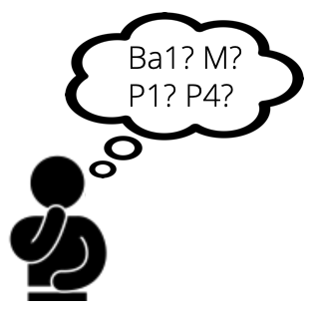 | What study year(s) will use the dashboard? |  | Why these study year(s)?
 | In what phase of the study year(s)? (If already clear: when exactly?) |  | Why this phase?
2: Communication  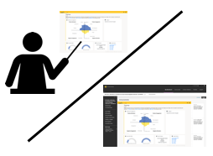 | Via what means will students be informed about the dashboard? |  | Why this way?
 | By whom will students be informed about the dashboard? |  | Why that person(s)?
 | Is there any support needed? Who can provide that support? |  | Why is that support needed?
3: Student use  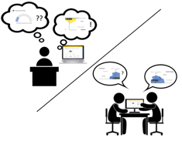 | How will the dashboard be embedded in the study program? |  | Why this form of integration?
 | To what extent are students expected or encouraged to use the dashboard? |  | Why this expectation?
 | How, where, and when will students use the dashboard? |  | Why this way?
 | Is there any support needed? Who can provide that support? |  | Why is that support needed?
4: Reflection & Action  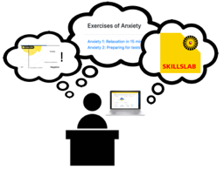 | How will students process and reflect on the dashboard? |  | Why this way?
 | Will students be able to compare results with peers? |  | Why this way?
 | How will students be able to ask questions to tutors or study advisors? |  | Why this way?
 | Is there any support needed? Who can provide that support? |  | Why is that support needed?
5: Follow-up  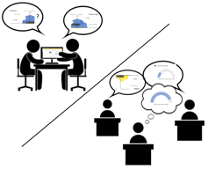 | How many moments of use are planned? |  | Why or why not?
 | Will the communication differ from first use? If so, in what way? |  | Why or why not?
 | Will student use of the dashboard differ from first use? If so, in what way? |  | Why or why not?
 | Will reflection & action differ from first use? If so, in what way? |  | Why or why not?
 | Will students be encouraged to compare their results to their earlier results? |  | Why will students be encouraged or not?
 | Is there any support needed? Who can provide that support? |  | Why is that support needed?
6. Evaluation | How and when will dashboard use be evaluated with students? |  | Why this way, and why then?
 | How and when will dashboard use and the implementation be evaluated with the team? |  | Why this way, and why then?
 | Is there any support needed? Who can provide that support?
Are there any other remarks regarding the implementation of the Thermos dashboard?

