Reflection Report 1
Log in to the Thermos-dashboard with your Solis-ID and watch the introduction video on how to use the dashboard. The dashboard will say something about different aspects related to studying, such as your study motivation and engagement. First, complete the questionnaire.
You will reflect on your study behavior using the results of the Thermos-dashboard. The aim of reflecting is to increase self-knowledge and further develop skills in order to improve your own actions. Korthagen's reflection model is used for this reflection (Figure 1). Going through these steps will take about 30 minutes but may vary from student to student. Take your time to reflect on the questions.
Take a look at your Thermos-dashboard. What are you satisfied with and what would you like to improve? Pick one aspect you are satisfied with and one aspect you would like to improve. First read the description of both aspects in the dashboard. Then, for each aspect, take a specific experience in your mind of how this manifests itself in your study behavior. Then go through the steps of Korthagen's reflection model for each aspect.
If you’re having trouble with thinking of a specific experience, look at the following example:
One element you may not be satisfied with, for example, is 'planning'. A concrete experience could be that you are behind on study assignments, cannot prepare lectures properly or cannot get an overview of your studies.
Finding it difficult to follow the steps below? Then ask your fellow students or tutor for help!
Figure 1
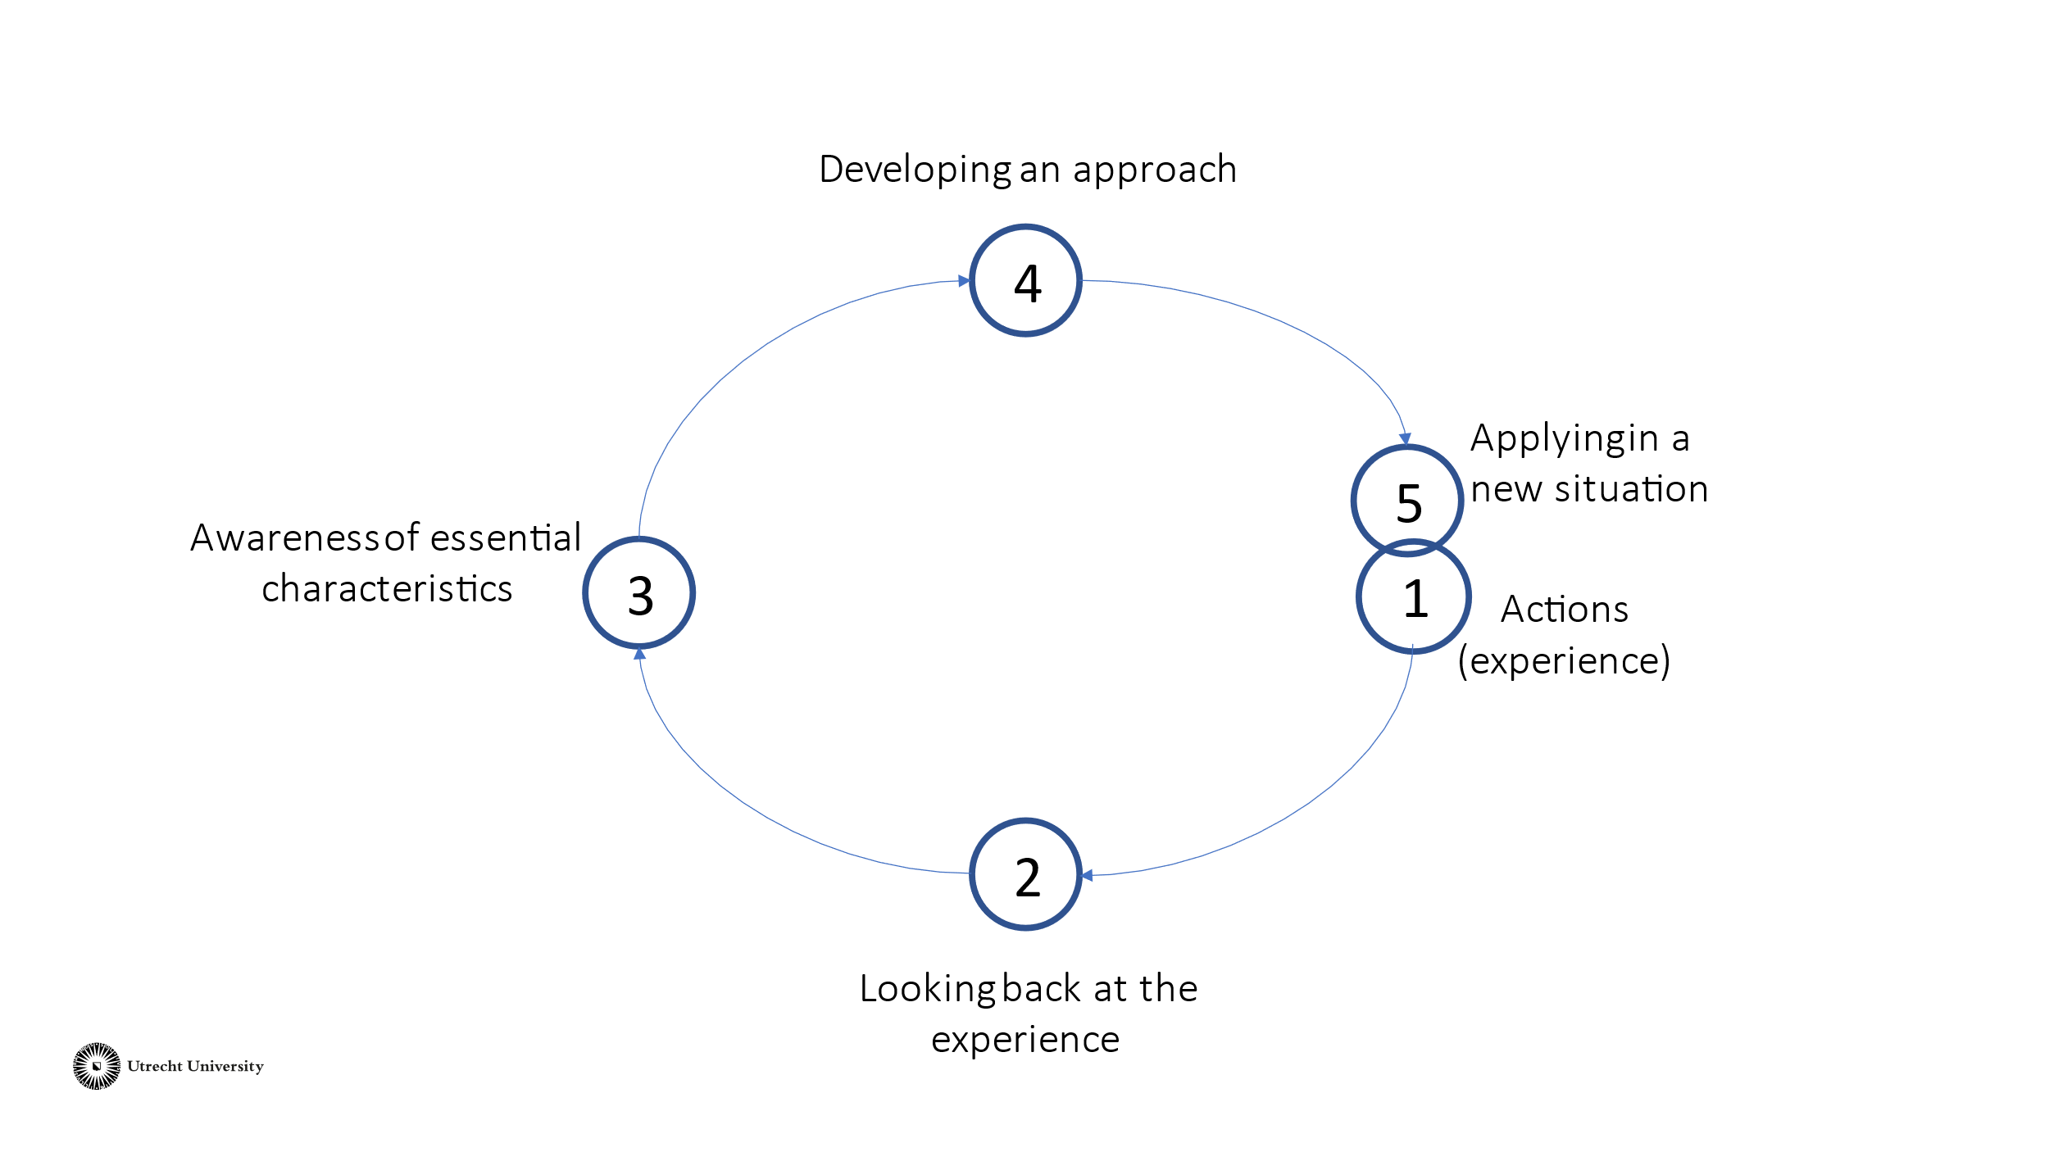
Korthagen’s Reflection Model
The aspect from my Thermos-dashboard that I am satisfied with is:

- Actions/Experience
Now describe your experience specifically. Think about: What did this element look like in your studies? What actions did you take? What consequences did this lead to? In this phase, try to remain objective by not writing down any judgements or opinions yet.

- Looking back at the experience
Look back at the experience as described in step 1. Look at the experience from your personal point of view. How did you experience it? What were you thinking? What did you do? What did you want?

- Awareness of essential characteristics
Try to gain insight into the situation by identifying essential characteristics or causes. This focuses on the 'why' of the experience. Consider the following questions: What contributed to the positive outcome of this element? What essential characteristics caused you to be satisfied with this experience? What is the positive discovery?

- Developing an approach
Now that you better understand your strengths, you can develop an approach to start using this more consciously. How could you hold on to this? How could you use this element in other contexts, or to avoid things you are less good at? Pick an approach you want to work on.

- Applying in a new situation
Think about how you can turn your approach into concrete actions. What do you want to achieve? What do you need to pay attention to? What do you want to avoid? How do you make sure it is achievable?
The aspect from my Thermos dashboard that I would like to improve is:

- Actions/Experience
Describe the experience concretely. What did this aspect look like in your study? What actions did you take? What consequences did this lead to? Try to remain objective at this stage by not writing down any judgements or opinions yet.

- Looking back at the experience
Look back at the experience as described in step 1. Look at the experience from your personal point of view. How did you experience it? What were you thinking? What did you do? What did you want?

- Awareness of essential characteristics
Try to gain insight into the situation by identifying essential characteristics or causes. This focuses on the 'why' of the experience. Consider the following questions: What caused the negative outcome of this element? What essential characteristics caused you to be dissatisfied with this experience? What is the discovery?

Note: focus on characteristics you can change.

- Developing an approach
Now that you better understand your point for improvement, you can start thinking of solutions for it. What are the implications of these findings? How could you do this differently? What alternatives are there? Choose an approach you want to work on.

Tip: Finding it hard to find a solution? Ask your friends, fellow students or a tutor for help.

- Applying in a new situation
Think about how you can turn your approach into concrete actions. What do you want to achieve? What do you need to pay attention to? What do you want to avoid? How do you make sure it is feasible?

