Thermos-dashboard Implementation Example 3

This implementation example is made to inspire tutors, study advisors, and other Thermos implementation partners to make deliberate choices in the implementation process. The three implementation examples differ in how the dashboard was implemented, and how students use the dashboard. Keep in mind; there is no ‘wrong’ or ‘best’ method of implementation but making conscious implementation decisions could help the process. Take a look at the other implementation examples as well, as they may provide interesting alternatives for your study program!

General info
Name of the study program:
Academic year:
implementation manager: | Study counselor
Who’s involved in the implementation of Thermos in the program, and in what role? | The tutors and student-mentors will be responsible for the implementation of Thermos. Student-mentors are the first contact person for students when they have questions or need guidance. They see a group of students regularly in the first year of the bachelor and afterwards students can individually make appointments with the student-mentors or tutors. Tutors are responsible for guiding the student-mentors.
If the dashboard was used previously;  1) What are the most important experiences or remarks?  2) How does this influence this implementation process? | The dashboard was used previously. However, the evaluation showed points for improvement, so we want to adjust the implementation for this academic year.  - The most important remark was that students wanted more autonomy in the use of the dashboard, and it was not feasible to embed the student activities in the study program each year.  - This influences the implementation process by adjusting the phases: aim, first use, and reflection & action.

0. Goals | What is the aim of implementing the Thermos-dashboard in the tutor program? | The aim is to learn students how to reflect on their study behavior, so they can do this throughout their study. | What is the reason for this aim? | It is important that students learn how to reflect on their own study behavior. This way, they develop and apply their qualities in their studies, and know how to reflect on their study skills.
1: Determining first use  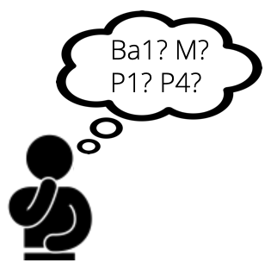 | What study year(s) will use the dashboard? | Bachelor year 1. | Why these study year(s)? | Because students just started in their study program and still have to get used to university. Therefore, it is important that we give them the tools to discover their strengths and possibilities.
 | In what phase of the study year(s)? (If already clear: when exactly?) | In the second period of the first semester. | Why this phase? | We want to give the students the opportunity to get used to university in the first period and not be overwhelmed with new things. Therefore, we chose to implement dashboard use in the second period. Additionally, a mandatory tutor session is planned in which students can be instructed about the dashboard.
2: Communication  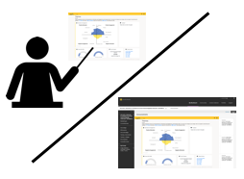 | Via what means will students be informed about the dashboard? | Student will be informed about the dashboard face-to-face. | Why this way? | Because we want to make sure that students receive the information and guidance when using the dashboard.
 | By whom will students be informed about the dashboard? | By their tutors and student-mentors. | Why that person(s)? | The tutors are responsible for overarching guidance of the students when using the dashboard, the student-mentors are available for practical tips and advice.
 | Is there any support needed? Who can provide that support? | An informationsheet for tutors that explains the aspects in the dashboard | Why is that support needed? | Because tutors need to know about the dashboard before they can inform students about it.
3: Student use  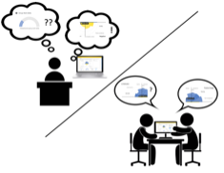 | How will the dashboard be embedded in the study program? | In the second period of the first semester, students will attend tutor sessions in which they will use the dashboard. | Why this form of integration? | Because these sessions are focused on study behavior and reflection. Which is why the dashboard is suitable here.
 | To what extent are students expected or encouraged to use the dashboard? | Students are expected to fill in the dashboard before the tutor session. They can use the dashboard afterwards if they want to, but it is voluntarily. | Why this expectation? | Because we want students to be prepared for the sessions in which we are going to reflect on the results.
 | How, where, and when will students use the dashboard? | They will use the dashboard individually, at their own time. | Why this way? | Because it is important that students have the privacy and the autonomy on when they want to use the dashboard in their study career.
 | Is there any support needed? Who can provide that support? |  | Why is that support needed?
4: Reflection & Action  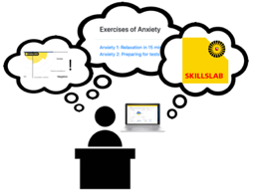 | How will students process and reflect on the dashboard? | During the tutor sessions, students will reflect on the dashboard through a peer-to-peer coaching activity. The student-mentor supervises this activity and is available for questions. | Why this way? | Students will reflect on their dashboard with a peer-to-peer coaching because we think students can learn from each other, support each other and provide new insights to each other. The student-mentor can provide insights from his/her own experience as a student. This will lead to a meaningful reflection.
 | Will students be able to compare results with peers? | Yes. | Why this way? | See above.
 | How will students be able to ask questions to tutors or study advisors? | Students can always reach out to tutors or student-mentors via email, but also during the tutor sessions. | Why this way? | The tutor is available during the tutor sessions, in which students can ask questions face-to-face. However, they can also be contacted through email to ask questions or make an individual appointment if needed.
 | Is there any support needed? Who can provide that support? | Perhaps guidance of Educational Development & Training. | Why is that support needed? | Because tutors might need additional training on how to guide students when using the dashboard.
5: Follow-up  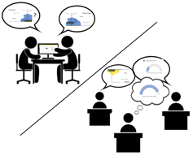 | How many moments of use are planned? | One moment. During this session, possibilities for follow-up use of the dashboard are explained and encouraged, but the initiative then lies with the student. | Why or why not? | Because we want to introduce students to the tool and teach them how to reflect on their study behavior. However, additional long term reflection by means of the dashboard is up to the student.
 | Will the follow-up communication differ from first use? If so, in what way? | Yes. Students will not be informed about the dashboard anymore. | Why or why not? | After the first use, students know about the dashboard and can use it individually if they want to. They can contact tutors via email if they want to ask questions about the dashboard.
 | Will follow-up student use of the dashboard differ from first use? If so, in what way? | Yes. It is now completely autonomous. They can get in touch with a tutor if they need to. | Why or why not? | Because we want students to continue with reflecting on their study behavior independently. Students are given the autonomy to determine their own needs and reach out to tutors on their own initiative.
 | Will follow-up reflection & action differ from first use? If so, in what way? | Yes. If students want to reflect on their dashboard, they have to initiate it themselves. | Why or why not? | Because we think students are now able to reflect and act upon their dashboard themselves.
 | Will students be encouraged to compare their results to their earlier results? | Yes, we will explain this in the tutor session. | Why will students be encouraged or not? | It is completely up to the students how they reflect on their results, but we want to encourage them to compare multiple moments of dashboard use.
 | Is there any support needed? Who can provide that support? |  | Why is that support needed?
6. Evaluation | How and when will dashboard use be evaluated with students? | Students will evaluate the dashboard after the first use. We will organize a focus group with students to reflect on the implementation. | Why this way, and why then? | Because this is the only time the dashboard is used in the program.
 | How and when will dashboard use and the implementation be evaluated with the team? | The team will reflect on the dashboard as well after the first use during a meeting. The adjustments to the implementation will be discussed as well, to explore if we reached our goals better this time. | Why this way, and why then? | Because tutors can exchange their experiences and opinions with each other. This way of evaluation allows us to compare with the previous implementation and identify improvements in the implementation.
 | Is there any support needed? Who can provide that support?
Are there any other remarks regarding the implementation of the Thermos dashboard?

