Thermos-dashboard Implementation Example 2

This implementation example is made to inspire tutors, study advisors, and other Thermos implementation partners to make deliberate choices in the implementation process. The three implementation examples differ in how the dashboard was implemented, and how students use the dashboard. Keep in mind; there is no ‘wrong’ or ‘best’ method of implementation but making conscious implementation decisions could help the process. Take a look at the other implementation examples as well, as they may provide interesting alternatives for your study program!

General info
Name of the study program:
Academic year:
Implementation manager: | The tutor coordinator.
Who’s involved in the implementation of Thermos in the program, and in what role? | The tutors will be responsible for the implementation of Thermos. They are the first contact person for students when they have questions or need guidance. They can also guide students in thinking about their future career and see them regularly during the end of the bachelor and in the masters.
If the dashboard was used previously;  1) What are the most important experiences or remarks?  2) How does this influence this implementation process? | The dashboard was used previously, and we were pleased with its implementation. Therefore, no changes were made.

0. Goals | What is the aim of implementing the Thermos-dashboard in the tutor program? | Supporting students in developing and understanding their study skills to prepare them for their career life. | What is the reason for this aim? | By using the Thermos-dashboard, students will learn about their study skills as a student. They will be encouraged to think about what skills are strengths and what skills they would like to develop. The focus will be on preparing them on how they can further develop and apply these skills in their later careers.
1: Determining first use  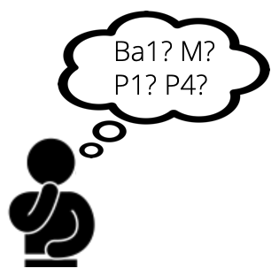 | What study year(s) will use the dashboard? | Bachelor year 3 and master. | Why these study year(s)? | Because in these years the students are about to graduate from university and should start thinking about their future careers.
 | In what phase of the study year(s)? (If already clear: when exactly?) | First use will be in the first semester of the academic year. | Why this phase? | Because students will then participate in meetings with tutors which are aimed at reflecting on career options. Since it’s the first semester, there is still time to work on skills that could use improvement.
2: Communication  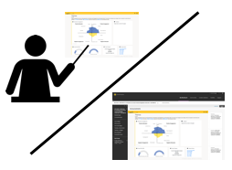 | Via what means will students be informed about the dashboard? | Via email and in tutor sessions. | Why this way? | Tutors will inform their students about the dashboard via email and during the tutor sessions to make sure students know what is expected from them and how the dashboard aspects link with the skills needed as a professional.
 | By whom will students be informed about the dashboard? | Tutors. | Why that person(s)? | Because the tutors will guide the students when using the dashboard. Students know the tutors, so informing them of the dashboard via the tutors will give them the personal touch.
 | Is there any support needed? Who can provide that support? | A tutor training. | Why is that support needed? | Tutors will also need guidelines for the use of the Thermos-dashboard
3: Student use  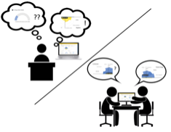 | How will the dashboard be embedded in the study program? | Students will use the dashboard outcomes during tutor sessions in the second semester. They will fill in the questionnaire beforehand and are asked to briefly reflect on their outcomes as preparation for the tutor session. | Why this form of integration? | Because these sessions are dedicated to the theme professional development, using the dashboard then fits the implementation goal.
 | To what extent are students expected or encouraged to use the dashboard? | Students are expected to use the results of their dashboard for the student activity. They will fill in the questionnaire as a preparation for the tutor session. We also encourage the students to use the dashboard more often during the academic year by explaining to them why its important to continuously reflect on study skills. | Why this expectation? | We want students to use the dashboard to reflect on their study skills in order to translate these skills to their future professional context. We urge students to reflect on their study behavior by using the dashboard in the first semester. Also, we encourage students to use the dashboard afterwards to keep track of their learning process if they want to.
 | How, where, and when will students use the dashboard? | In their own time. | Why this way? | We want to give students the freedom to choose when and in which environment they use the dashboard. We do expect them to use the outcome of their brief preparatory reflection on the dashboard in the tutor sessions.
 | Is there any support needed? Who can provide that support? | An introduction video about the dashboard. | Why is that support needed? | Because we want students to have practical information about the dashboard available if they are going to use it independently.
4: Reflection & Action  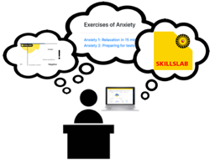 | How will students process and reflect on the dashboard? | Students will reflect on the process and their dashboard through the student activity ‘interview’. Additionally, they might reflect on their dashboard during individual meetings with a tutor. | Why this way? | Because we want to encourage students to reflect on their study behavior by interviewing other students. In addition to this exercise, we ask them to translate the reflection on their study skills to their professional development.
 | Will students be able to compare results with peers? | Yes, the exercise is carried out in pairs. | Why this way? | Because this gives space to share results and reflections with each other, but in a small group so that there is also enough time to discuss each individual’s reflection process.
 | How will students be able to ask questions to tutors or study advisors? | In the tutor sessions or via email. | Why this way? | Because tutors are available in these sessions and email is an easy way to reach them for questions.
 | Is there any support needed? Who can provide that support? | Perhaps guidelines for students during the reflection about what kind of questions are helpful to ensure a safe environment to reflect. | Why is that support needed? | Because additional guidance might support the safe environment during the session and lead to a more effective reflection.
5: Follow-up  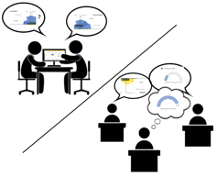 | How many moments of use are planned? | Two moments of use are structurally planned in the study program. Additional use is encouraged by the tutors. | Why or why not? | Because students then have the possibility to actively reflect on their study behavior and translate it to their professional development.
 | Will the follow-up communication differ from first use? If so, in what way? | Yes. After the first use, students will also be encouraged to use the dashboard through promotion on blackboard. | Why or why not? | We want students to autonomously use the dashboard more often. Therefore, we will promote its use several times to remind students of this possibility.
 | Will follow-up student use of the dashboard differ from first use? If so, in what way? | No. | Why or why not? | Because we want to give students the options for use during the program while also maintaining freedom for their own use.
 | Will follow-up reflection & action differ from first use? If so, in what way? | No/maybe. | Why or why not? | The reflection and action provided by the study program will not differ. However, students are free to find new ways to individually reflect on their dashboard. Therefore, other student activities for reflection such as the reflection report will be available on blackboard.
 | Will students be encouraged to compare their results to their earlier results? | Yes. In the exercise. | Why will students be encouraged or not? | Students can compare their own results if they want to in the interview exercise. But this will not be mandatory to do so.
 | Is there any support needed? Who can provide that support? |  | Why is that support needed?
6. Evaluation | How and when will dashboard use be evaluated with students? | At the end of the academic year, students will fill out an evaluation form. | Why this way, and why then? | Because we want to give the students the time to use the dashboard on their own and reflect on its advantages and disadvantages afterwards. In doing so, we especially want to know whether students find it useful to apply their study skills to their professional development
 | How and when will dashboard use and the implementation be evaluated with the team? | At the end of the academic year, we will schedule a meeting with the team to reflect on the implementation. | Why this way, and why then? | Because we want to evaluate the implementation after the evaluation with the students. This will allow the tutors to take into account the opinion of the students, but also their own experience.
 | Is there any support needed? Who can provide that support?
Are there any other remarks regarding the implementation of the Thermos dashboard?

