Thermos-dashboard Implementation Example 1

This implementation example is made to inspire tutors, study advisors, and other Thermos implementation partners to make deliberate choices in the implementation process. The three implementation examples differ in how the dashboard was implemented, and how students use the dashboard. Keep in mind; there is no ‘wrong’ or ‘best’ method of implementation but making conscious implementation decisions could help the process. Take a look at the other implementation examples as well, as they may provide interesting alternatives for your study program!

General info
Name of the study program:
Academic year:
Implementation manager: | The coordinator of the tutors.
Who else is involved in the implementation of Thermos in the program, and in what role? | All of the tutors are involved in the implementation of the Thermos-dashboard. Tutors are responsible for guiding the students in their learning process during the entire bachelor program. As part of the study program, there are two mandatory tutor sessions for all students during the bachelor. In these sessions, a group of students is guided by a tutor. Additionally, tutors are available for individual counseling.
If the dashboard was used previously;  1) What are the most important experiences or remarks?  2) How does this influence this implementation process? | This is the first time this study program is going to implement the dashboard.

0. Goals | What is the aim of implementing the Thermos-dashboard in the tutor program? | Supporting students in reflecting on the development of their study behavior throughout their bachelor program, and taking action where they see fit. | What is the reason for this aim? | By using the Thermos-dashboard, students will be challenged to actively reflect upon their study behavior and formulate learning goals for improvement.
1: Determining first use  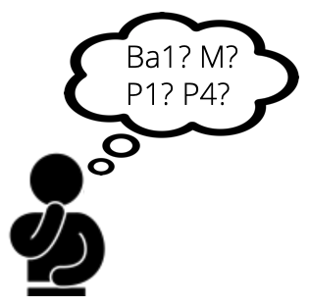 | What study year(s) will use the dashboard? | Bachelor year 1, 2, and 3 | Why these study year(s)? | By structuring the implementation for all 3 years, students will monitor their progress throughout the bachelor's program. This encourages long-term reflection.
 | In what phase of the study year(s)? (If already clear: when exactly?) | Students will be actively using the Thermos-dashboard two times per academic year: at the end of the first semester and at the end of the second semester. | Why this phase? | By using the dashboard at the end of the first semester, students gain some experience of studying in that academic year entails, which offers them concrete situations to reflect upon. Using the dashboard at the end of the academic year allows student to reflect on their progress and bring this development on to the next academic year. Additionally, students have tutor sessions twice a year.
2: Communication  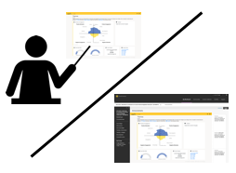 | Via what means will students be informed about the dashboard? | Students will be informed about the dashboard during the tutor sessions and blackboard. | Why this way? | Blackboard is a tool with which we can easily reach our students. Additionally, the information posted there is always available. Also, students will be informed by the dashboard in the tutor sessions, so they can ask questions to a tutor if they have any.
 | By whom will students be informed about the dashboard? | Students will be informed about the dashboard by their tutors. | Why that person(s)? | The tutor is the first contact person for students if they need help. They will also know how the dashboard works and how they can guide students. The introduction of a tutor will perhaps also add a more personal touch, instead of only posting text on blackboard.
 | Is there any support needed? Who can provide that support? | The tutors will need a tutor training. | Why is that support needed? | A tutor training is needed because tutors will need to know how the dashboard works and what their role is in guiding students in using the dashboard. Therefore, a training is needed to prepare tutors for the use of the dashboard.
3: Student use  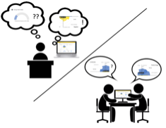 | How will the dashboard be embedded in the study program? | The dashboard will be embedded in the program by using it during the tutor sessions. Students fill out the questionnaire and reflect upon its outcome by using student activities during the tutor sessions. | Why this form of integration? | The tutor sessions are meant for reflection on study behavior and therefore lend themselves for the use of the dashboard. These tutor sessions are already imbedded in the program, so imbedding the Thermos-dashboard there makes sense.
 | To what extent are students expected or encouraged to use the dashboard? | Students will be expected to use the dashboard two times per academic year during the tutor sessions. They are encouraged to use the dashboard more often if they want to, but that is voluntarily. | Why this expectation? | Students are expected to use the dashboard at least two times per academic year because these moments are fitting moments for the reflection exercises and are already embedded in the study program. However, we also want to encourage students to autonomously reflect on and monitor their study behavior if they want to.
 | How, where, and when will students use the dashboard? | Students will use the dashboard during the tutor sessions. Additional voluntarily use will be in their own time. | Why this way? | Students will use the dashboard in the tutor sessions to guarantee the availability of guidance when students need it. This will create the opportunity to ask questions and reflect on the dashboard with tutors or peers.
 | Is there any support needed? Who can provide that support? | Technical support. | Why is that support needed? | If we want students to use the dashboard, we need a contact person for students if they have questions.
4: Reflection & Action  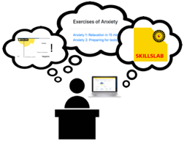 | How will students process and reflect on the dashboard? | Students will use the student activities for reflection. During the first year of the bachelor, students will write reflection report 1 in the first semester and reflection report 2 in the second semester. In the second year, students will do the student interviews. In the third year, students use the intervision activity. | Why this way? | Students will be encouraged to think about the study behavior through different activities. These activities guide students to reflect in depth on their study behavior and progress. This will eventually lead to long-term reflection and development.
 | Will students be able to compare results with peers? | Students can compare their results in the second and third year of the bachelor. Then the exercises will be carried out in groups of two or more. The first year is individually, but they can discuss topics if they want to. | Why this way? | In the first year, students are still adjusting to university and getting to know their peers. Therefore, the first reflection exercises will be individually. Later on, students will be asked to discuss with peers to support each other in their development.
 | How will students be able to ask questions to tutors or study advisors? | They can contact them via email or during the tutor sessions. | Why this way? | Because tutors are available in these sessions and email is an easy way to reach them for questions.
 | Is there any support needed? Who can provide that support? |  | Why is that support needed?
5: Follow-up  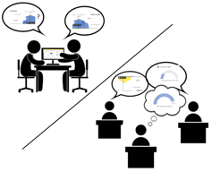 | How many moments of use are planned? | Two moments in each academic year. Six times during the bachelor. | Why or why not? | Because these moments are planned during the tutor sessions. Therefore, every year will have the same structure for planned moments.
 | Will the follow-up communication differ from first use? If so, in what way? | No | Why or why not? | We want to keep the communication the same throughout the bachelor's program to avoid misunderstandings.
 | Will follow-up student use of the dashboard differ from first use? If so, in what way? | No | Why or why not? | Students will be expected to use the dashboard every year as preparation or during the tutor sessions.
 | Will follow-up reflection & action differ from first use? If so, in what way? | Yes | Why or why not? | Because the student activities will be individually in the first year, in pairs of two in the second year, and in a larger group the third year. Therefore, the students will gain more and more input from fellow students which gives different perspectives and helps them in their reflection process.
 | Will students be encouraged to compare their results to their earlier results? | Yes | Why will students be encouraged or not? | In the first year, students write two reflection reports. The second report builds on the first report. Additionally, students are encouraged to reflect on their progress during all moments of use and therefore compare earlier results.
 | Is there any support needed? Who can provide that support? | Not that we can think of now. | Why is that support needed?
6. Evaluation | How and when will dashboard use be evaluated with students? | The students are asked to reflect on the dashboard after its first use each year through an online feedback form. This form contains questions about their experience with the dashboard, its usability, and its usefulness. | Why this way, and why then? | It is important to reflect with students in each bachelor year to understand what they think about the dashboard and if they found it useful. This allows us to adjust the implementation if necessary. We chose an online form to guarantee availability and anonymity and due to practical reasons.
 | How and when will dashboard use and the implementation be evaluated with the team? | The team is asked to reflect on the dashboard after its first use each year during a feedback session. During this session, tutors will be asked about their experiences with guiding students who have used the dashboard. | Why this way, and why then? | It is also important to reflect with the team in each bachelor year to get an insight into the advantages and disadvantages for adjustment for the next academic year. But also, to know if any more support is needed for tutors.
 | Is there any support needed? Who can provide that support? | External expertise in terms of evaluation, so they can help us with guiding the evaluation process.
Are there any other remarks regarding the implementation of the Thermos-dashboard?

