Instruction Tutor Training

Dear tutor coordinator, this document explains how to use the tutor training. This explanation consists of three parts: preparation, duration, and instruction per slide. This is an example of an elaboration of a tutor training, but it is also possible to make adjustments according to the preferences of the relevant study program.
Preparation | - Read the explanation of this tutor training carefully beforehand.  - Print out the appendices. Make sure there is one case for each pair of two tutors.  - It is important that the tutors have been introduced to the dashboard once. As preparation, make sure the tutors watched the introductory video about Thermos or watch it together before this activity. https://thermos.sites.uu.nl/information-for-tutors/
Duration | Performing this tutor training will take +/- 60 minutes.
Slides | Instruction
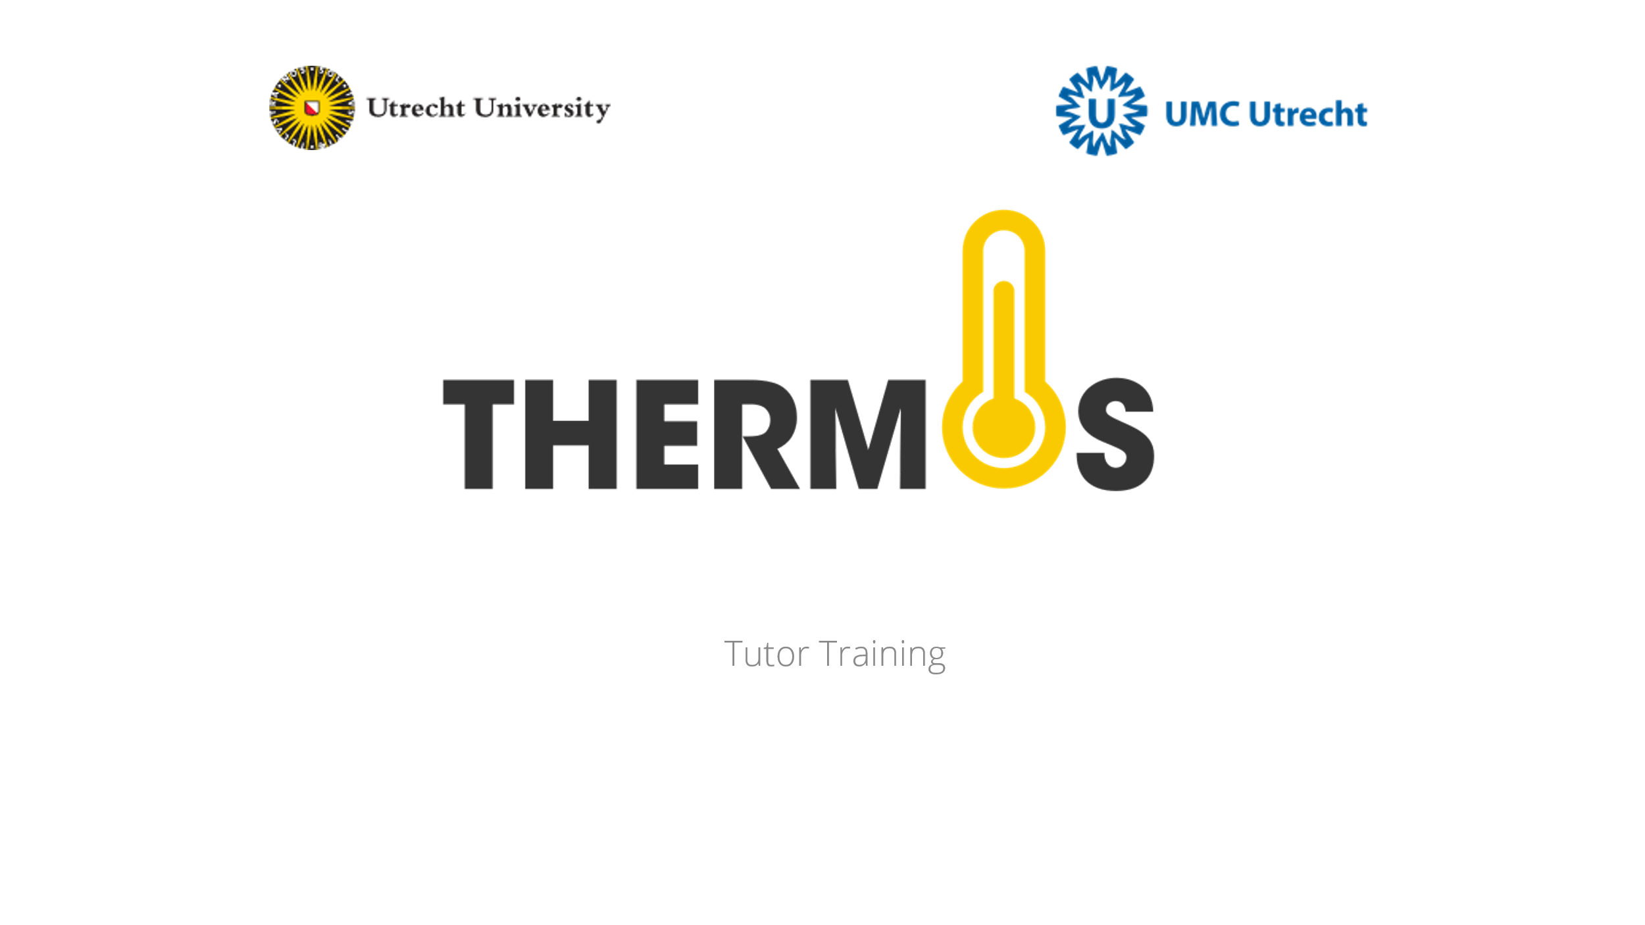
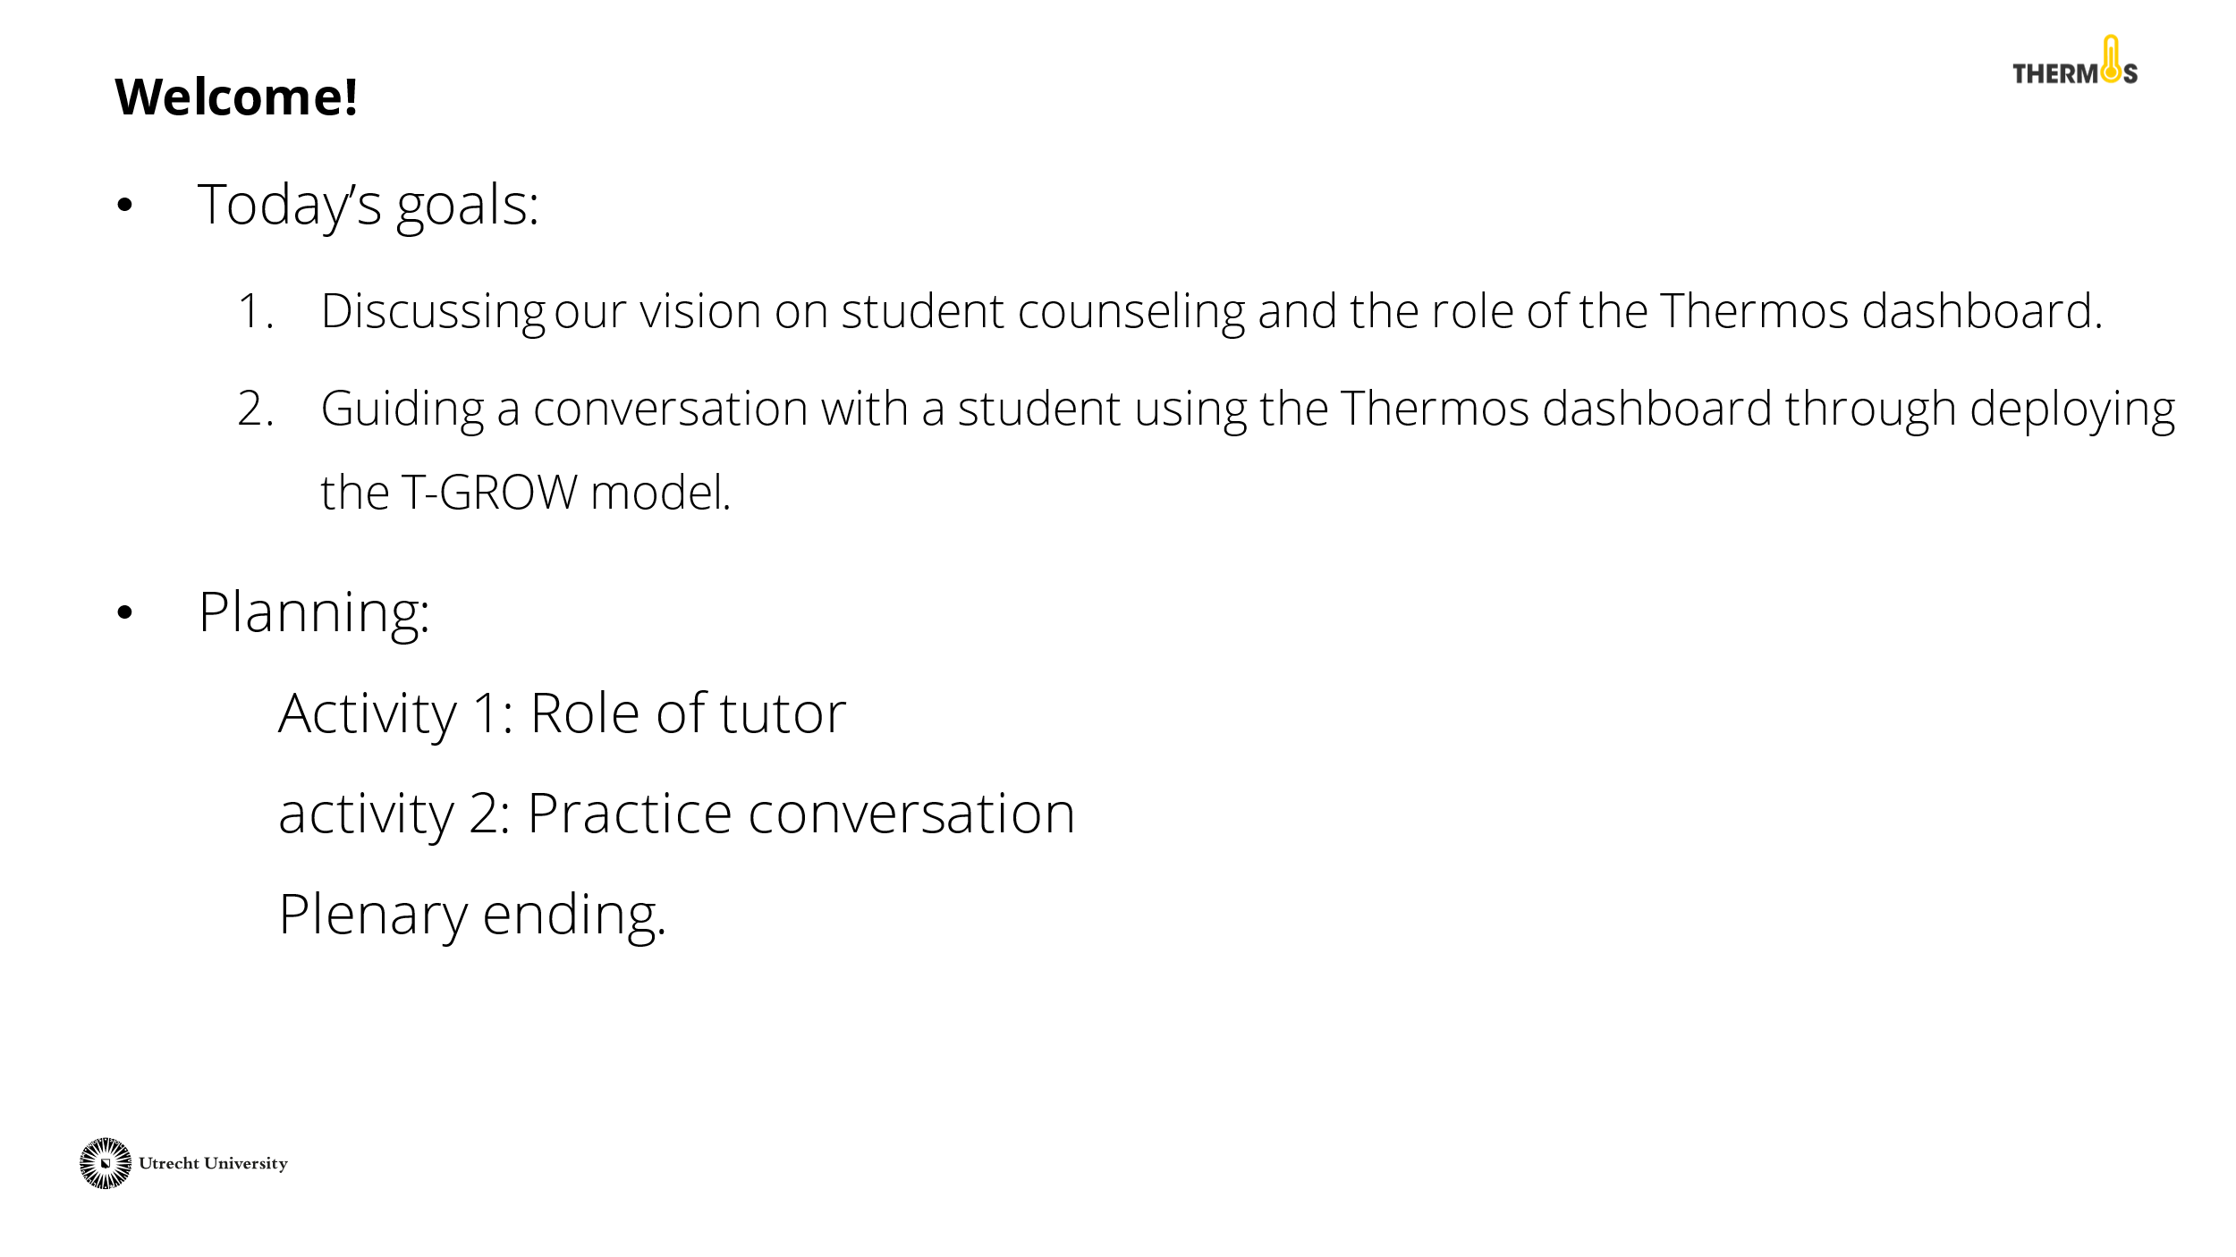 | Discuss the goal and planning of this activity with the tutors.
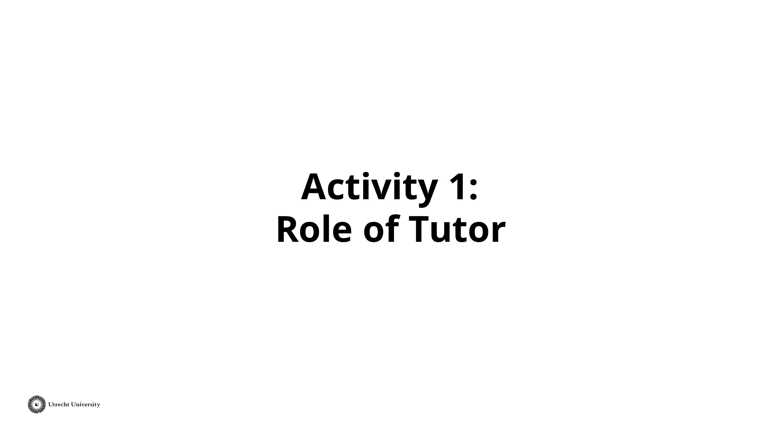 | The first activity is called 'Role of Tutor' and will take about 15 minutes.
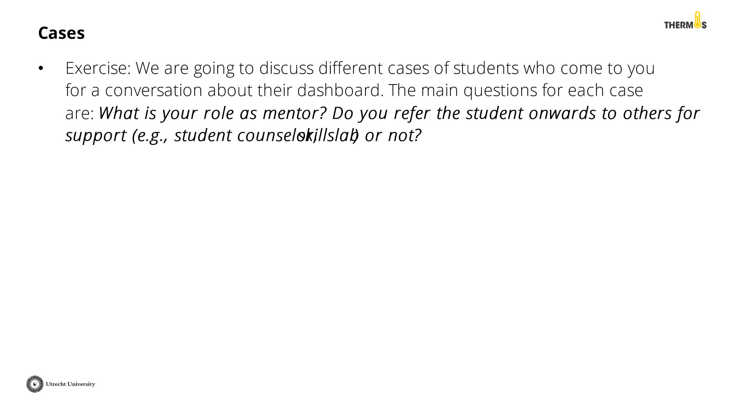 | You will discuss the role of the tutor and the Thermos dashboard with the tutors through two different cases. The central question is: "What is your role as a tutor?". Start a conversation about which issues you take up yourself as a tutor, when you refer a student onwards, and what possibilities the Thermos dashboard has in this regard.
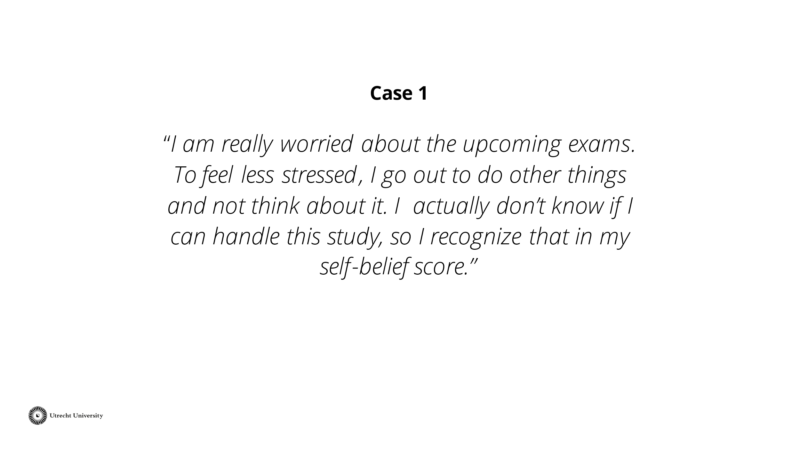 | Read the case out loud or give the tutors time to read the case themselves. Afterward, give the tutors some time to think about what they would do in this situation.  Then discuss with the group of tutors what the counseling of this student would look like. Also include the Thermos-dashboard and its role in student counseling.  Tip: Also refer to the role of the tutor as described by your faculty or study program.
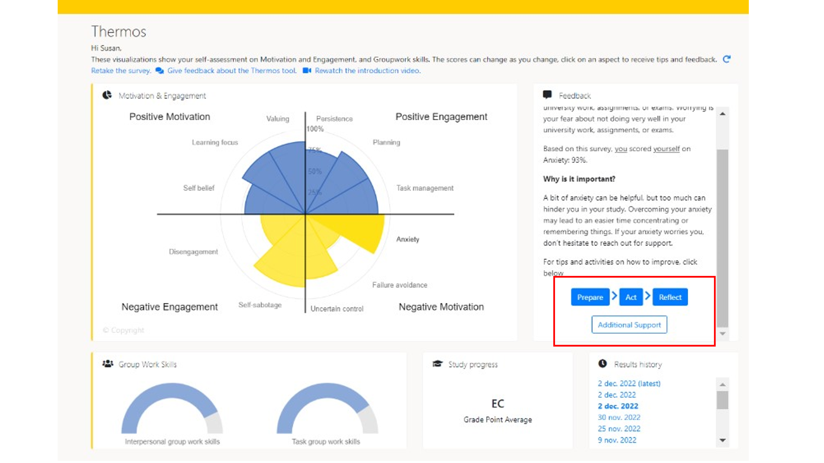 | Discuss with the tutors how the Thermos dashboard and its possibilities can play a role in the guidance of students.  Within the Thermos-dashboard, students can click on an aspect (such as anxiety). More information about this aspect will appear on the right frame. In addition, there are four options that students can click on to further develop themselves regarding this aspect. The four options are: 'Prepare', 'Action', 'Reflect', and 'Additional support'. The next slide shows what that looks like.
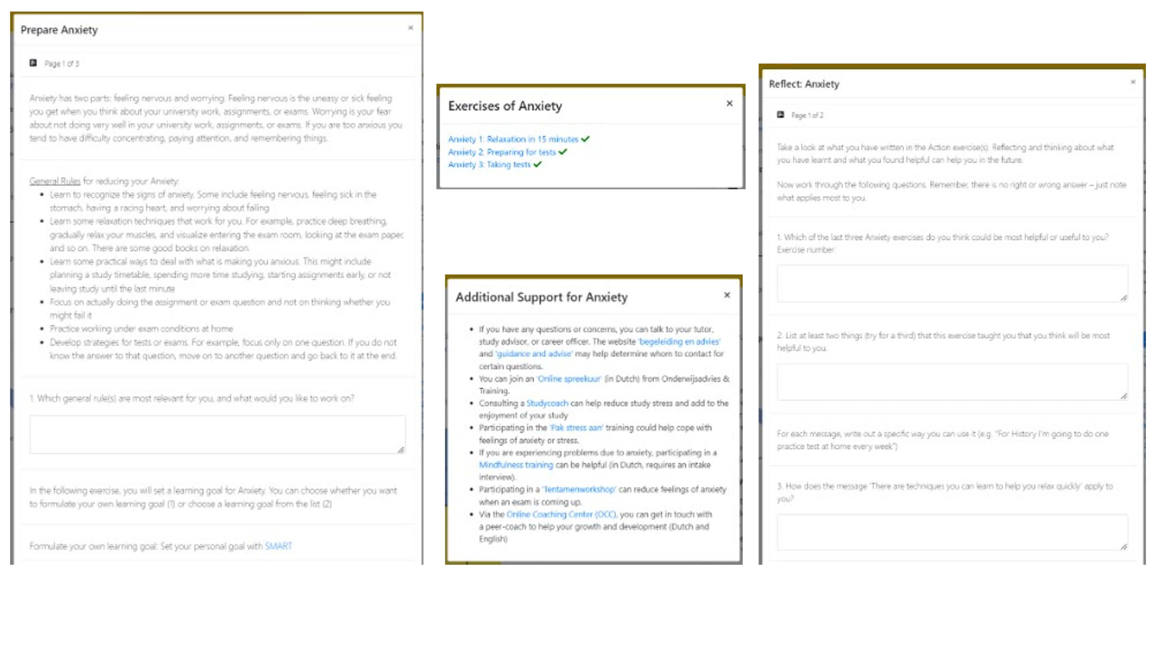 | This slide shows what the page looks like when a student clicks on the referral options. The options 'Prepare', 'Action', and 'Reflect' are assignments on which the student can work independently. These assignments include the formulation of a goal, activities, and opportunities for reflection. In addition, there is the option 'Additional support'. When a student clicks on this, referral options such as training courses and a study coach appear.  Discuss with the group how these components can be used in student counseling.  Alternative: open the Thermos-dashboard before the training to show it live to tutors. In that case, make sure the questionnaire has been completed once.
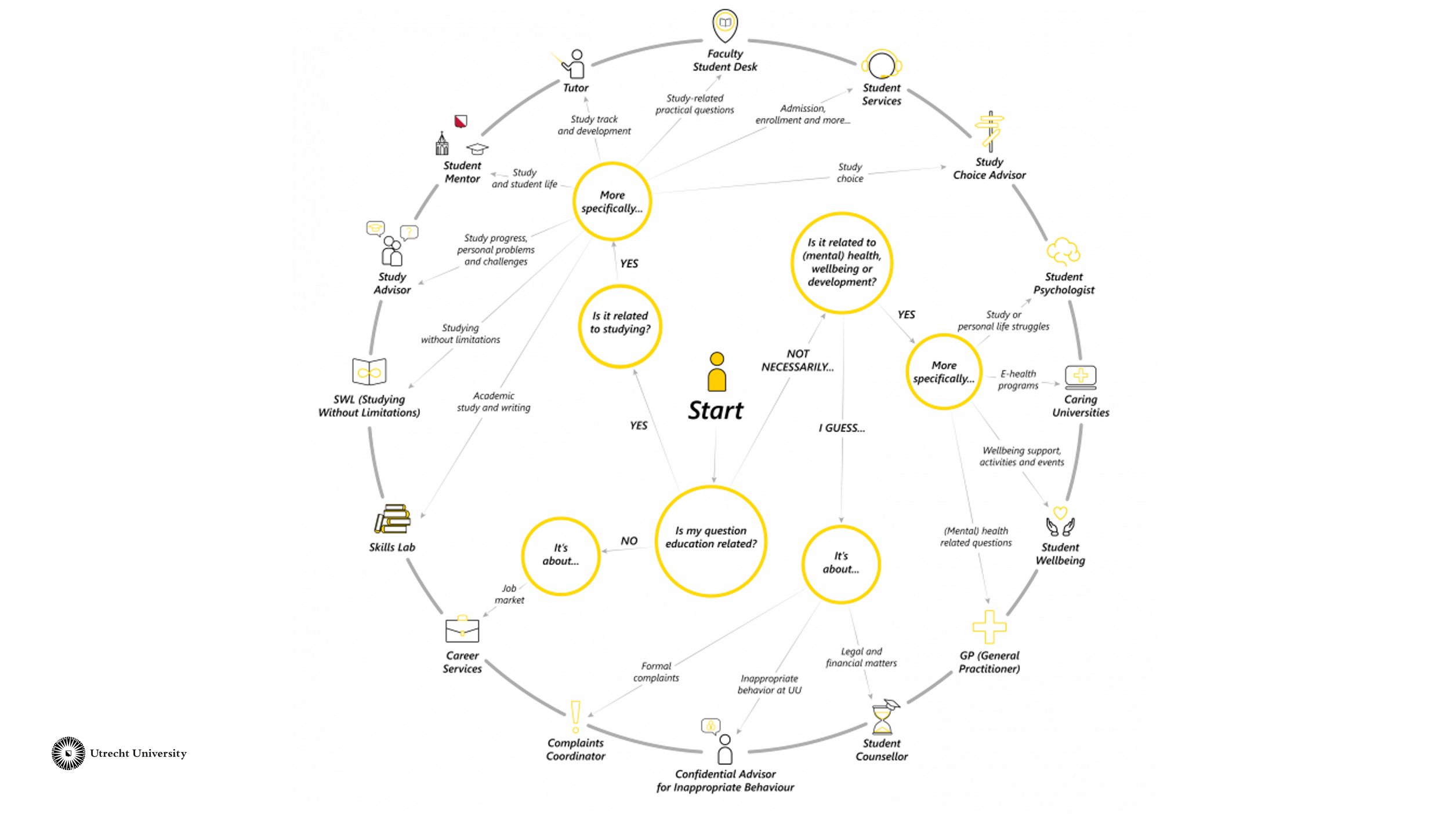 | On the Utrecht University website, there is a picture with possible referrals for a student. You can show this picture to the tutors to let them get familiar with the possibilities within the University. In the Thermos-dashboard, some of these possibilities are also listed as referrals under the heading 'additional support'.  https://students.uu.nl/en/guidance-and-development/who-to-contact
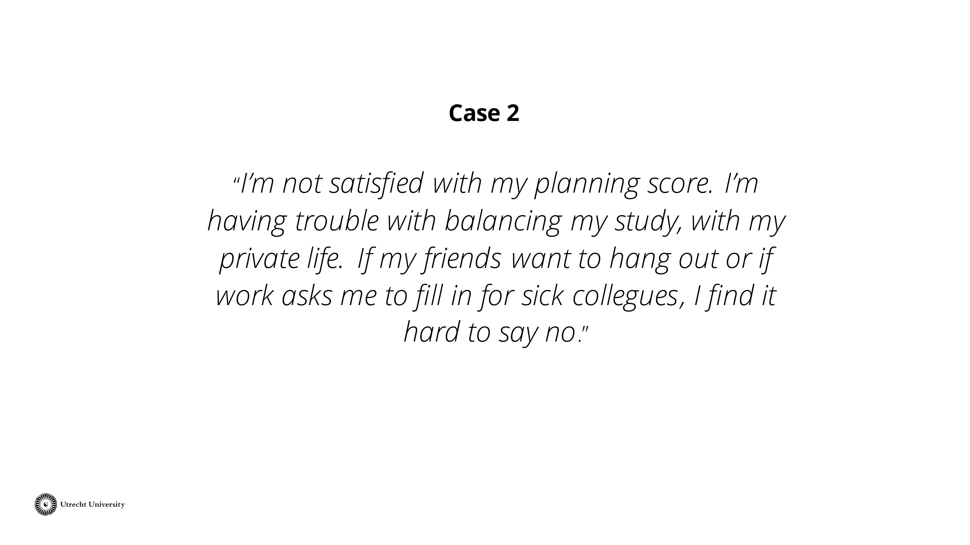 | Read the case out loud or give the tutors time to read the case themselves. Give the tutors some time to think about what they would do in this situation.  Then discuss with the group of tutors what the counseling of this student would look like. Also include the Thermos Dashboard and its role in student counseling.  Tip: Also refer to the role of the tutor as described by your faculty or study program.
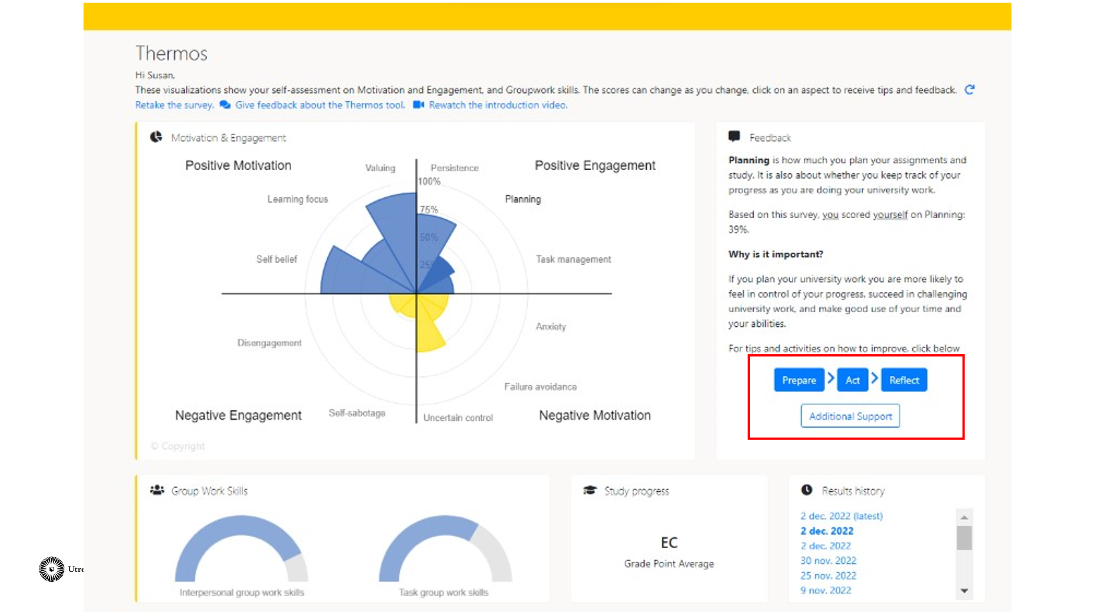 | Discuss with the tutors how the Thermos dashboard and its possibilities can play a role in the guidance of students.  Within the Thermos dashboard, students can click on an aspect (such as anxiety). More information about this aspect will appear on the right frame. In addition, there are four options that students can click on to further develop themselves regarding this aspect. The four options are: 'Prepare', 'Action', 'Reflect', and 'Additional support'. The next slide shows what that looks like.
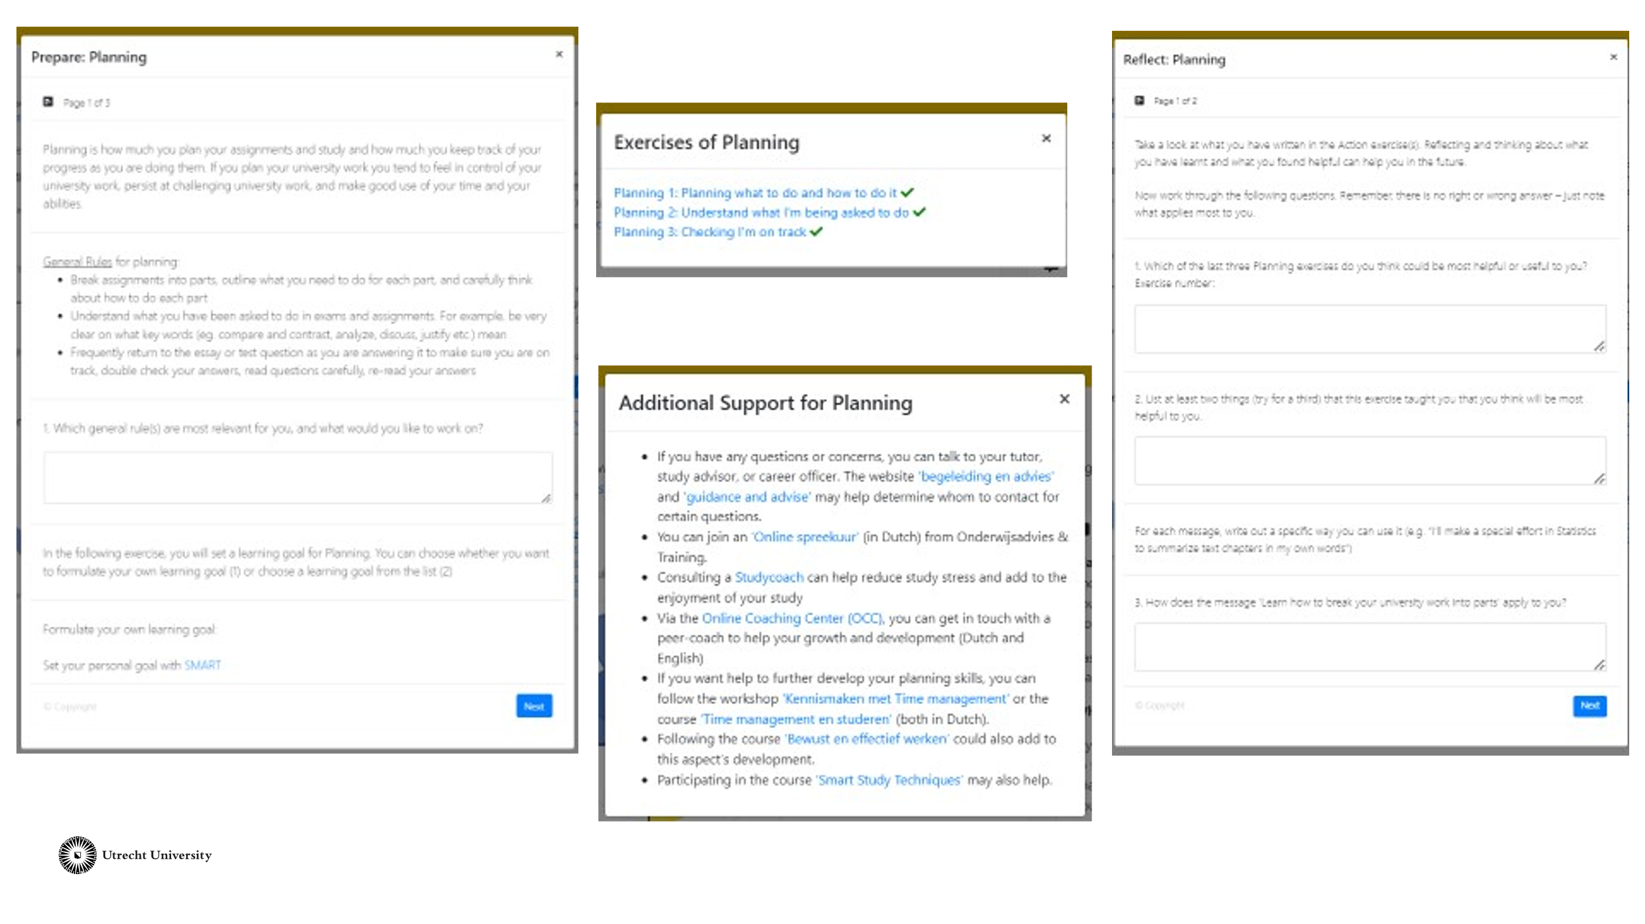 | This slide shows what the page looks like when a student clicks on the referral options. The options 'Prepare', 'Action', and 'Reflect' are assignments on which the student can work independently. These assignments include the formulation of a goal, activities, and opportunities for reflection. In addition, there is the option 'Additional support'. When a student clicks on this, referral options such as training courses and a study coach appear.  Let the tutors compare this case with the previous one. Engage in a conversation about when to refer or not. Does the referral look different now? Why?
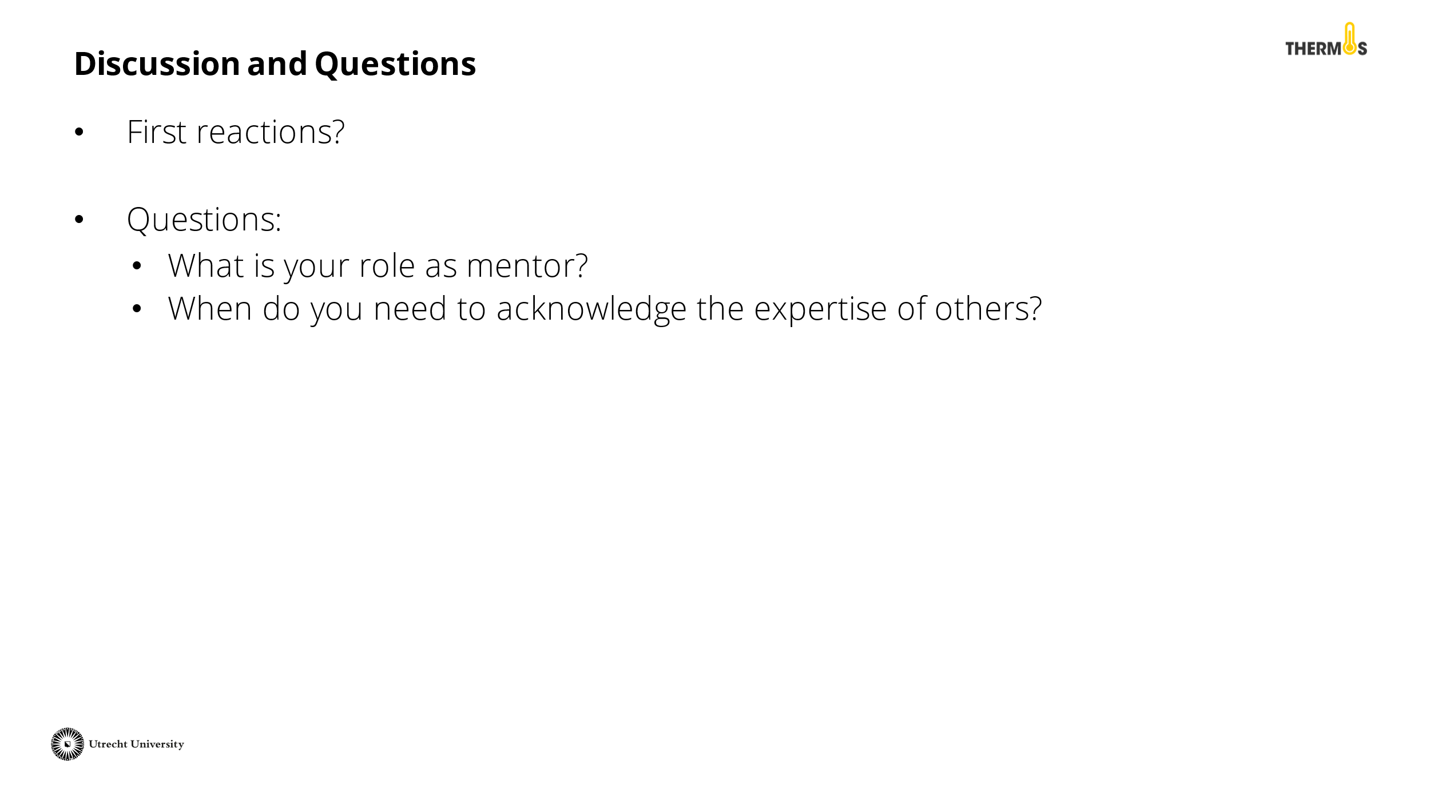 | Reflect on the activity with the tutors. Did you arrive at a shared vision? When should you recognise the expertise of others? What challenges do you still encounter as a tutor?
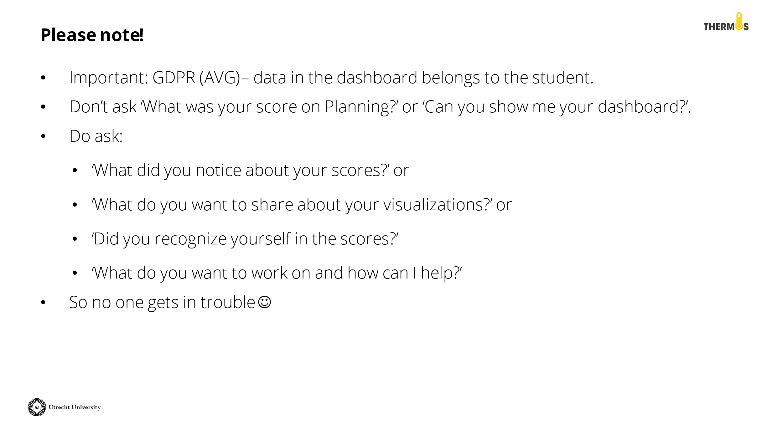 | Discuss with the tutors the AVG rules for working with the Thermos dashboard. It is important to remember that the data from the dashboard belongs to the student. Therefore, they should not feel pressured to share this information, even if a tutor asks about it with the best of intentions. See the PowerPoint slide for an example of questions you can ask as a tutor.
 | Give the tutors a short break.
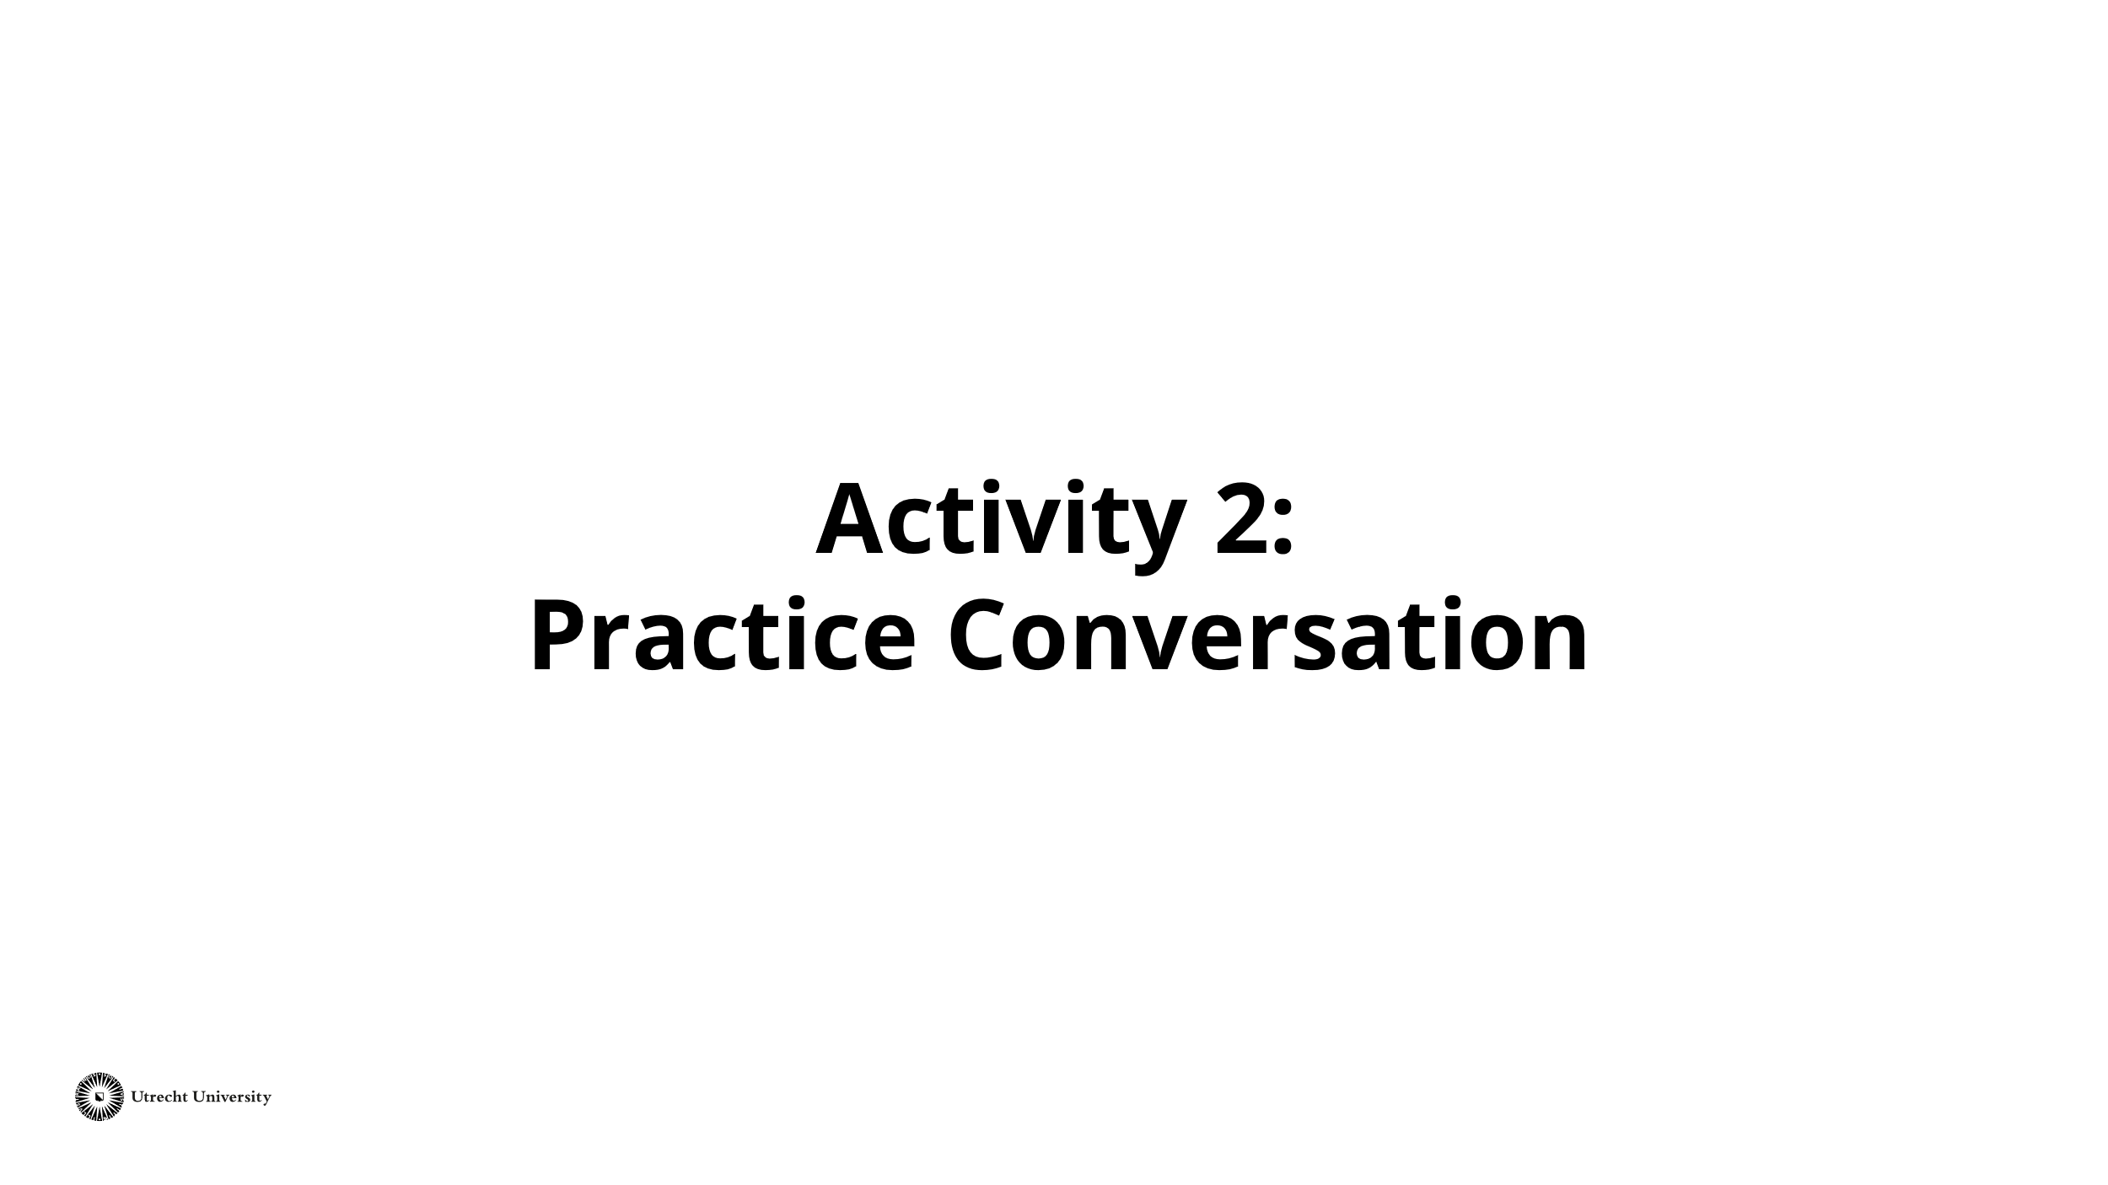 | The second activity is called 'Practice Conversation' and will last about 30 minutes.
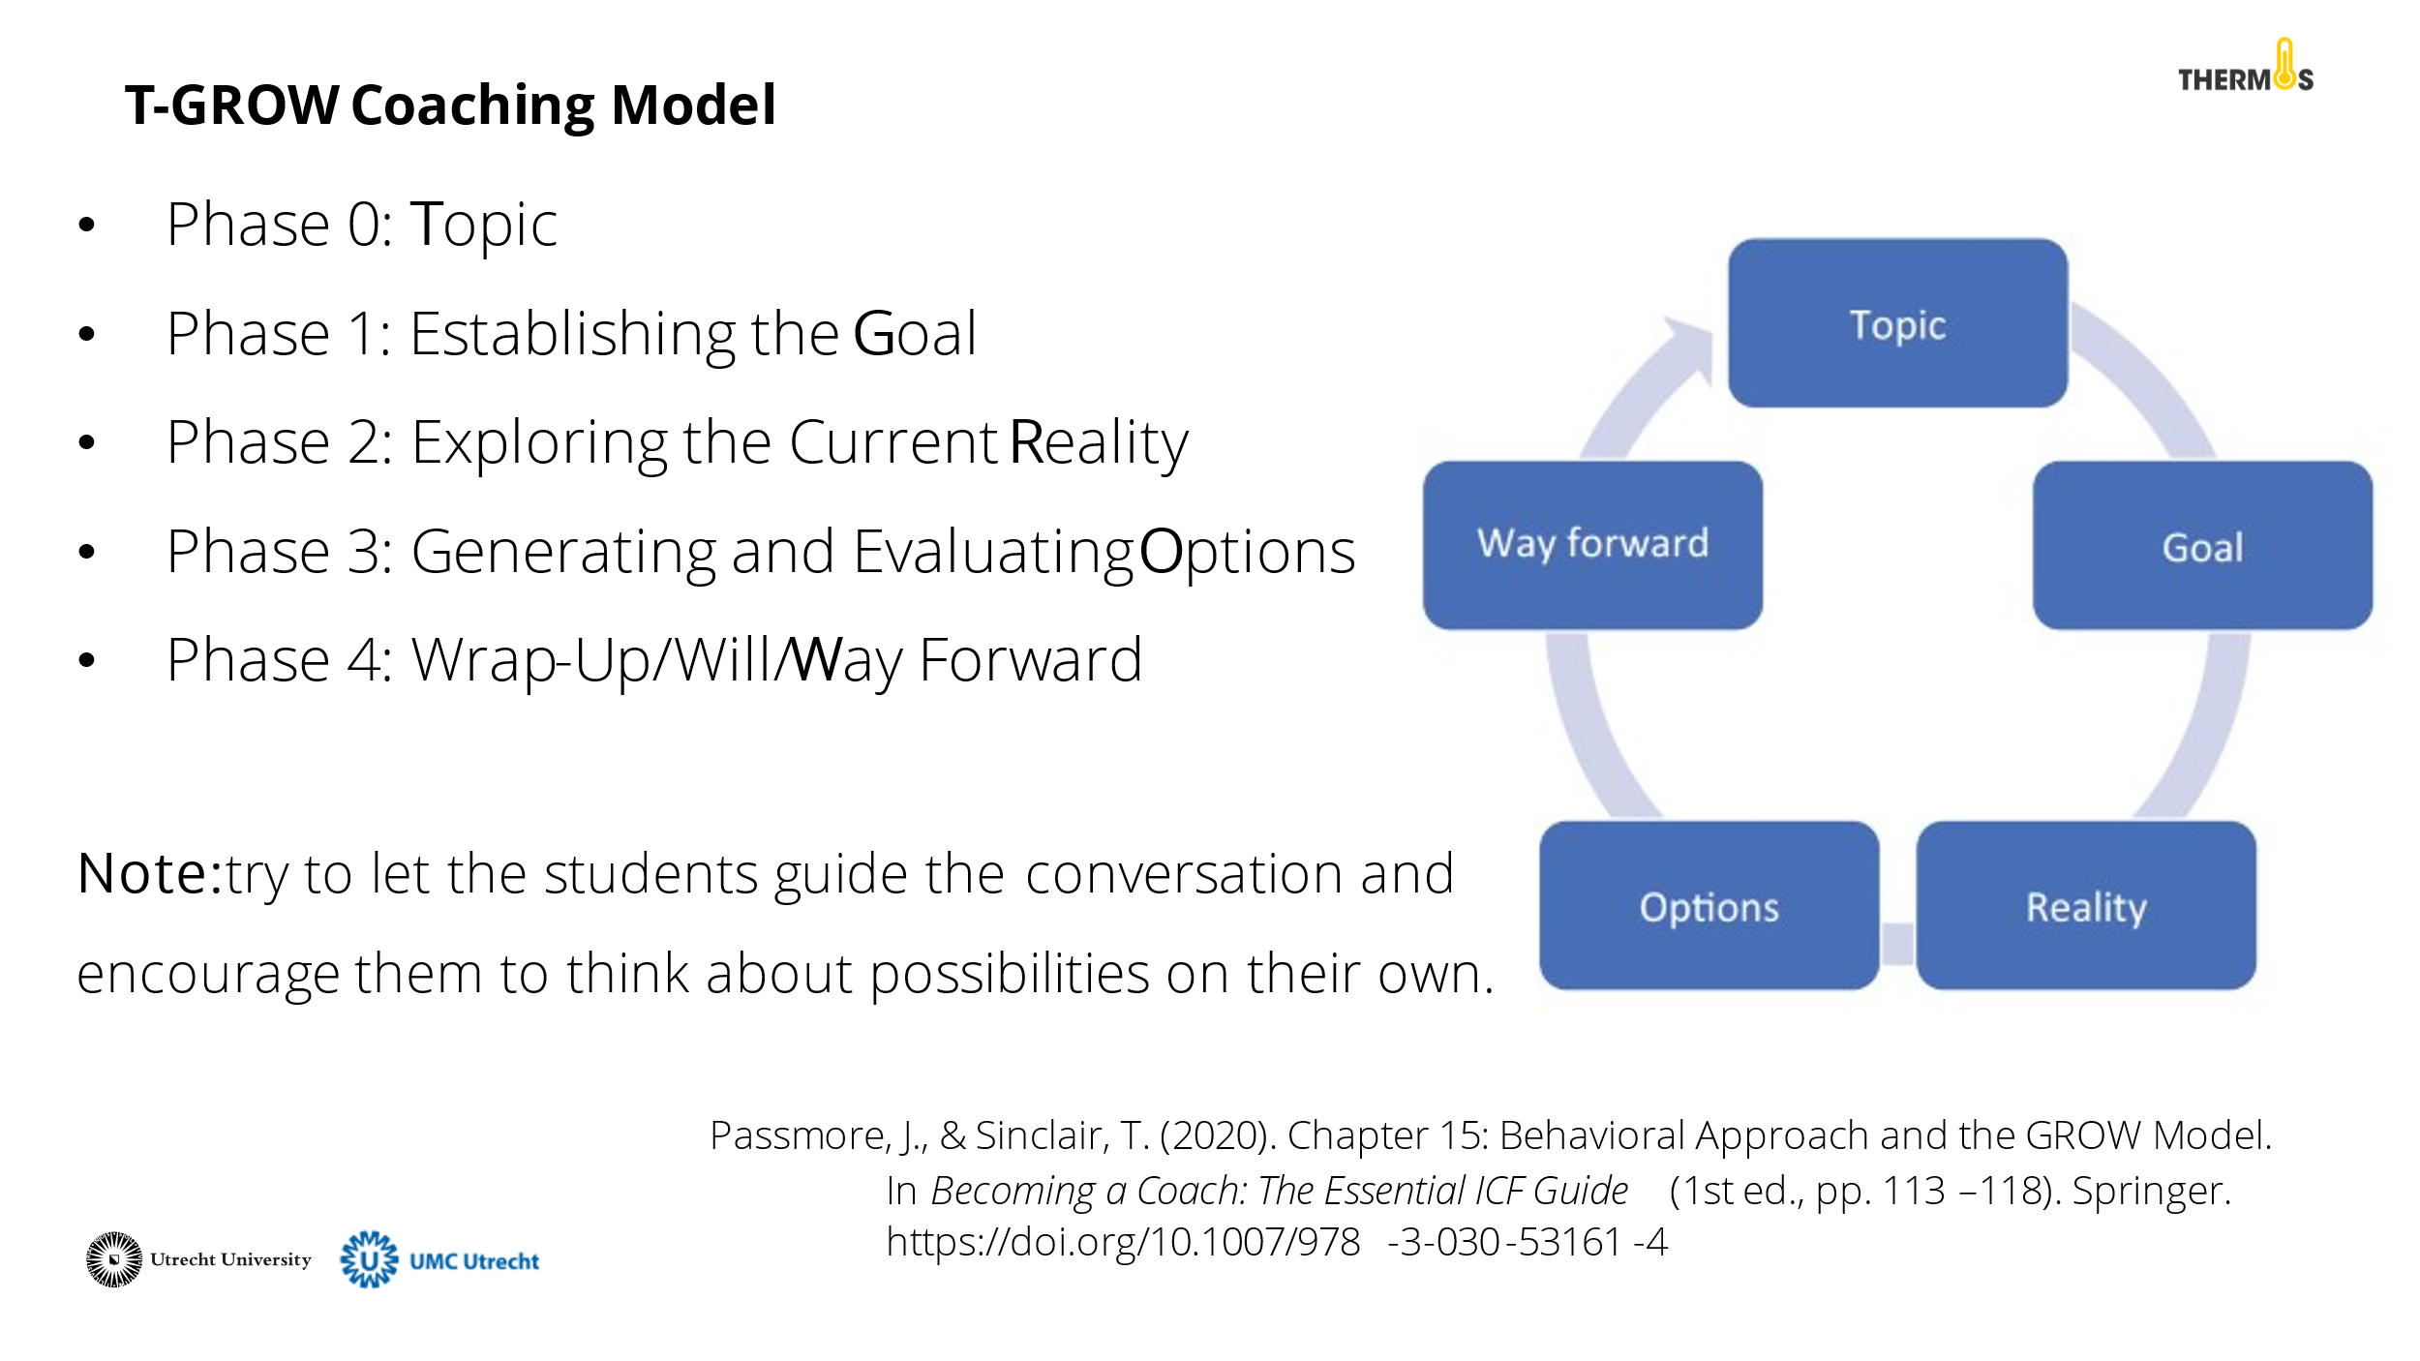 | One model for coaching is the T-GROW model. The student is in charge of the outcomes. The tutor encourages and guides the student to think for themselves and arrive at solutions This model consists of the following components and can be used flexibly:  Phase 0: Topic  It is important to establish the topic. Perhaps that has already been determined before the conversation. If not, that is the first step.  Phase 1: Establishing the Goal  In the first phase, a goal is set. What does the student want to achieve? For example, what stands out on the dashboard that the student wants to work on? It is important that the student formulates a positive goal (i.e., not: I want to procrastinate less, but: I want to spend an hour every week on my report). The more concrete the goal is defined, the more meaningful it is for the student and the more likely progress can be made.  Phase 2: Exploring the Current Reality  In the second phase, the student reflects on the current situation. This does not involve searching for solutions yet. Let the student think about possible causes and consequences, what has been tried so far, what are blockages, viewing the situation from different perspectives, etc. In doing so, the focus should not be too long on the past. However, it is important to recognise the core of the problem or contexts in which the problem does not occur.  Phase 3: Generating and Evaluating Options  The third phase consists of two parts: generating options and evaluating those options. In the first part, students brainstorm about all possible options. It is important that the student is encouraged to come up with solutions. For example, ask about situations where things do work out or skills that the student possesses that might be used to achieve this aim. Here, advantages and disadvantages are not yet considered.  The second part involves looking at the most appropriate action to realise the goal. Try to encourage the student to think for themselves and ask open questions.  Phase 4: Wrap-Up/Will/Way Forward  The final phase focuses on creating an action plan. What steps will the student take to realise this goal? What support does the student need in doing so?  For a more detailed explanation of the model:  Passmore, J., & Sinclair, T. (2020). Chapter 15: Behavioral Approach and the GROW Model.In Becoming a Coach: The Essential ICF Guide (1st ed., pp. 113–118). Springer. https://doi.org/10.1007/978-3-030-53161-4
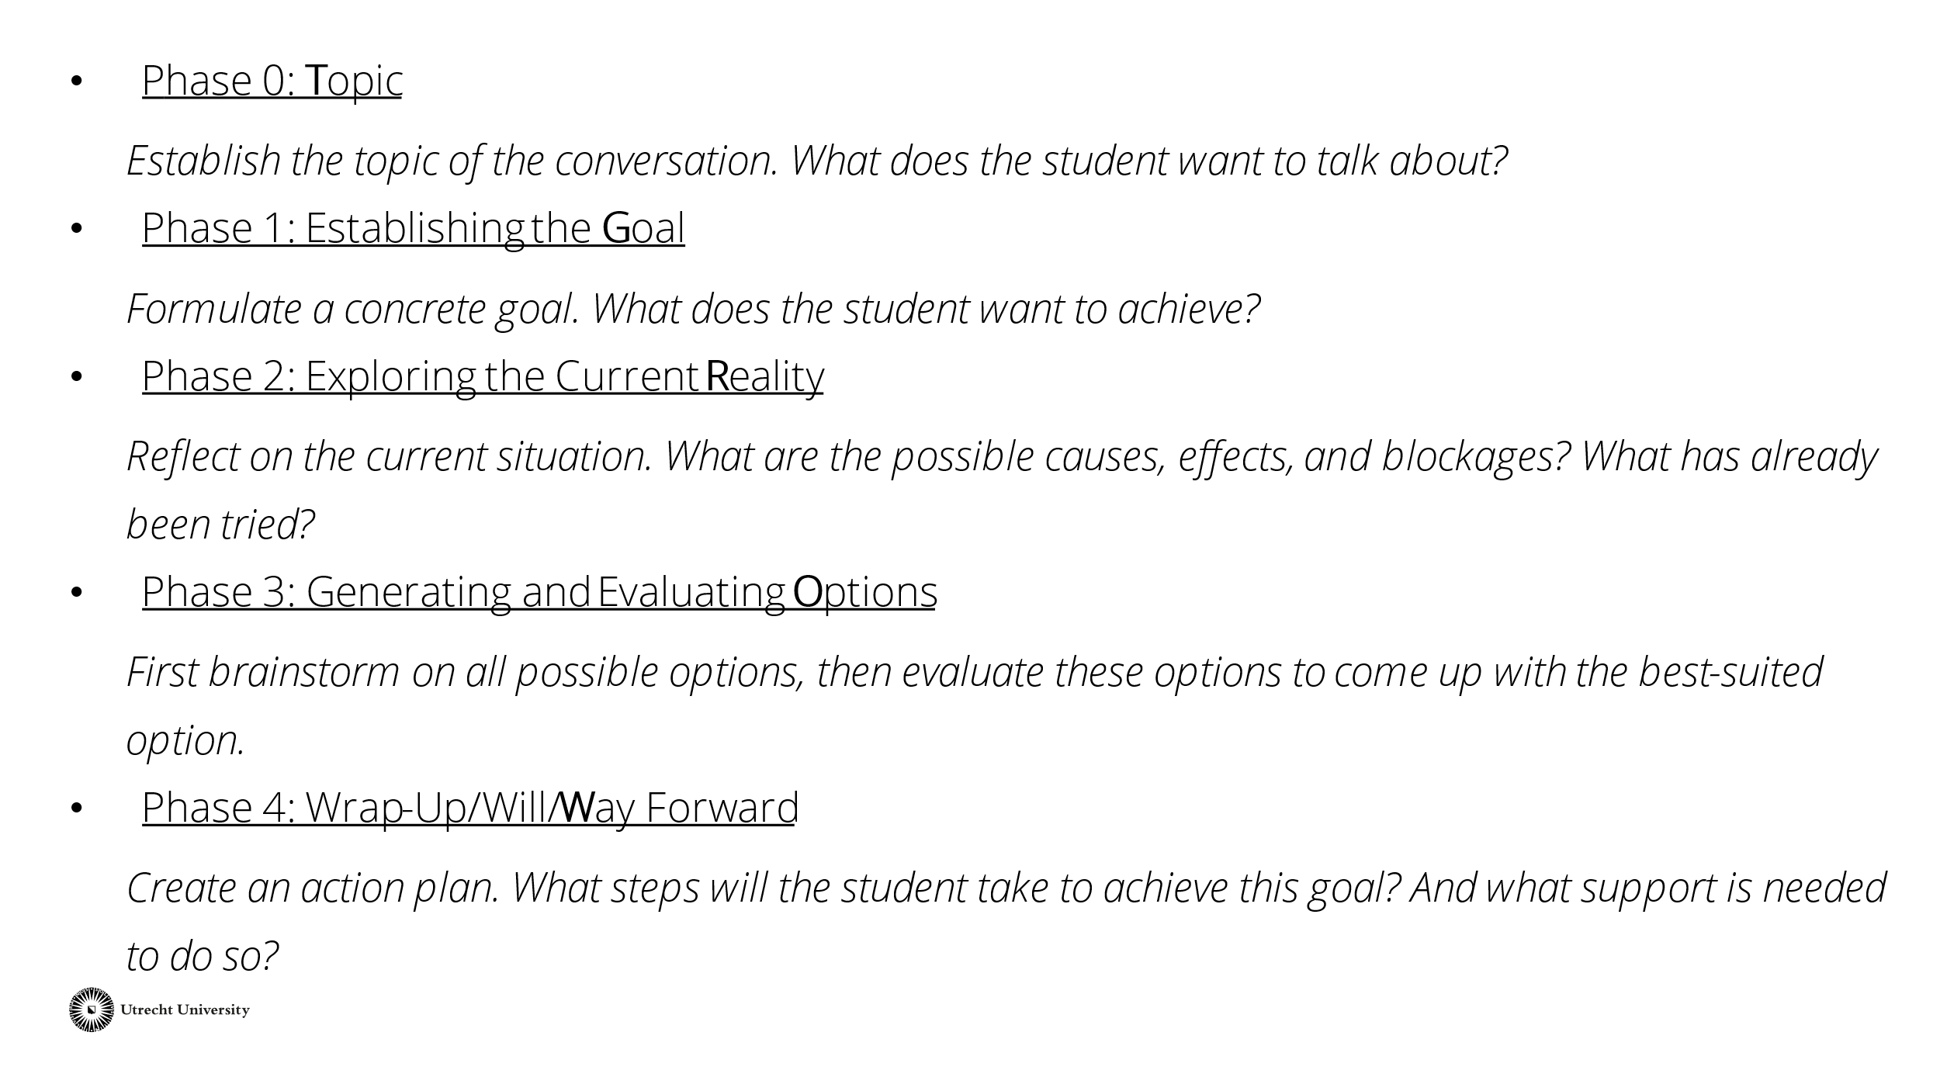 | This slide briefly explains the phases for the tutors. If necessary, leave this slide on the board during the performance of the work form as a reminder.  Tip: share this slide or the whole PowerPoint with the tutors afterward.
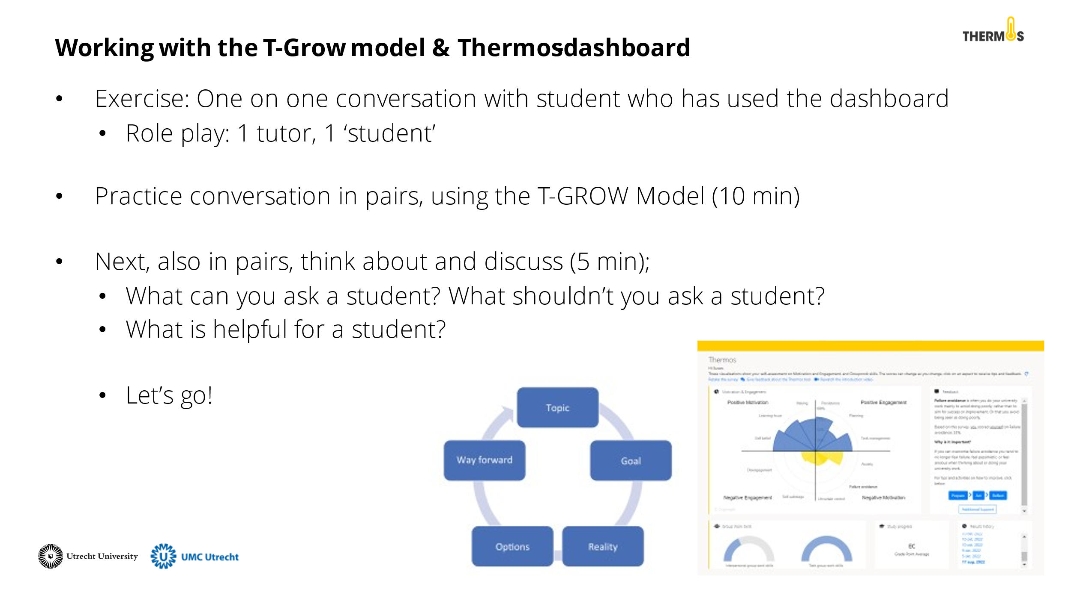 | During the activity, the tutors engage in a practice conversation by role-playing. The tutors do this in pairs. One tutor is the tutor, and one tutor is the 'student'. The 'student' receives a Thermos-dashboard (see appendix). The tutor starts a conversation with the 'student' using the T-GROW model. The 'student' can use the information from the dashboard to think about the topic of this conversation. They have about 10 minutes for this.  Then the pairs discuss the questions on the slide for about 5 minutes.
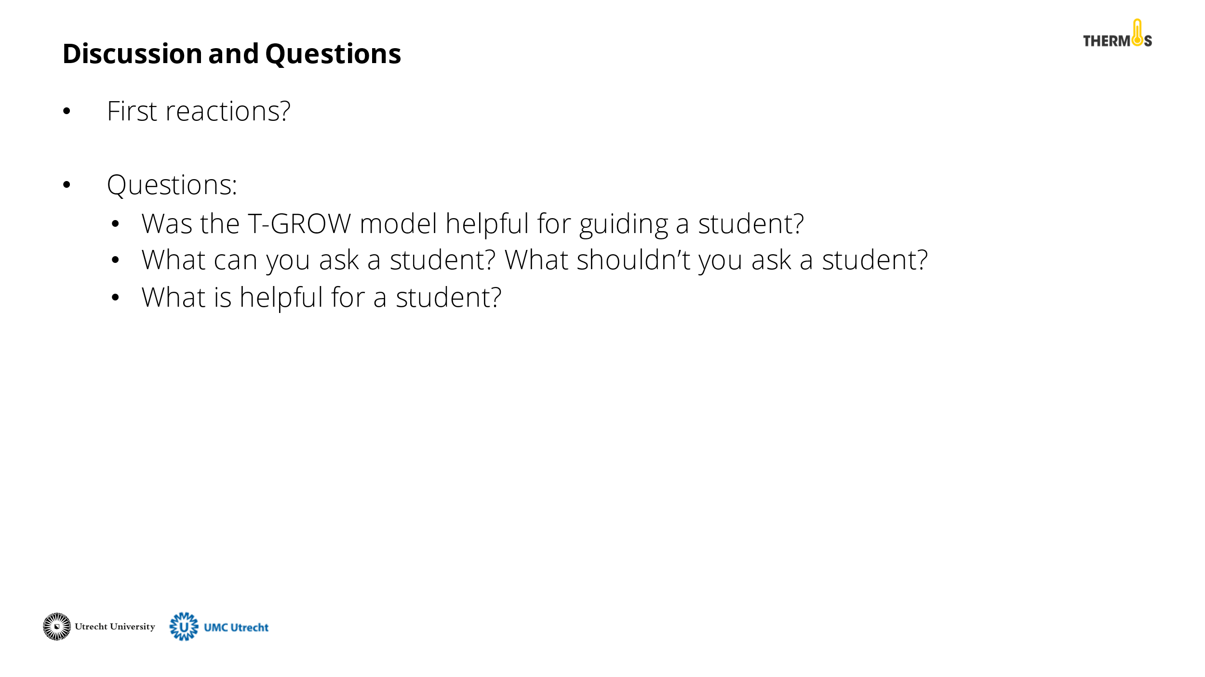 | Discuss with the tutors what their thoughts are about the GROW model and the activity. What insights do they take away from this training?
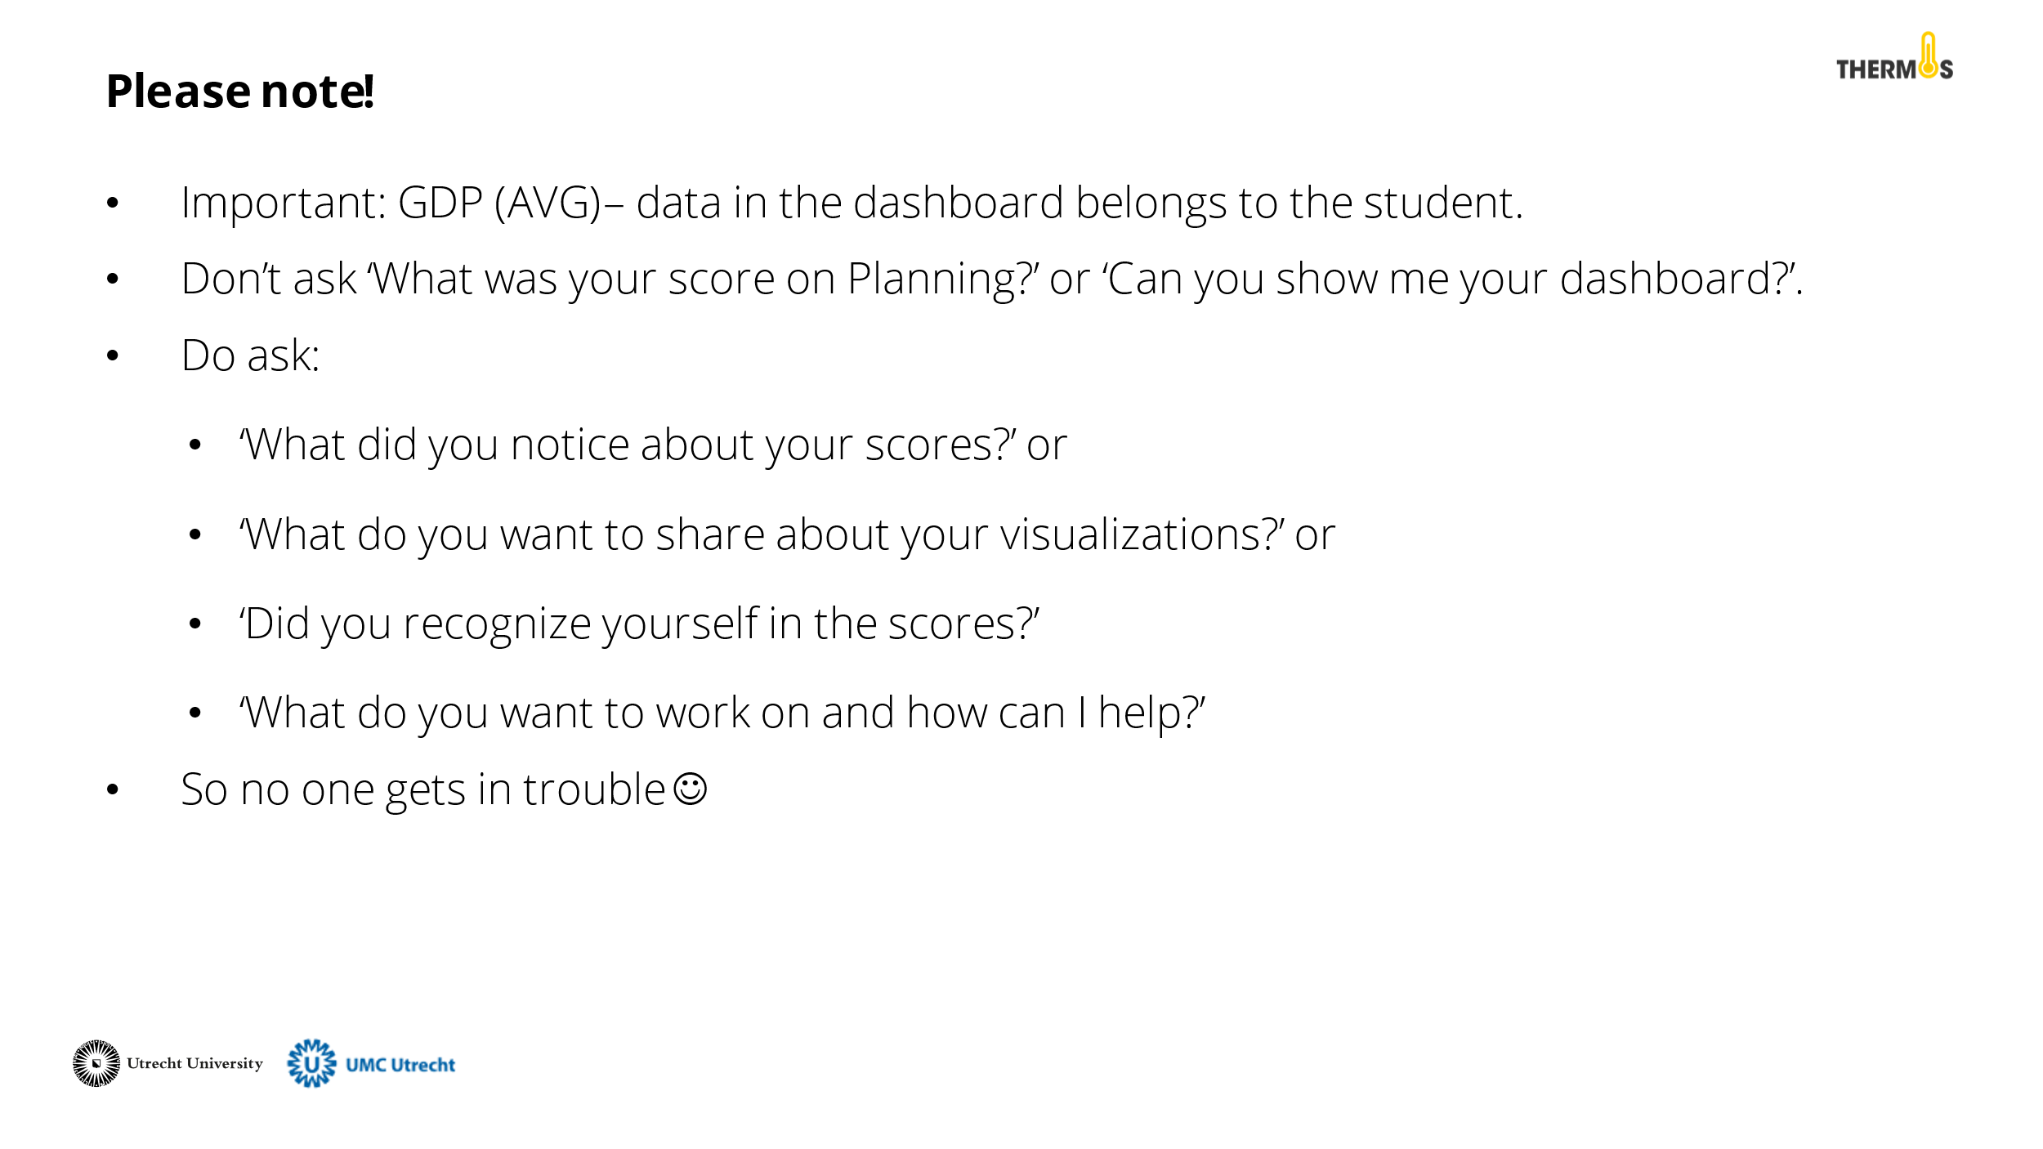 | Discuss with the tutors the AVG rules for working with the Thermos-dashboard. It is important to remember that the data from the dashboard belongs to the student. Therefore, they should not feel pressured to share this information. See the PowerPoint slide for an example of questions you can ask as a tutor.
Finally, close the presentation by thanking the tutors for their participation and addressing whom they can contact for questions.

Tip: Ask the tutors if there is a need for intervision after they have worked with thermos in practice. Then plan a follow-up meeting, see activity 3 about intervision.

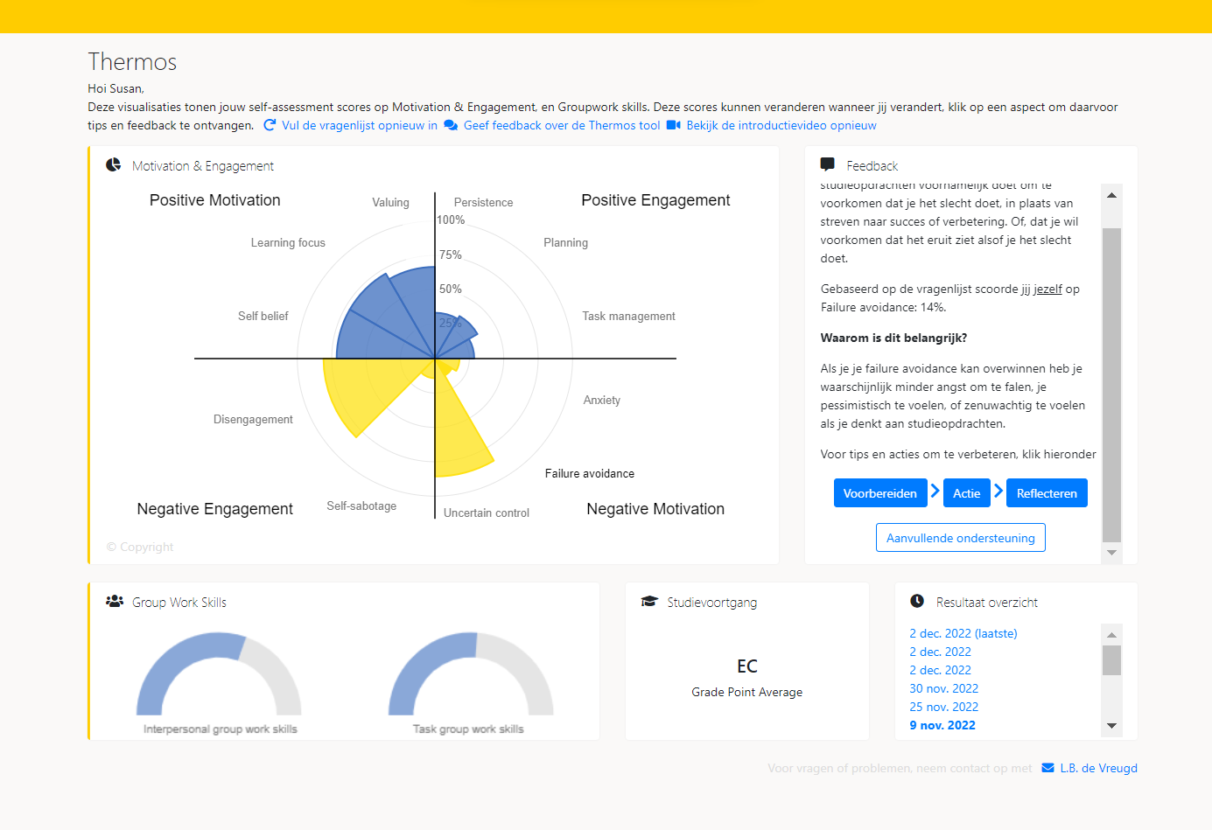
Appendices

