Instruction Tutor-to-tutor coaching

Dear tutor coordinator, this document explains how to use the activity ‘tutor-to-tutor coaching’. This explanation consists of three parts: preparation, duration, and instruction per slide. This is an example of an elaboration of this activity, but it is also possible to make adjustments according to the preferences of the relevant study program.
Preparation | - Read the explanation of this activity carefully beforehand.  - It is important that the tutors already used the Thermos dashboard for student counseling. Let the tutor think of problems or issues they encountered using Thermos in advance to use for this coaching session. Let them write down this case in a maximum of five sentences.
Duration | Performing this activity will take +/- 40 minutes.
Slides | Instruction
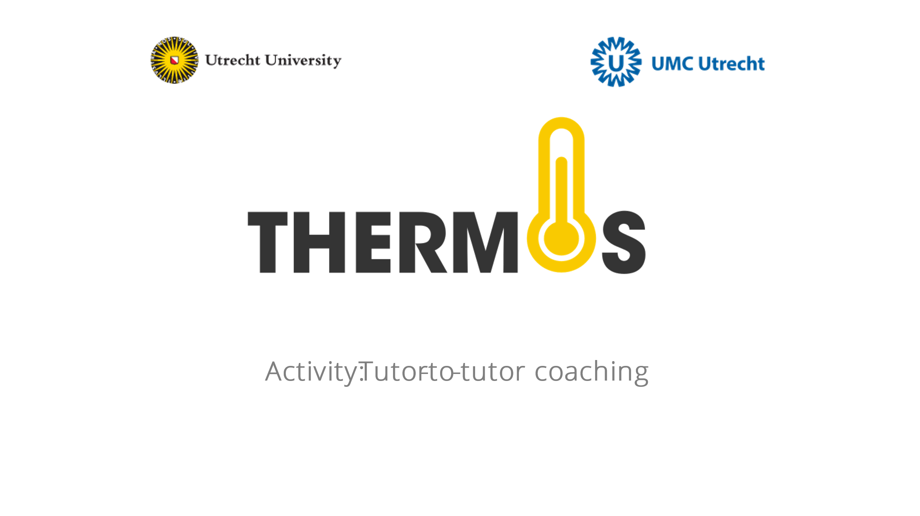
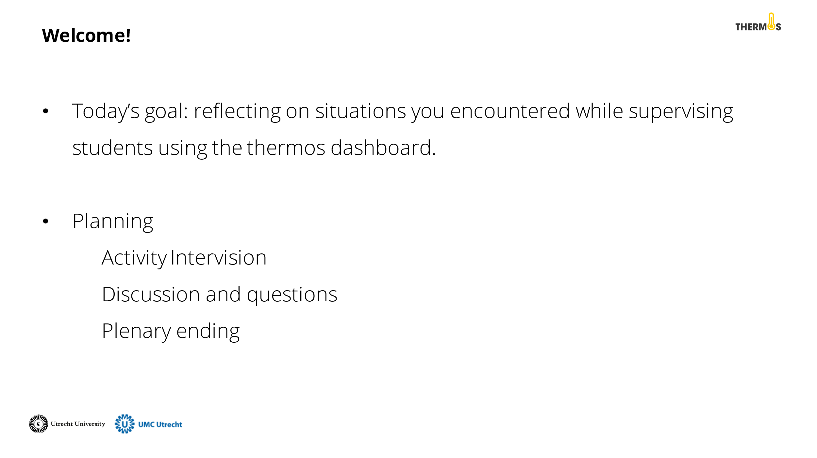 | Discuss the goal and planning of this activity with the tutors.
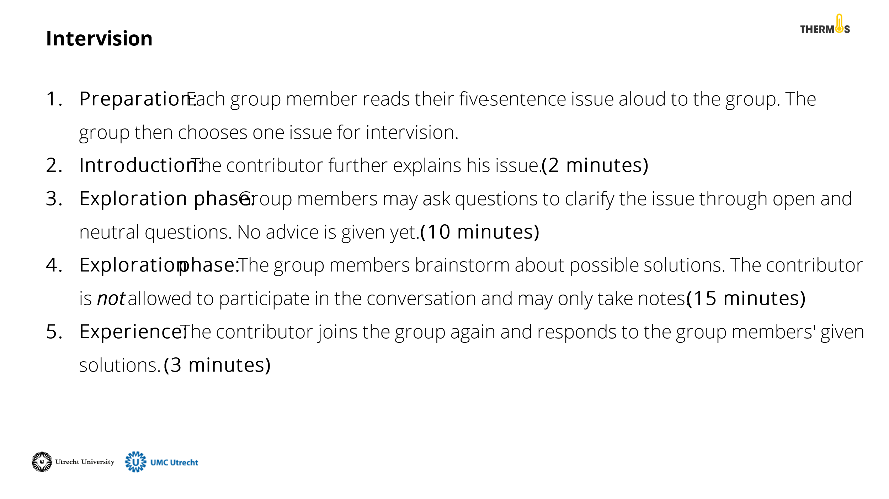 | Divide the tutors into small groups of approximately four tutors. Explain the method for coaching. This method contains of five phases which are explained below. Keep track of the time to let the groups know when to move on to the next phase.  - Preparation: Each group member reads their five-sentence issue aloud to the group. The group then chooses one issue for the session.  - Introduction: The contributor further explains his issue. (2 minutes)  - Exploration phase: Group members may ask questions to clarify the issue through open and neutral questions. No advice is given yet. (10 minutes)  - Brainstorm phase: The group members brainstorm about possible solutions. The contributor is not allowed to participate in the conversation and may only take notes. (15 minutes)  - Experience: The contributor joins the group again and responds to the group members' given solutions. (3 minutes)
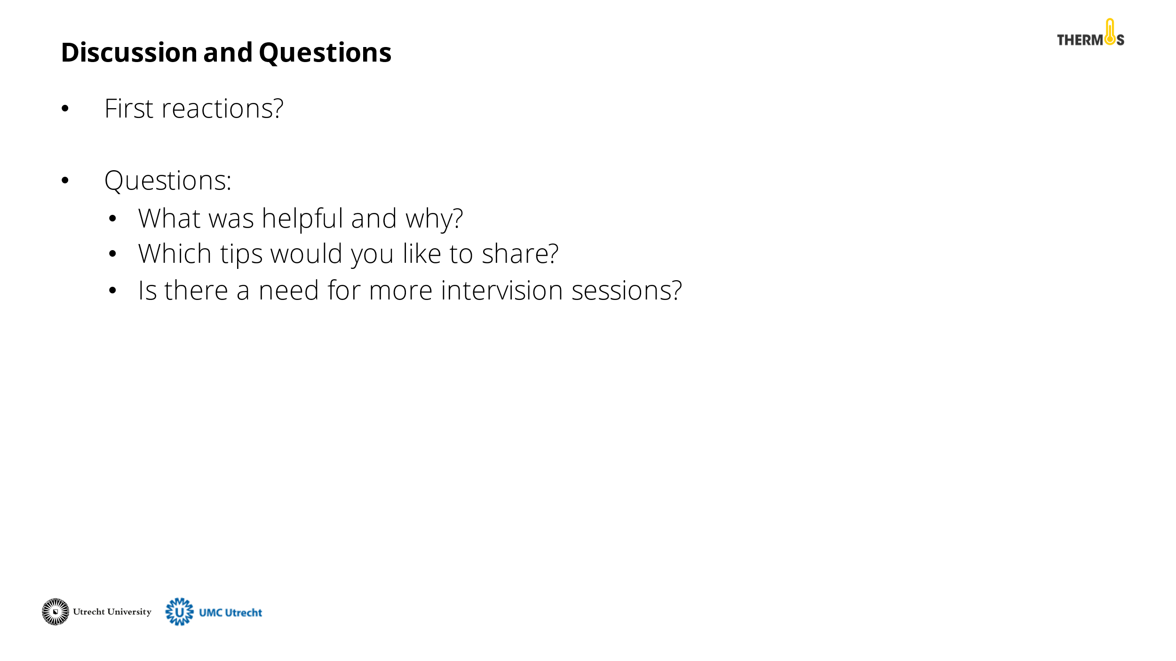 | Reflect on the activity with the tutors. Was the coaching session helpful and why? Which tips or solutions would you like to share with the group? Is there a need for more tutor-to-tutor coaching sessions?
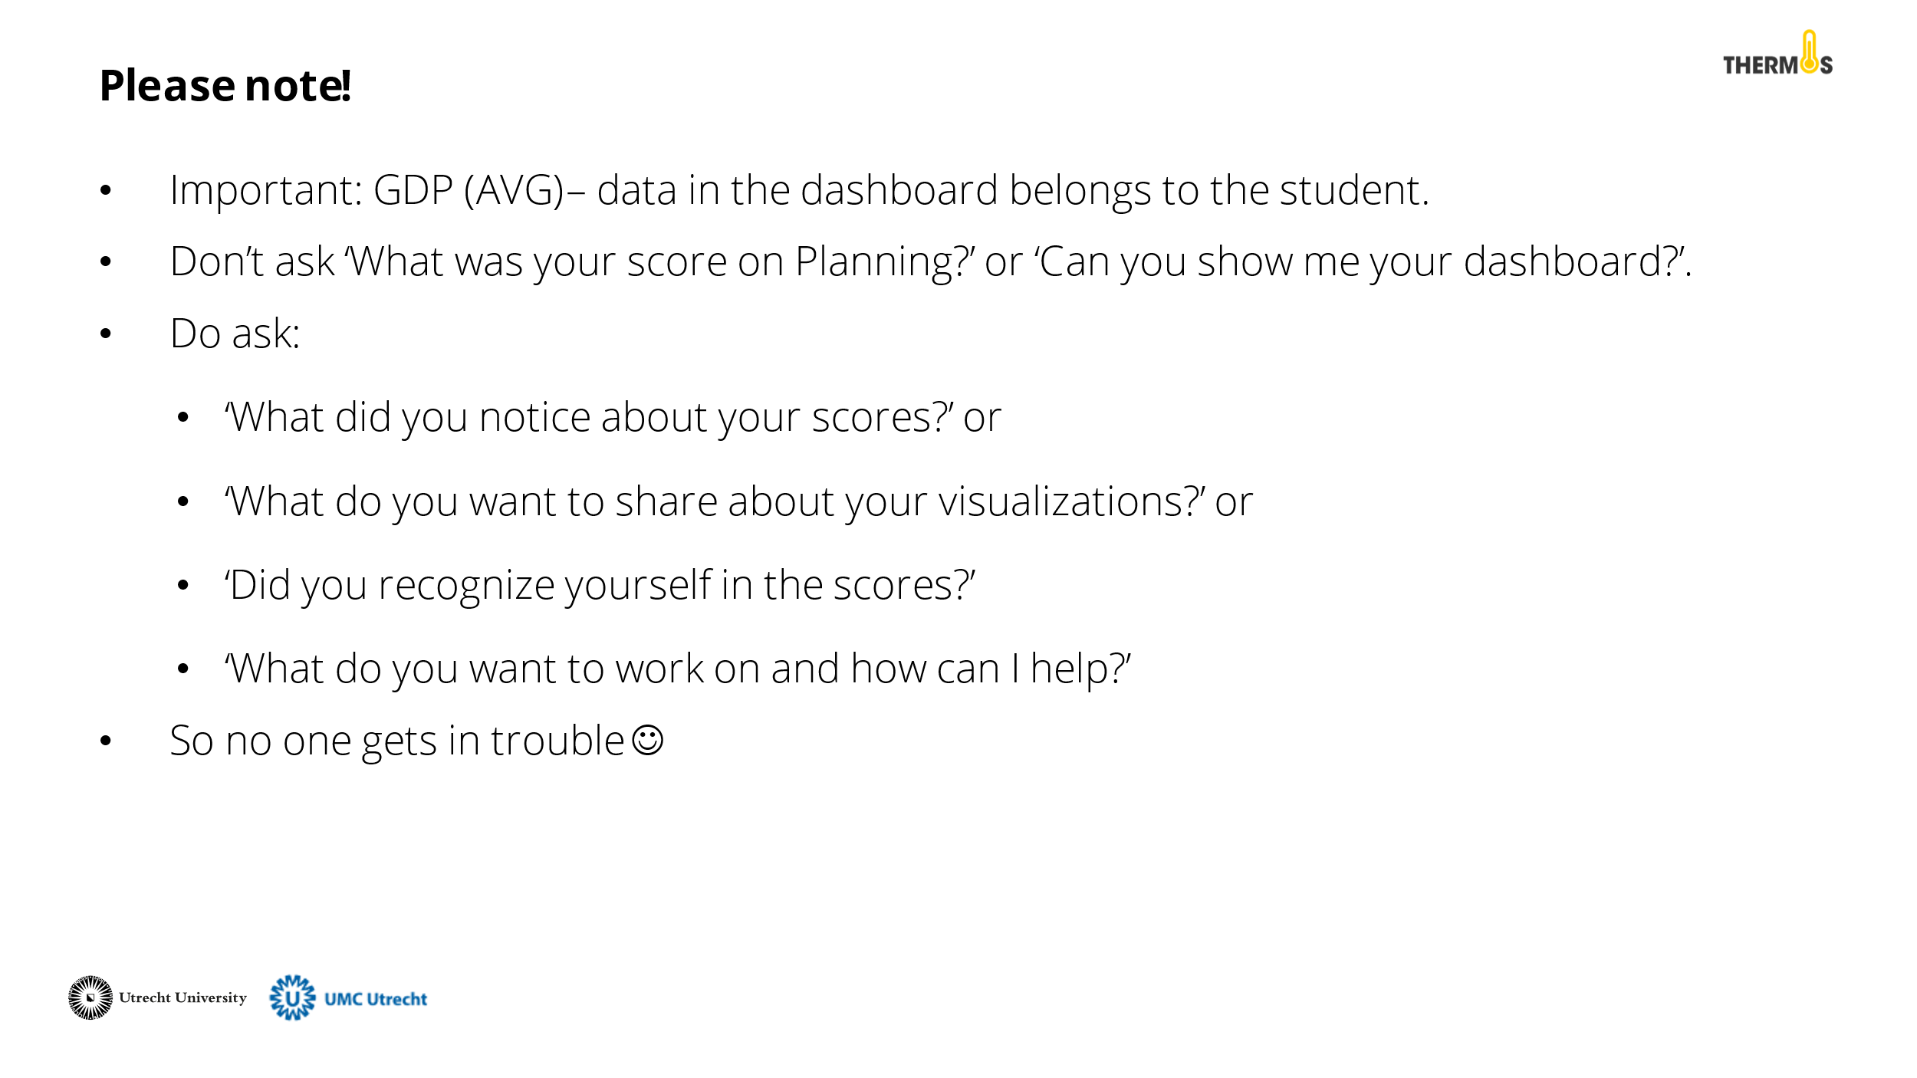 | Discuss with the tutors the AVG rules for working with the Thermos dashboard. It is important to remember that the data from the dashboard belongs to the student. Therefore, they should not feel pressured to share this information. See the PowerPoint slide for an example of questions you can ask as a tutor.
 | Finally, close the presentation by thanking the tutors for their participation and addressing whom they can contact for questions.

