Instruction Role of Tutor

Dear tutor coordinator, this document explains how to use the activity ‘Role of Tutor’. This explanation consists of three parts: preparation, duration, and instruction per slide. This is an example of an elaboration of this activity, but it is also possible to make adjustments according to the preferences of the relevant study program.
Preparation | - Read the explanation of this activity carefully beforehand.  - It is important that the tutors have been introduced to the dashboard once. As preparation, make sure the tutors watched the introductory video about Thermos or watch it together before this activity. https://thermos.sites.uu.nl/information-for-tutors/
Duration | Performing this activity will take +/- 15 minutes.
Slides | Instruction
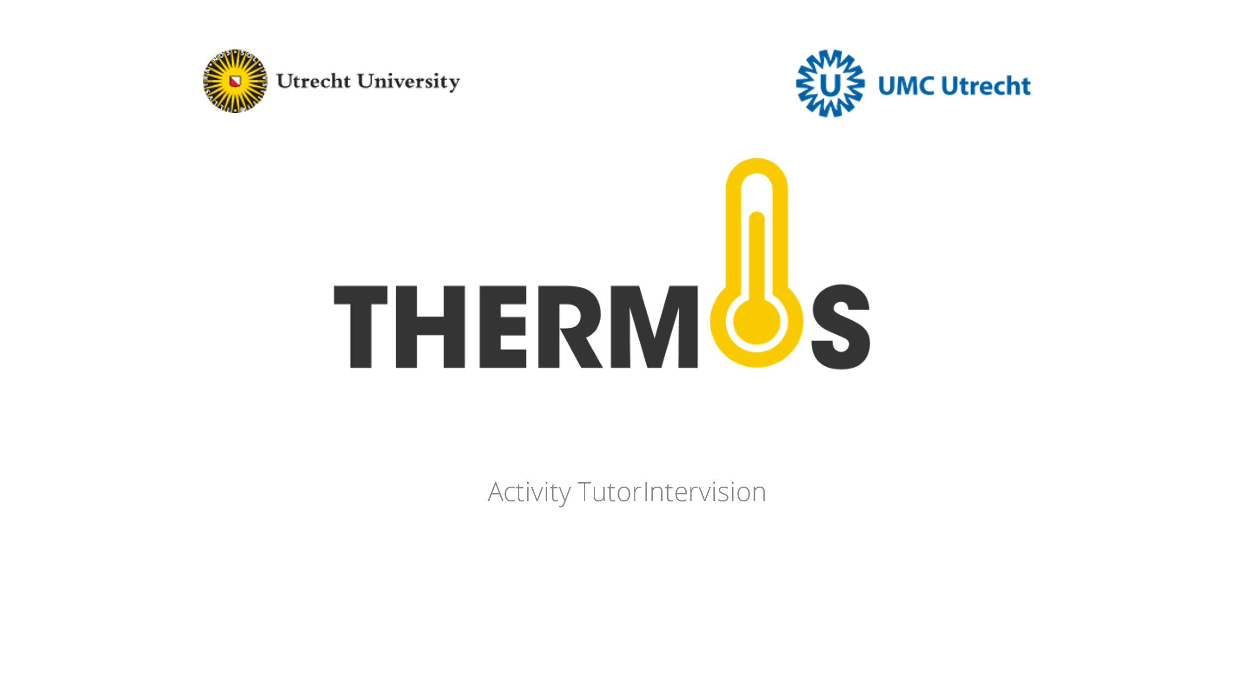
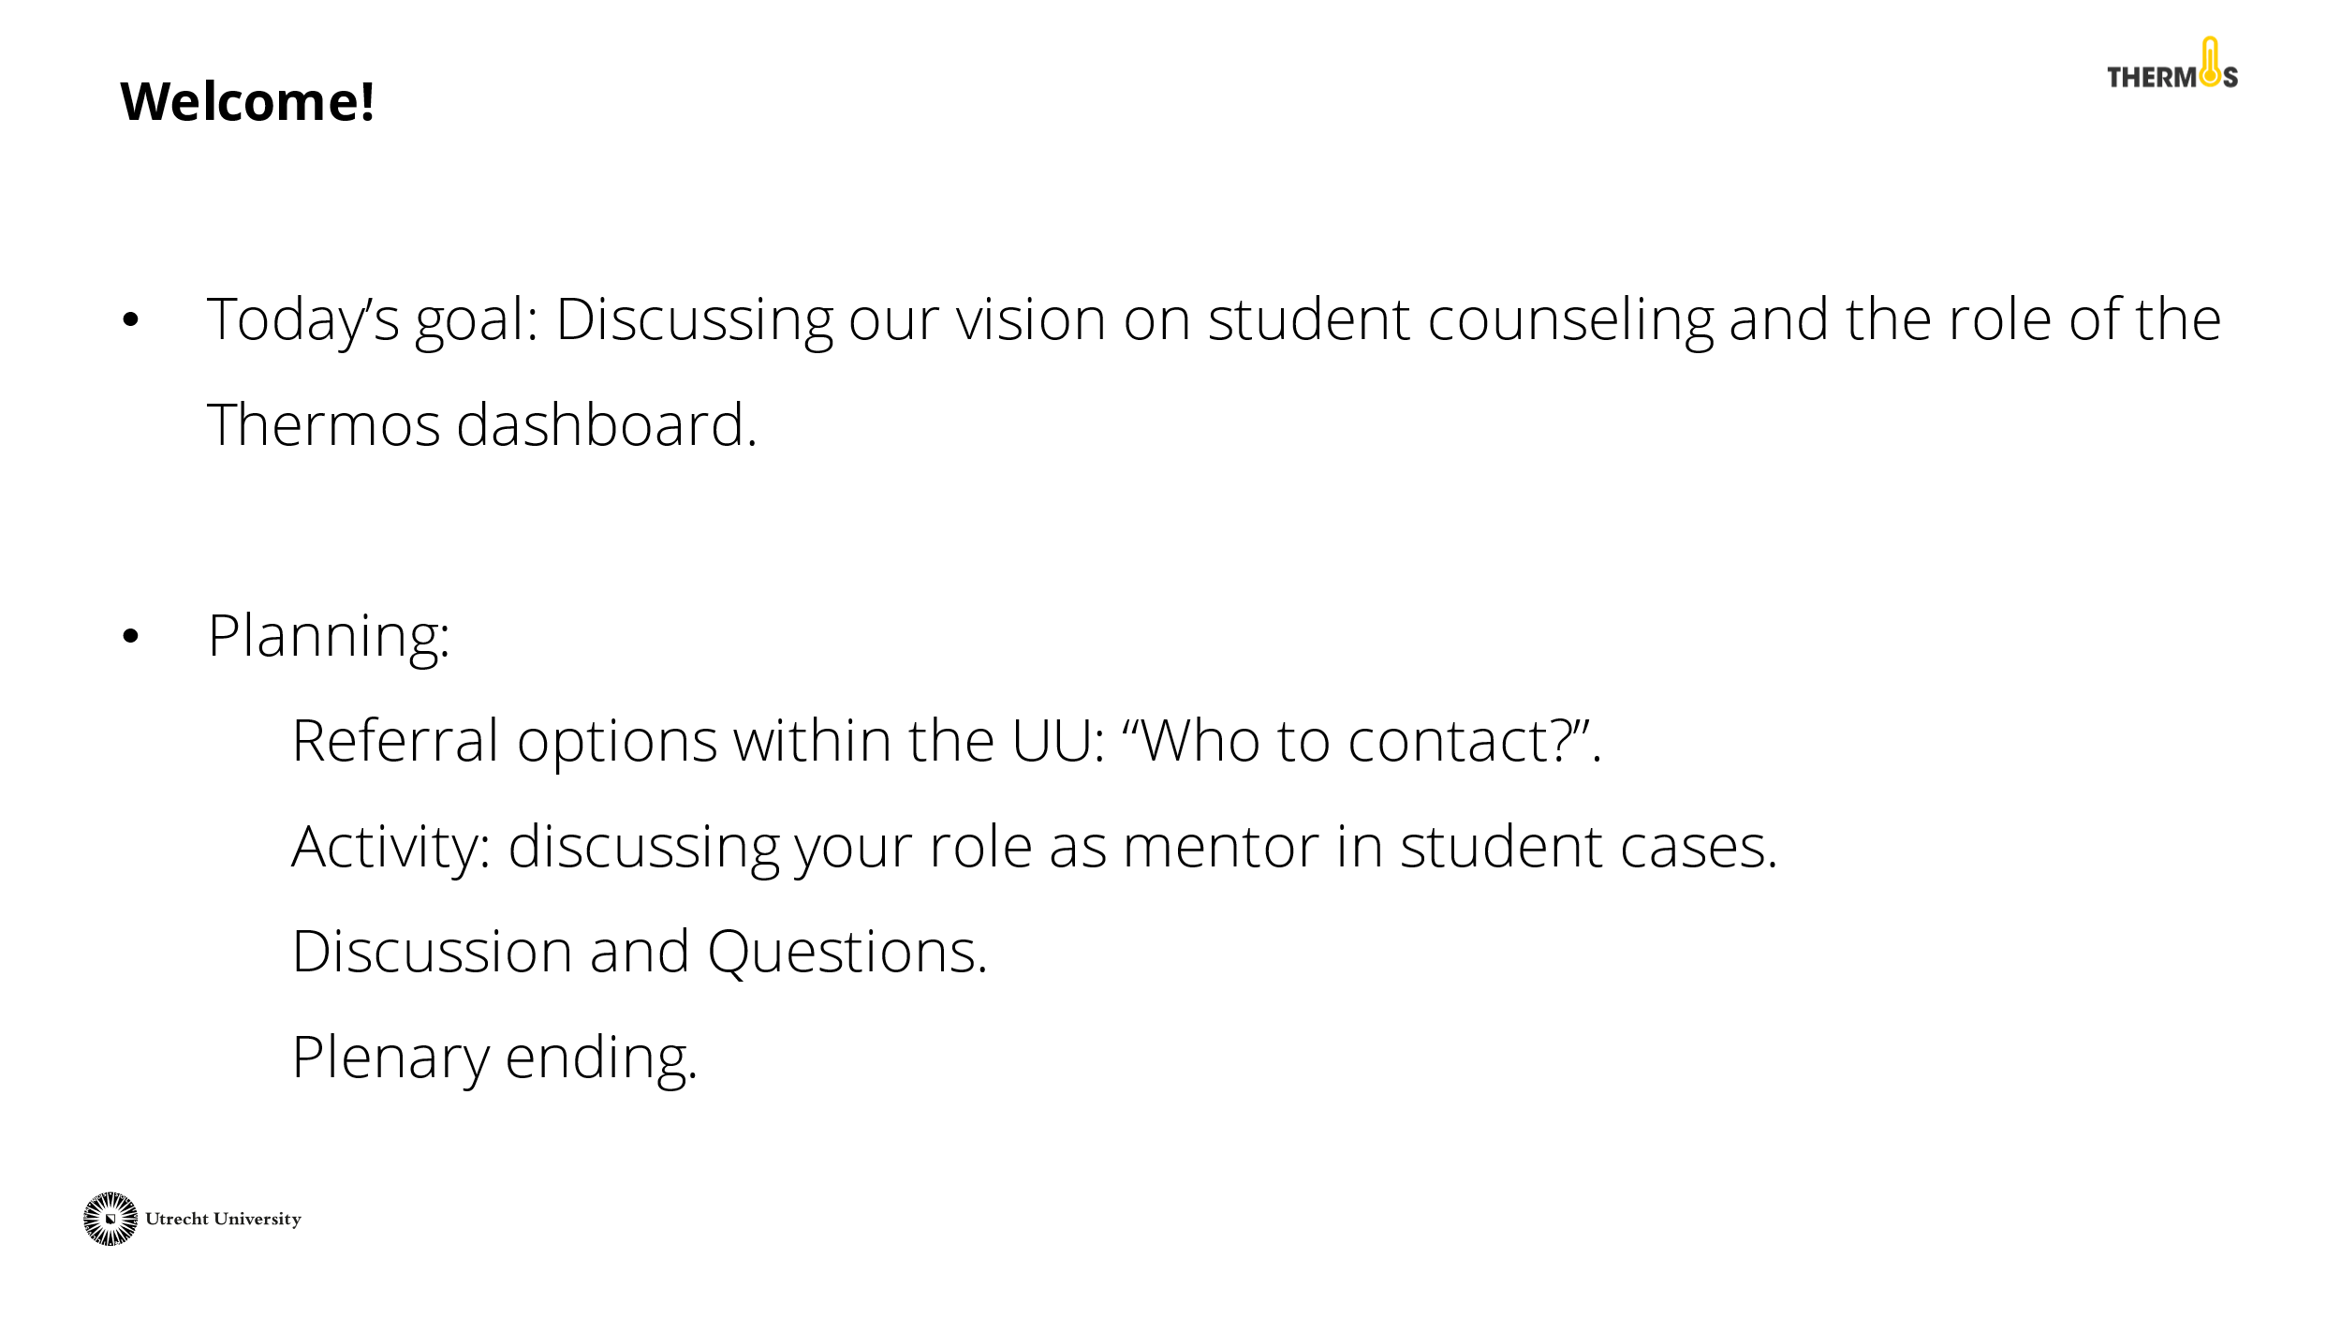 | Discuss the goal and planning of this activity with the tutors.
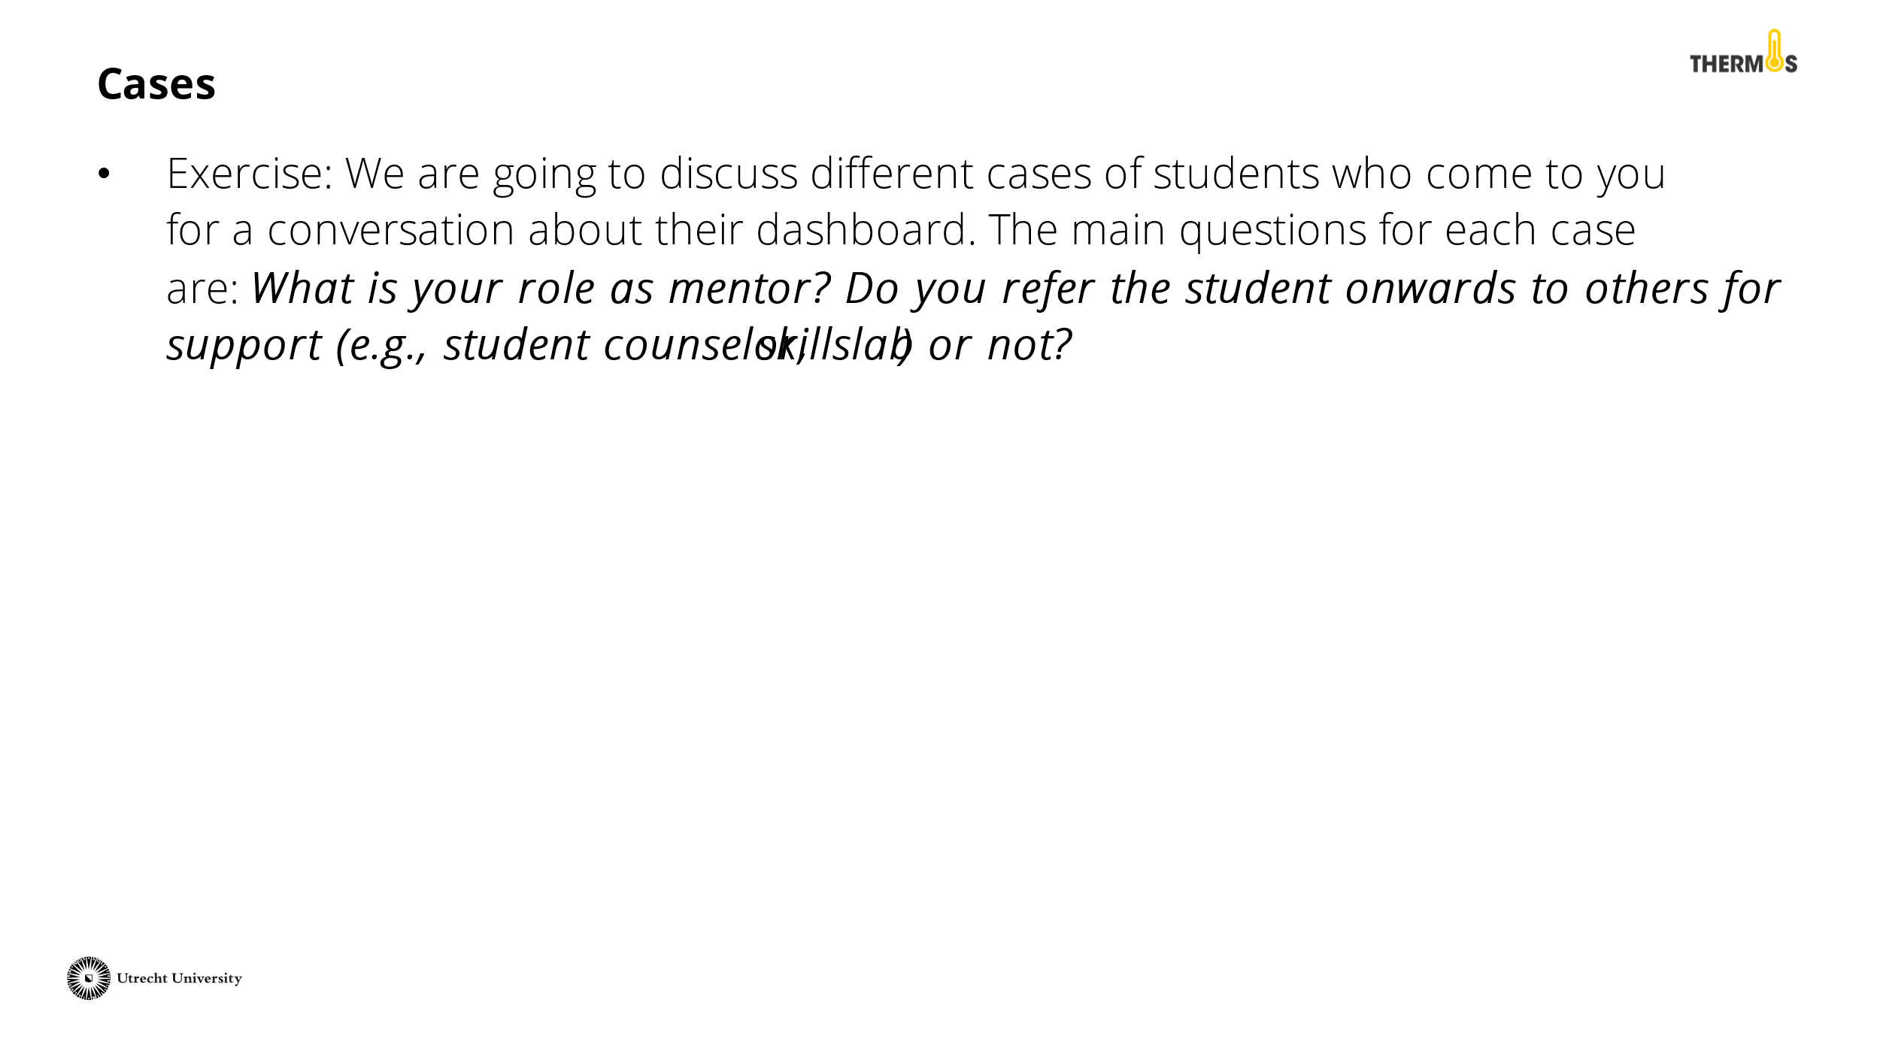 | You will discuss the role of the tutor and the Thermos dashboard with the tutors through two different cases. The central question is: "What is your role as a tutor?". Start a conversation about which issues you take up yourself as a tutor, when you refer a student onwards, and what possibilities the Thermos dashboard has in this regard.
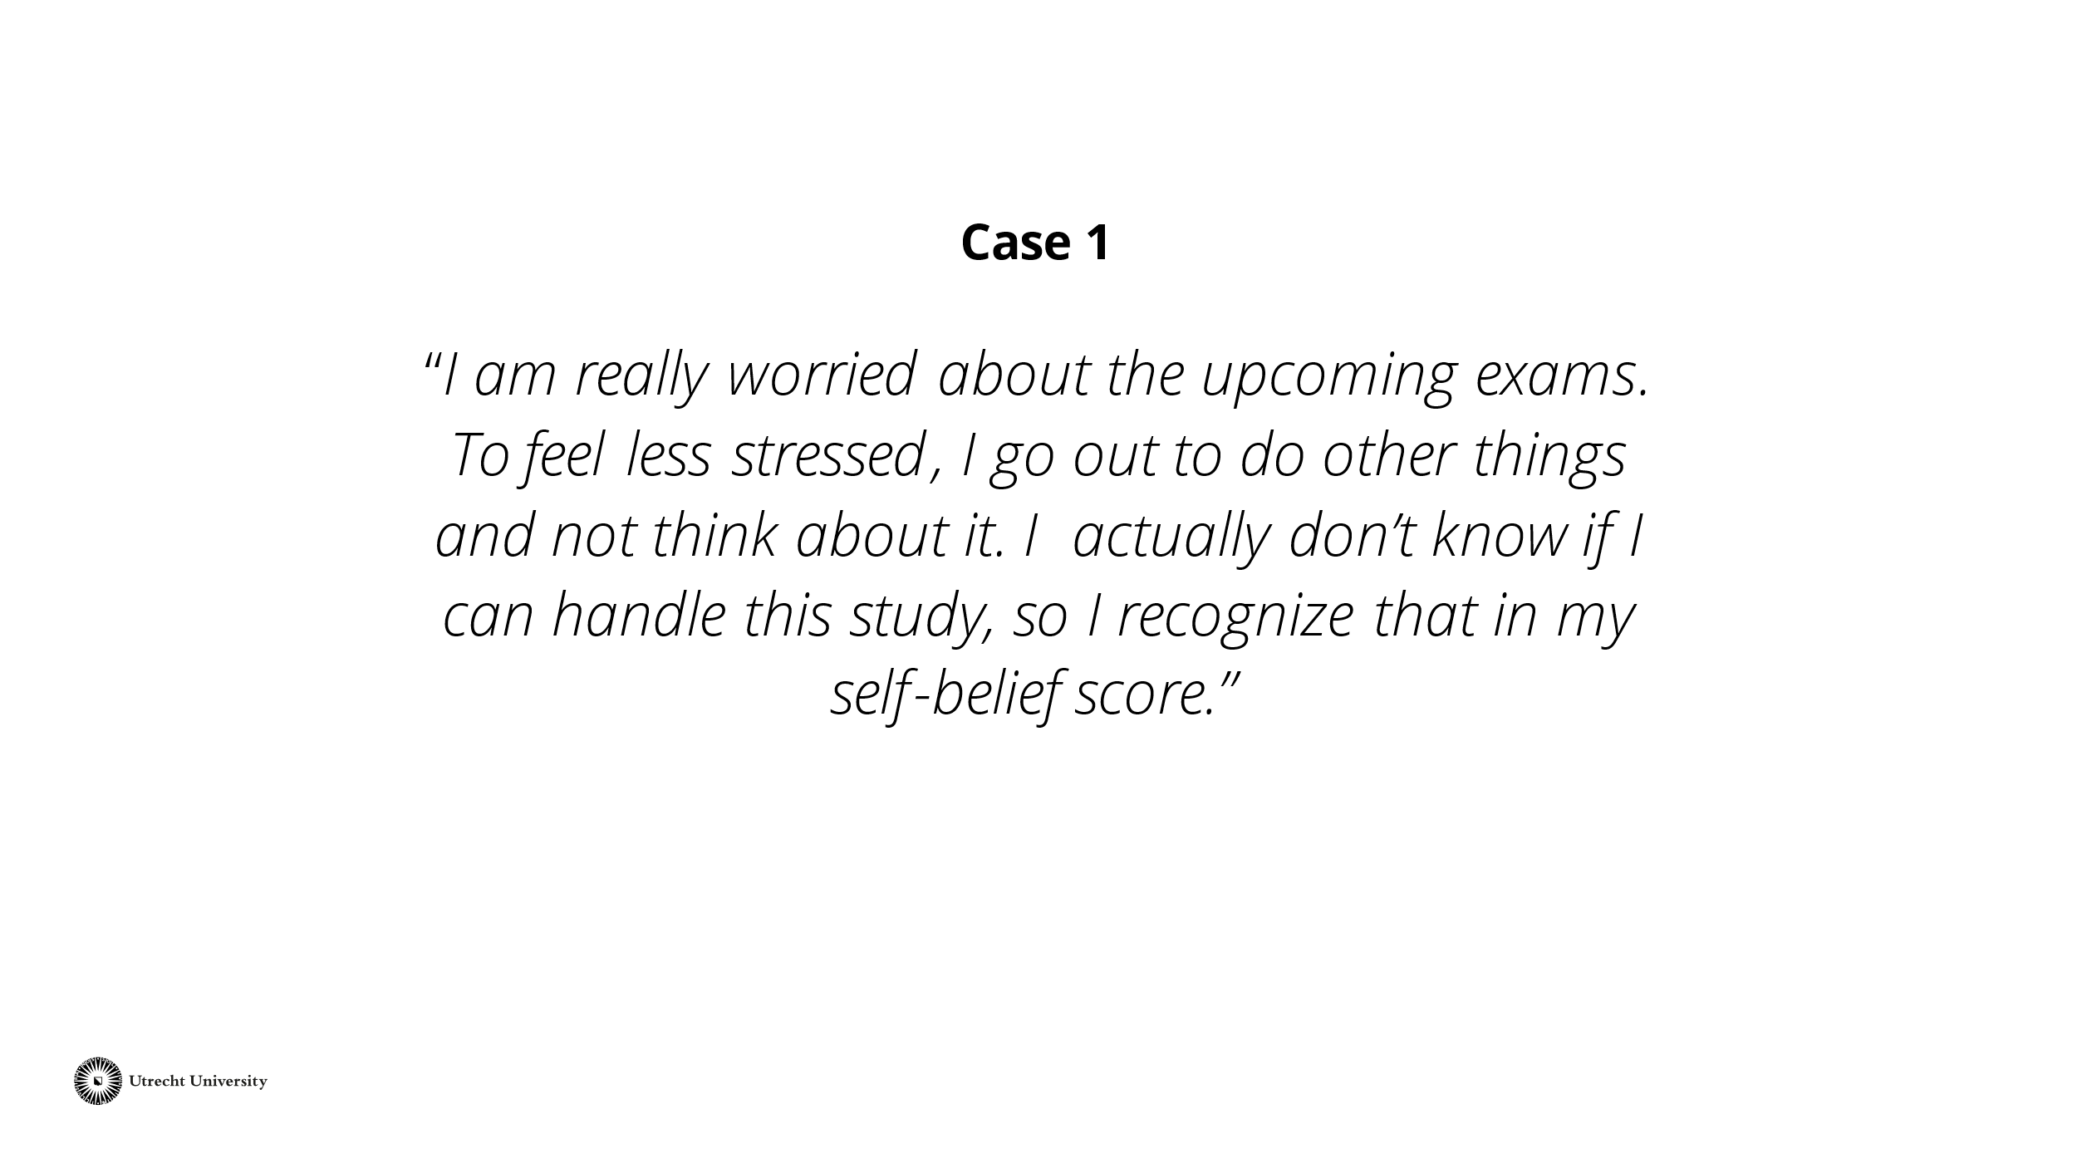 | Read the case out loud or give the tutors time to read the case themselves. Afterward, give the tutors some time to think about what they would do in this situation.  Then discuss with the group of tutors what the counseling of this student would look like. Also include the Thermos-dashboard and its role in student counseling.  Tip: Also refer to the role of the tutor as described by your faculty or study program.
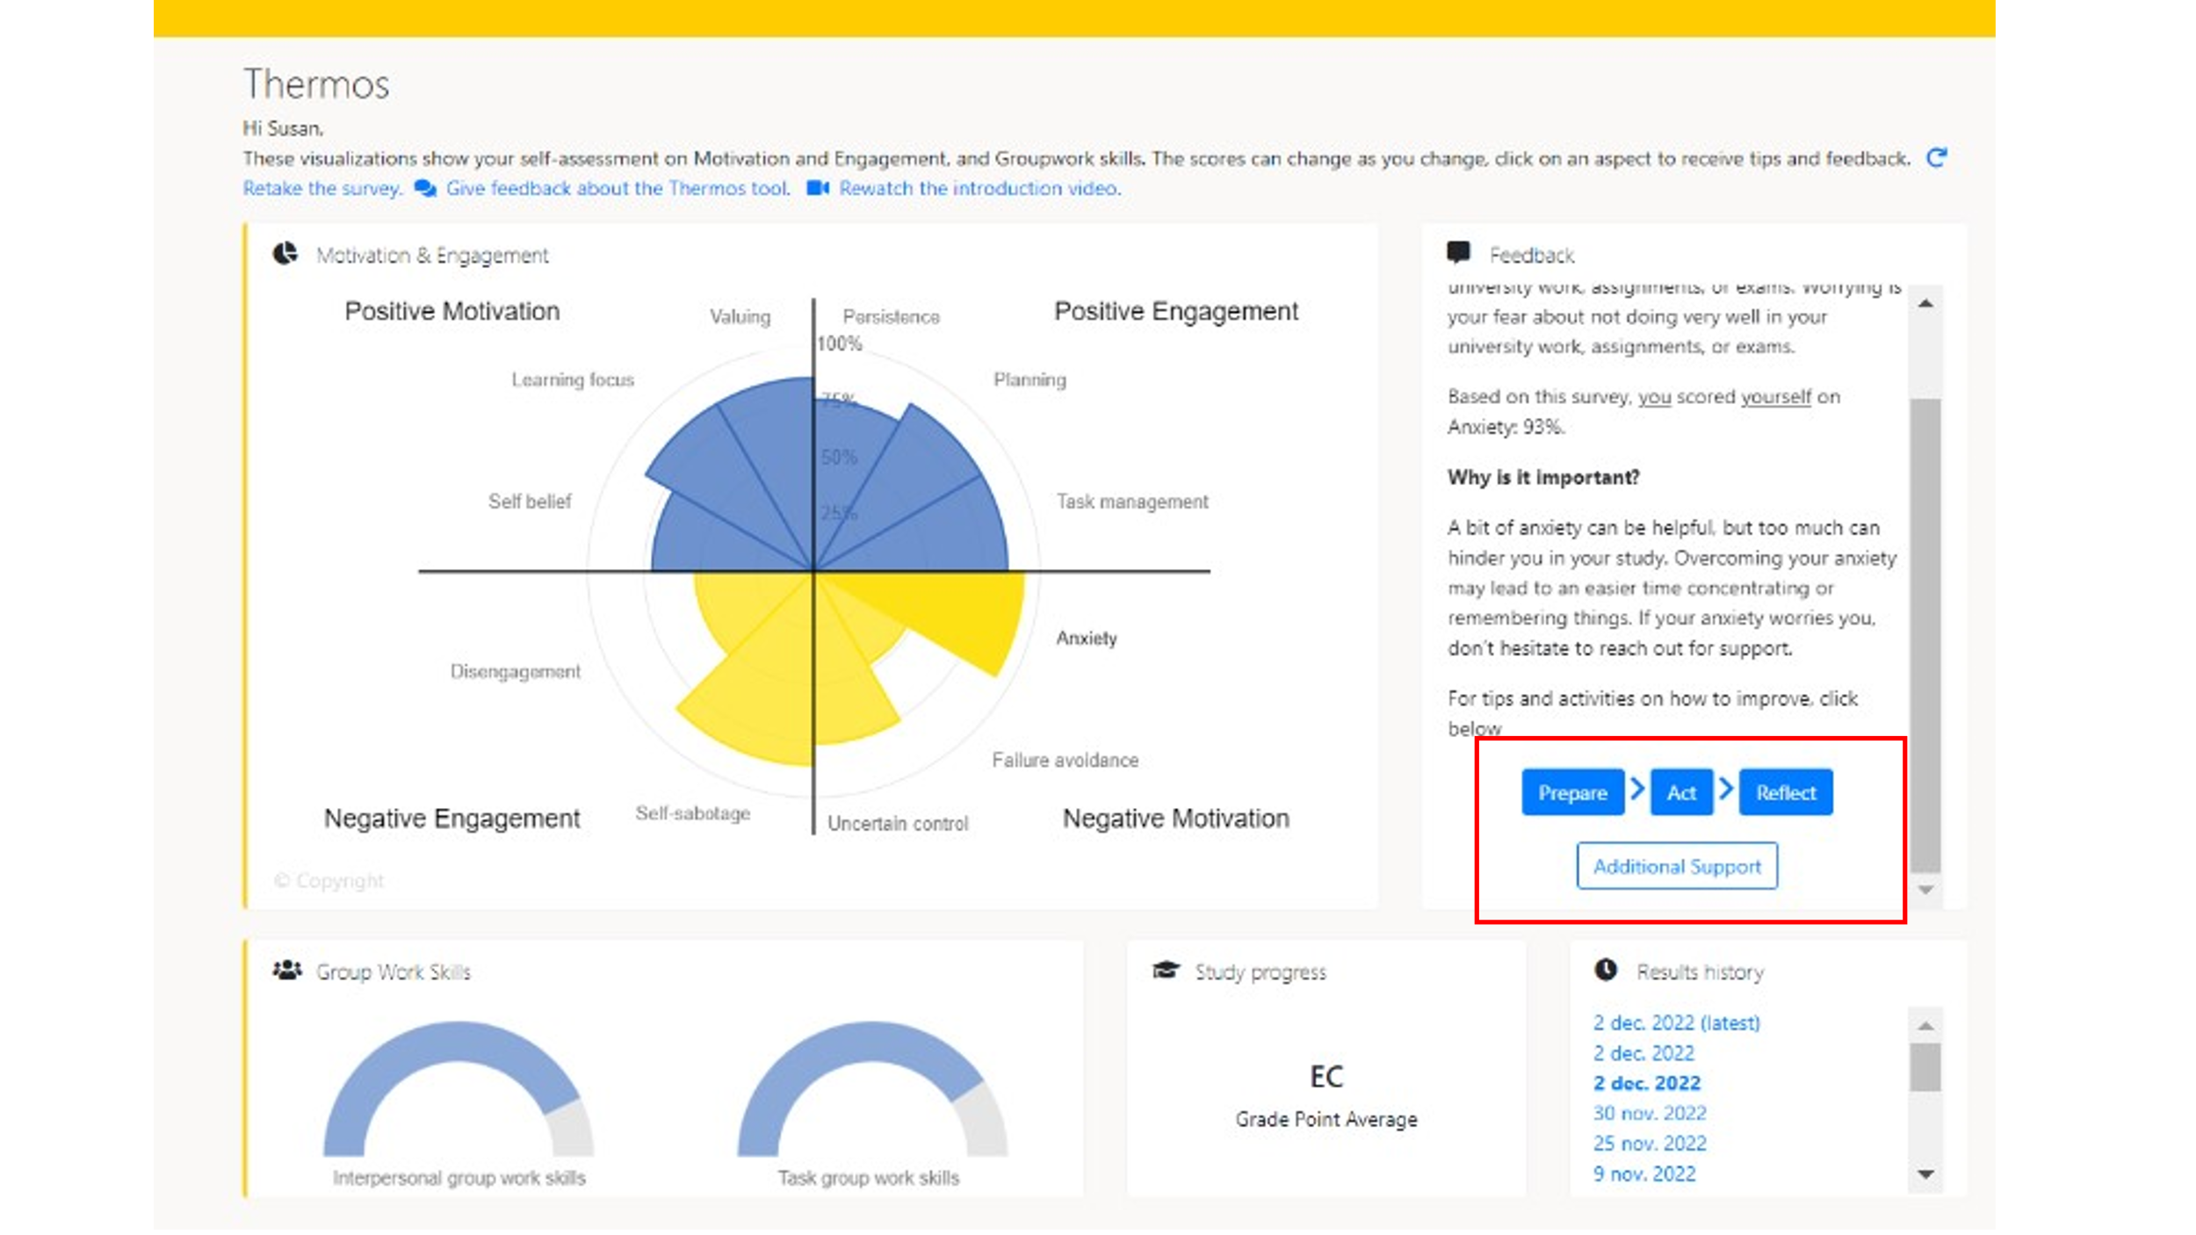 | Discuss with the tutors how the Thermos dashboard and its possibilities can play a role in the guidance of students.  Within the Thermos-dashboard, students can click on an aspect (such as anxiety). More information about this aspect will appear on the right frame. In addition, there are four options that students can click on to further develop themselves regarding this aspect. The four options are: 'Prepare', 'Action', 'Reflect', and 'Additional support'. The next slide shows what that looks like.
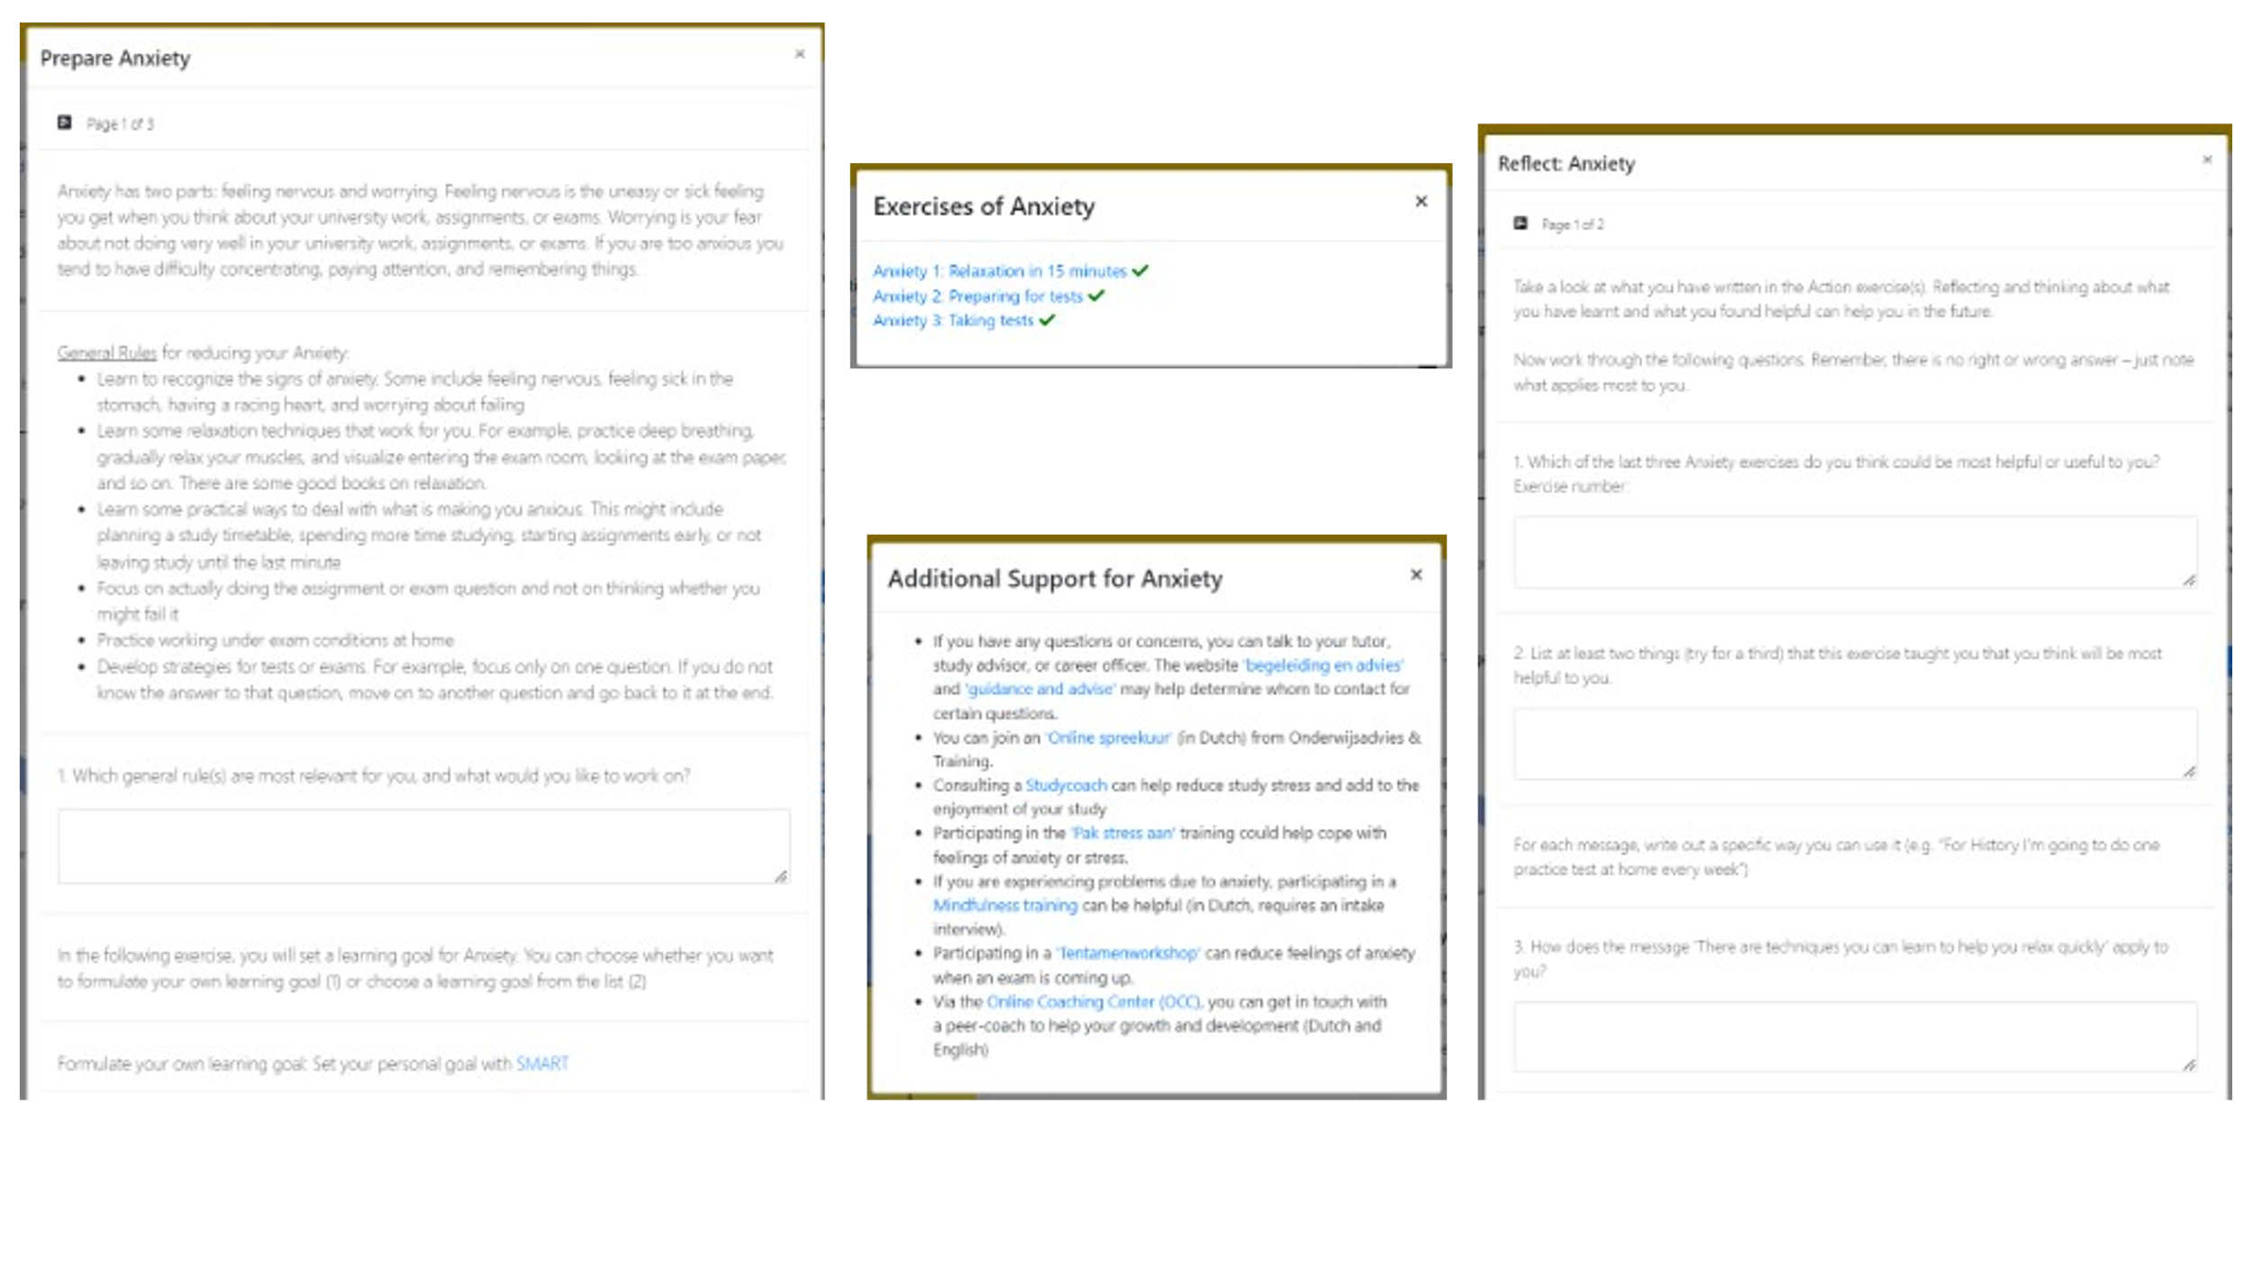 | This slide shows what the page looks like when a student clicks on the referral options. The options 'Prepare', 'Action', and 'Reflect' are assignments on which the student can work independently. These assignments include the formulation of a goal, activities, and opportunities for reflection. In addition, there is the option 'Additional support'. When a student clicks on this, referral options such as training courses and a study coach appear.  Discuss with the group how these components can be used in student counseling.  Alternative: open the Thermos-dashboard before the training to show it live to tutors. In that case, make sure the questionnaire has been completed once.
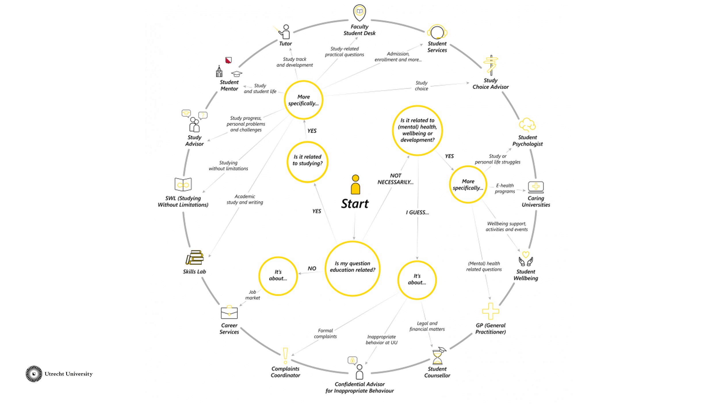 | On the Utrecht University website, there is a picture with possible referrals for a student. You can show this picture to the tutors to let them get familiar with the possibilities within the University. In the Thermos-dashboard, some of these possibilities are also listed as referrals under the heading 'additional support'.  https://students.uu.nl/en/guidance-and-development/who-to-contact
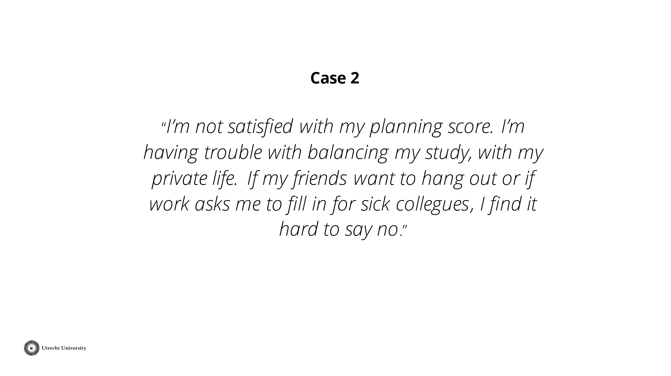 | Read the case out loud or give the tutors time to read the case themselves. Give the tutors some time to think about what they would do in this situation.  Then discuss with the group of tutors what the counseling of this student would look like. Also include the Thermos Dashboard and its role in student counseling.  Tip: Also refer to the role of the tutor as described by your faculty or study program.
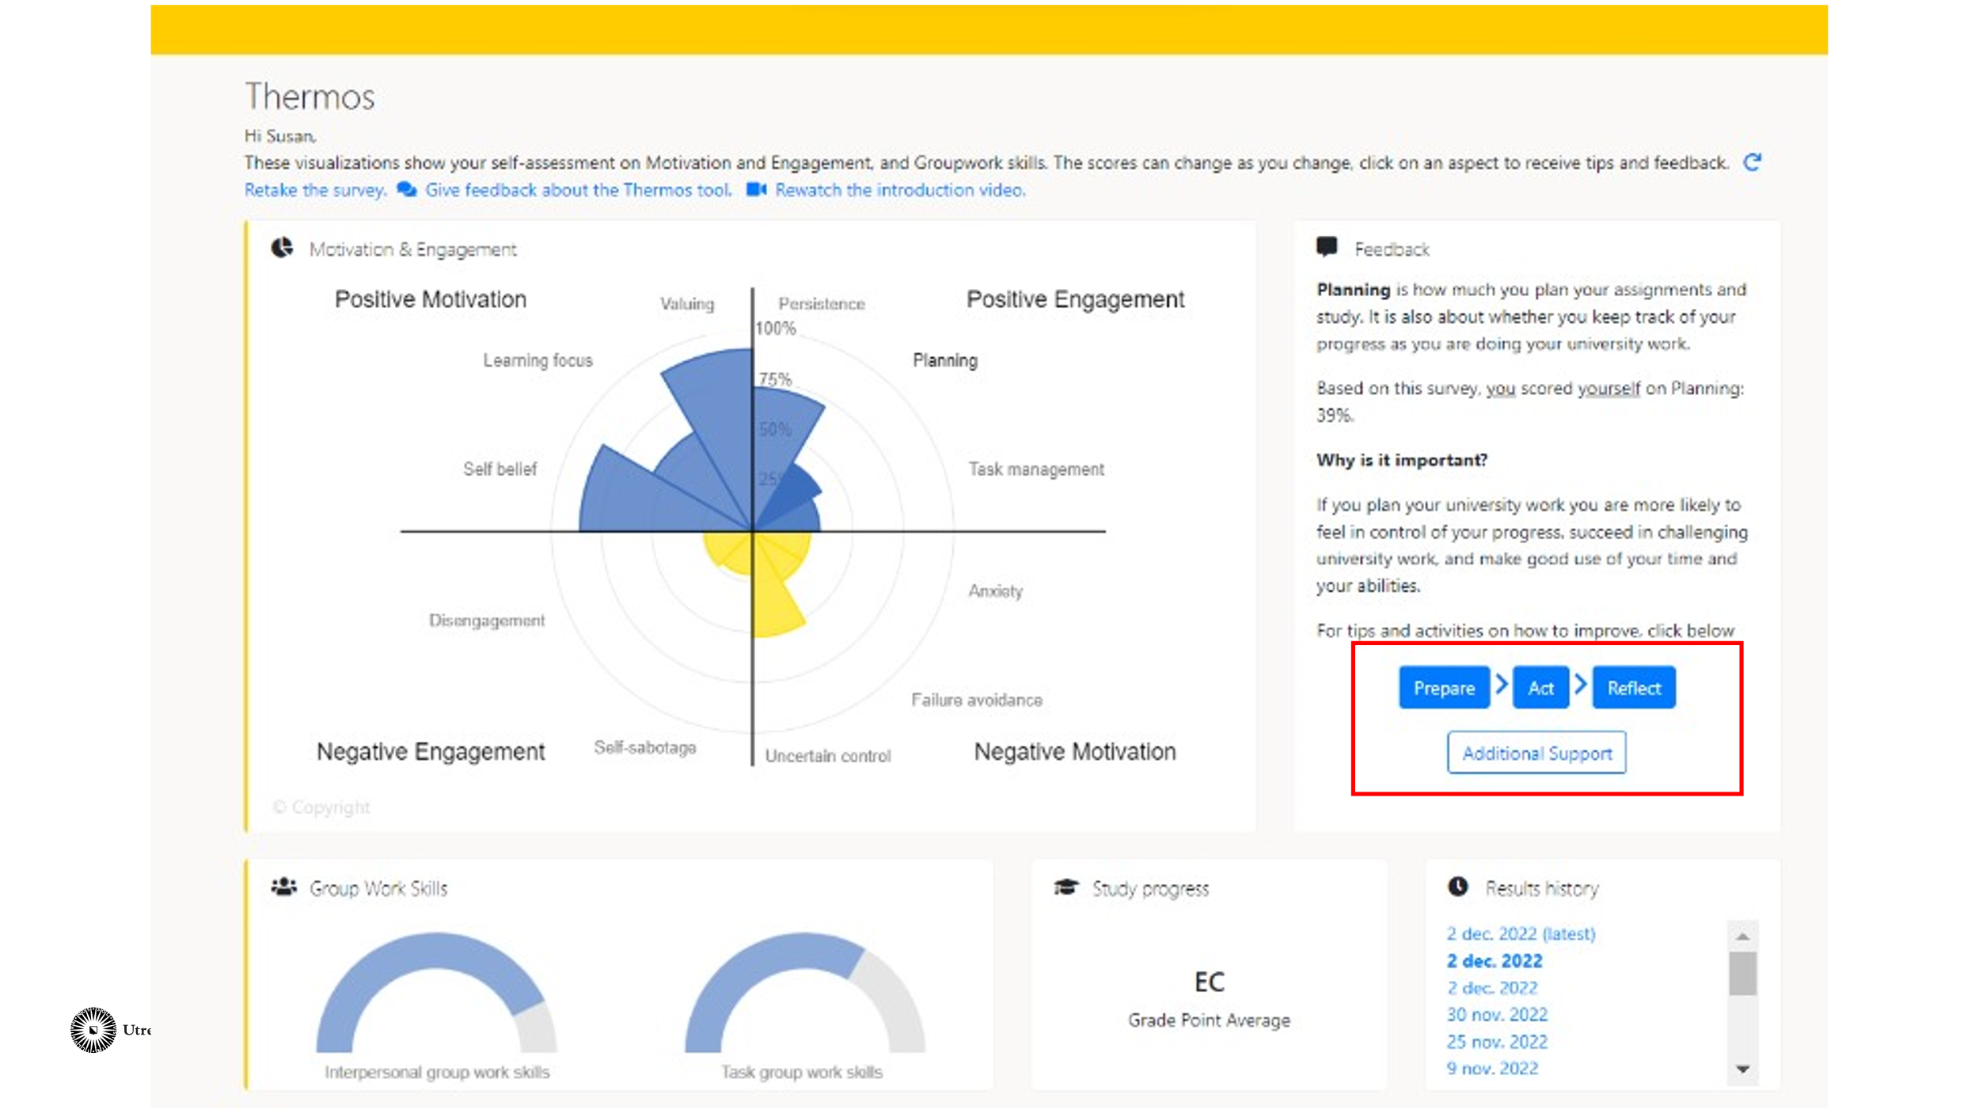 | Discuss with the tutors how the Thermos dashboard and its possibilities can play a role in the guidance of students.  Within the Thermos dashboard, students can click on an aspect (such as anxiety). More information about this aspect will appear on the right frame. In addition, there are four options that students can click on to further develop themselves regarding this aspect. The four options are: 'Prepare', 'Action', 'Reflect', and 'Additional support'. The next slide shows what that looks like.
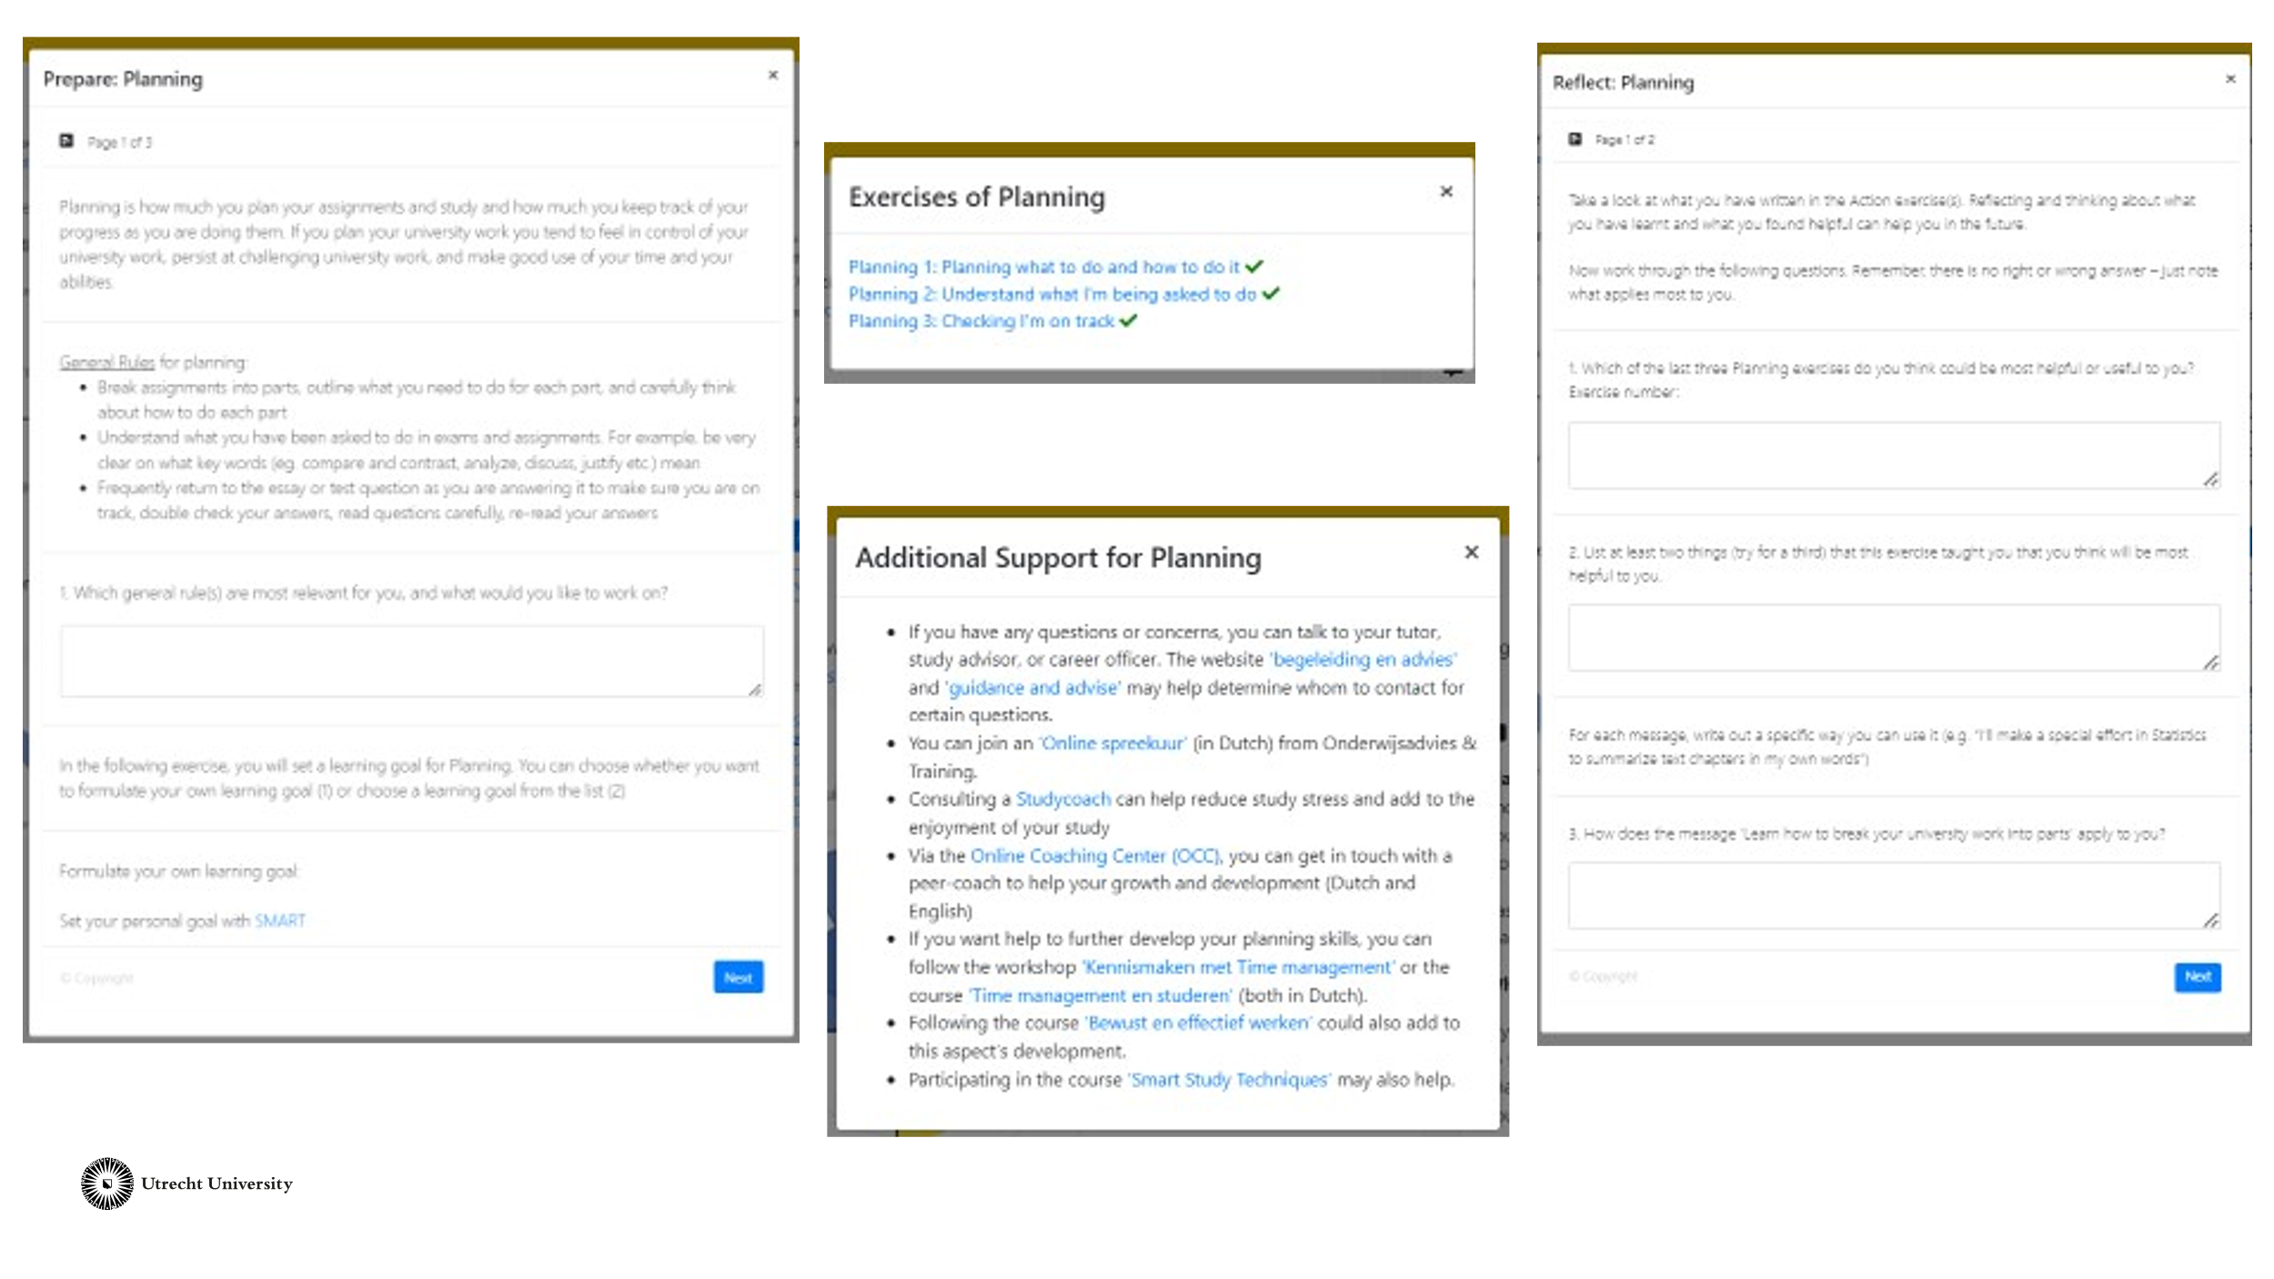 | This slide shows what the page looks like when a student clicks on the referral options. The options 'Prepare', 'Action', and 'Reflect' are assignments on which the student can work independently. These assignments include the formulation of a goal, activities, and opportunities for reflection. In addition, there is the option 'Additional support'. When a student clicks on this, referral options such as training courses and a study coach appear.  Let the tutors compare this case with the previous one. Engage in a conversation about when to refer or not. Does the referral look different now? Why?
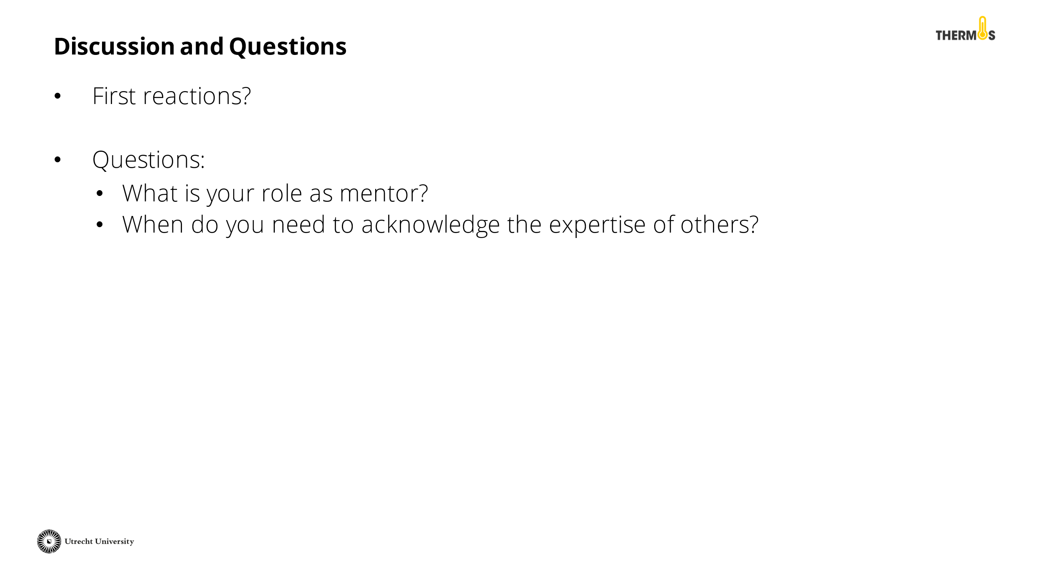 | Reflect on the activity with the tutors. Did you arrive at a shared vision? When should you recognise the expertise of others? What challenges do you still encounter as a tutor?
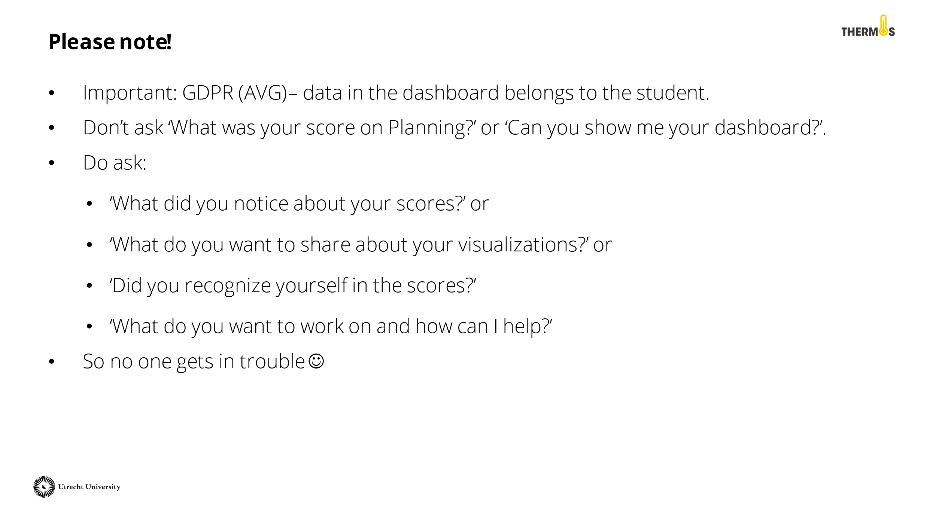 | Discuss with the tutors the AVG rules for working with the Thermos dashboard. It is important to remember that the data from the dashboard belongs to the student. Therefore, they should not feel pressured to share this information, even if a tutor asks about it with the best of intentions. See the PowerPoint slide for an example of questions you can ask as a tutor.
 | Finally, close the presentation by thanking the tutors for their participation and addressing whom they can contact for questions.

