Instruction Activity Practice Conversation

Dear tutor coordinator, this document explains how to use the activity 'Practice Conversation'. This explanation consists of three parts: preparation, duration, and instruction per slide. This is an example of an elaboration of this activity, but it is also possible to make adjustments according to the preferences of the relevant study program.
Preparation | - Read the explanation of this activity carefully beforehand.  - Print out the appendices. Make sure there is one case for each pair of two tutors.  - It is important that the tutors have been introduced to the dashboard once. As preparation, make sure the tutors watched the introductory video about Thermos or watch it together before this activity. https://thermos.sites.uu.nl/information-for-tutors/
Duration | Performing this activity will take +/- 30 minutes.
Slides | Instruction
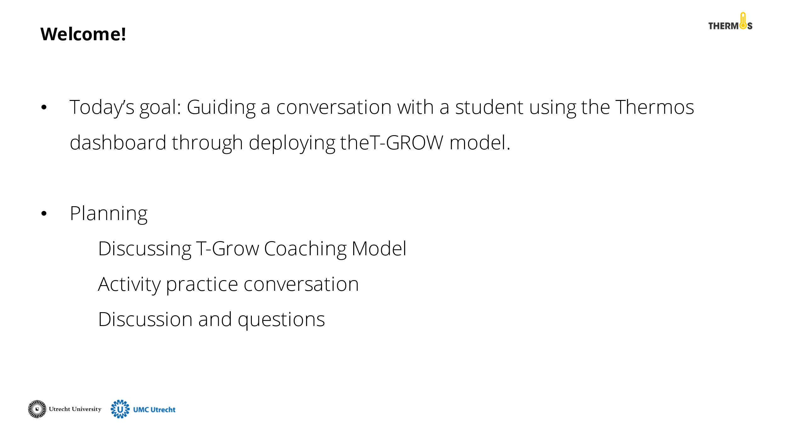 | Discuss the goal and planning of this activity with the tutors.
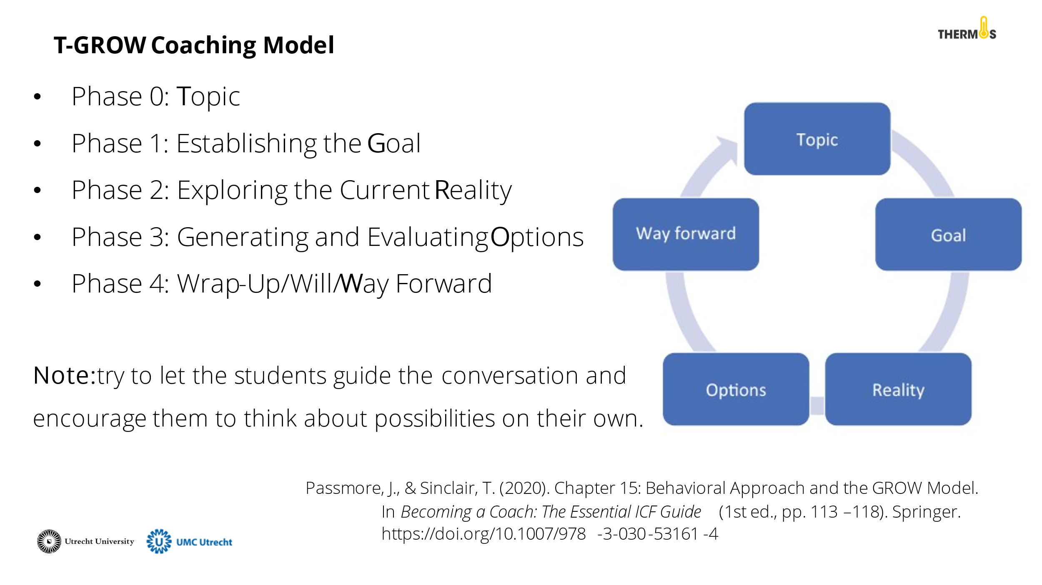 | One model for coaching is the T-GROW model. The student is in charge of the outcomes. The tutor encourages and guides the student to think for themselves and arrive at solutions This model consists of the following components and can be used flexibly:  Phase 0: Topic  It is important to establish the topic. Perhaps that has already been determined before the conversation. If not, that is the first step.  Phase 1: Establishing the Goal  In the first phase, a goal is set. What does the student want to achieve? For example, what stands out on the dashboard that the student wants to work on? The more concrete the goal is defined, the more meaningful it is for the student and the more likely progress can be made.  Phase 2: Exploring the Current Reality  In the second phase, the student reflects on the current situation. This does not involve searching for solutions yet. Let the student think about possible causes and consequences, what has been tried so far, what are blockages, viewing the situation from different perspectives, etc.  Phase 3: Generating and Evaluating Options  The third phase consists of two parts: generating options and evaluating those options. In the first part, students brainstorm about all possible options. Here, advantages and disadvantages are not yet considered. The second part involves looking at the most appropriate action to realise the goal. Try to encourage the student to think for themselves and ask open questions.  Phase 4: Wrap-Up/Will/Way Forward  The final phase focuses on creating an action plan. What steps will the student take to realise this goal? What support does the student need in doing so?  For a more detailed explanation of the model:  Passmore, J., & Sinclair, T. (2020). Chapter 15: Behavioral Approach and the GROW Model.In Becoming a Coach: The Essential ICF Guide (1st ed., pp. 113–118). Springer. https://doi.org/10.1007/978-3-030-53161-4
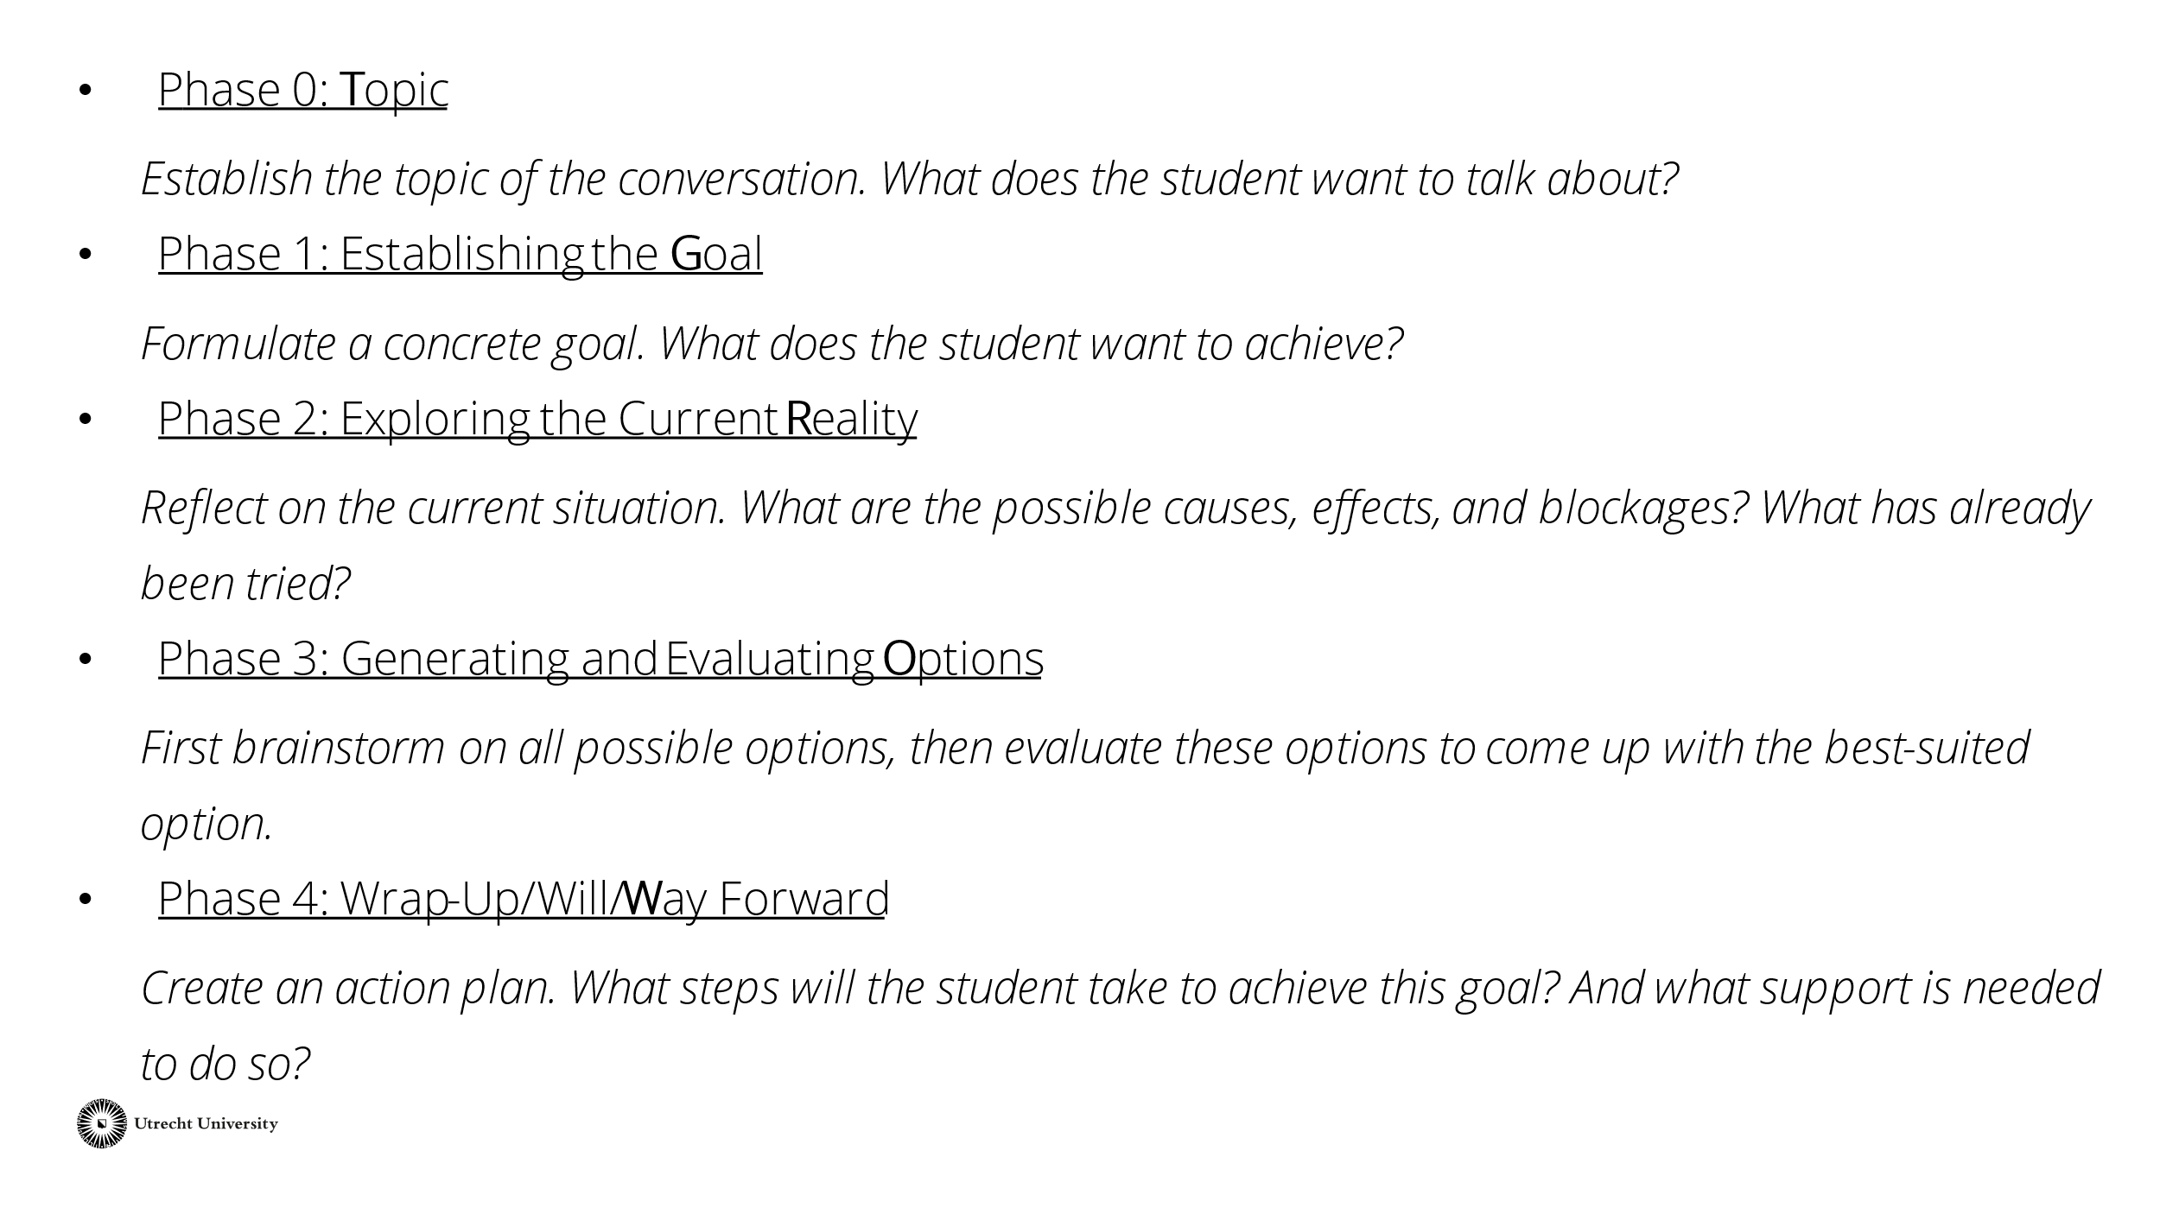 | This slide briefly explains the phases for the tutors. If necessary, leave this slide on the board during the performance of the work form as a reminder.  Tip: share this slide or the whole PowerPoint with the tutors afterwards.
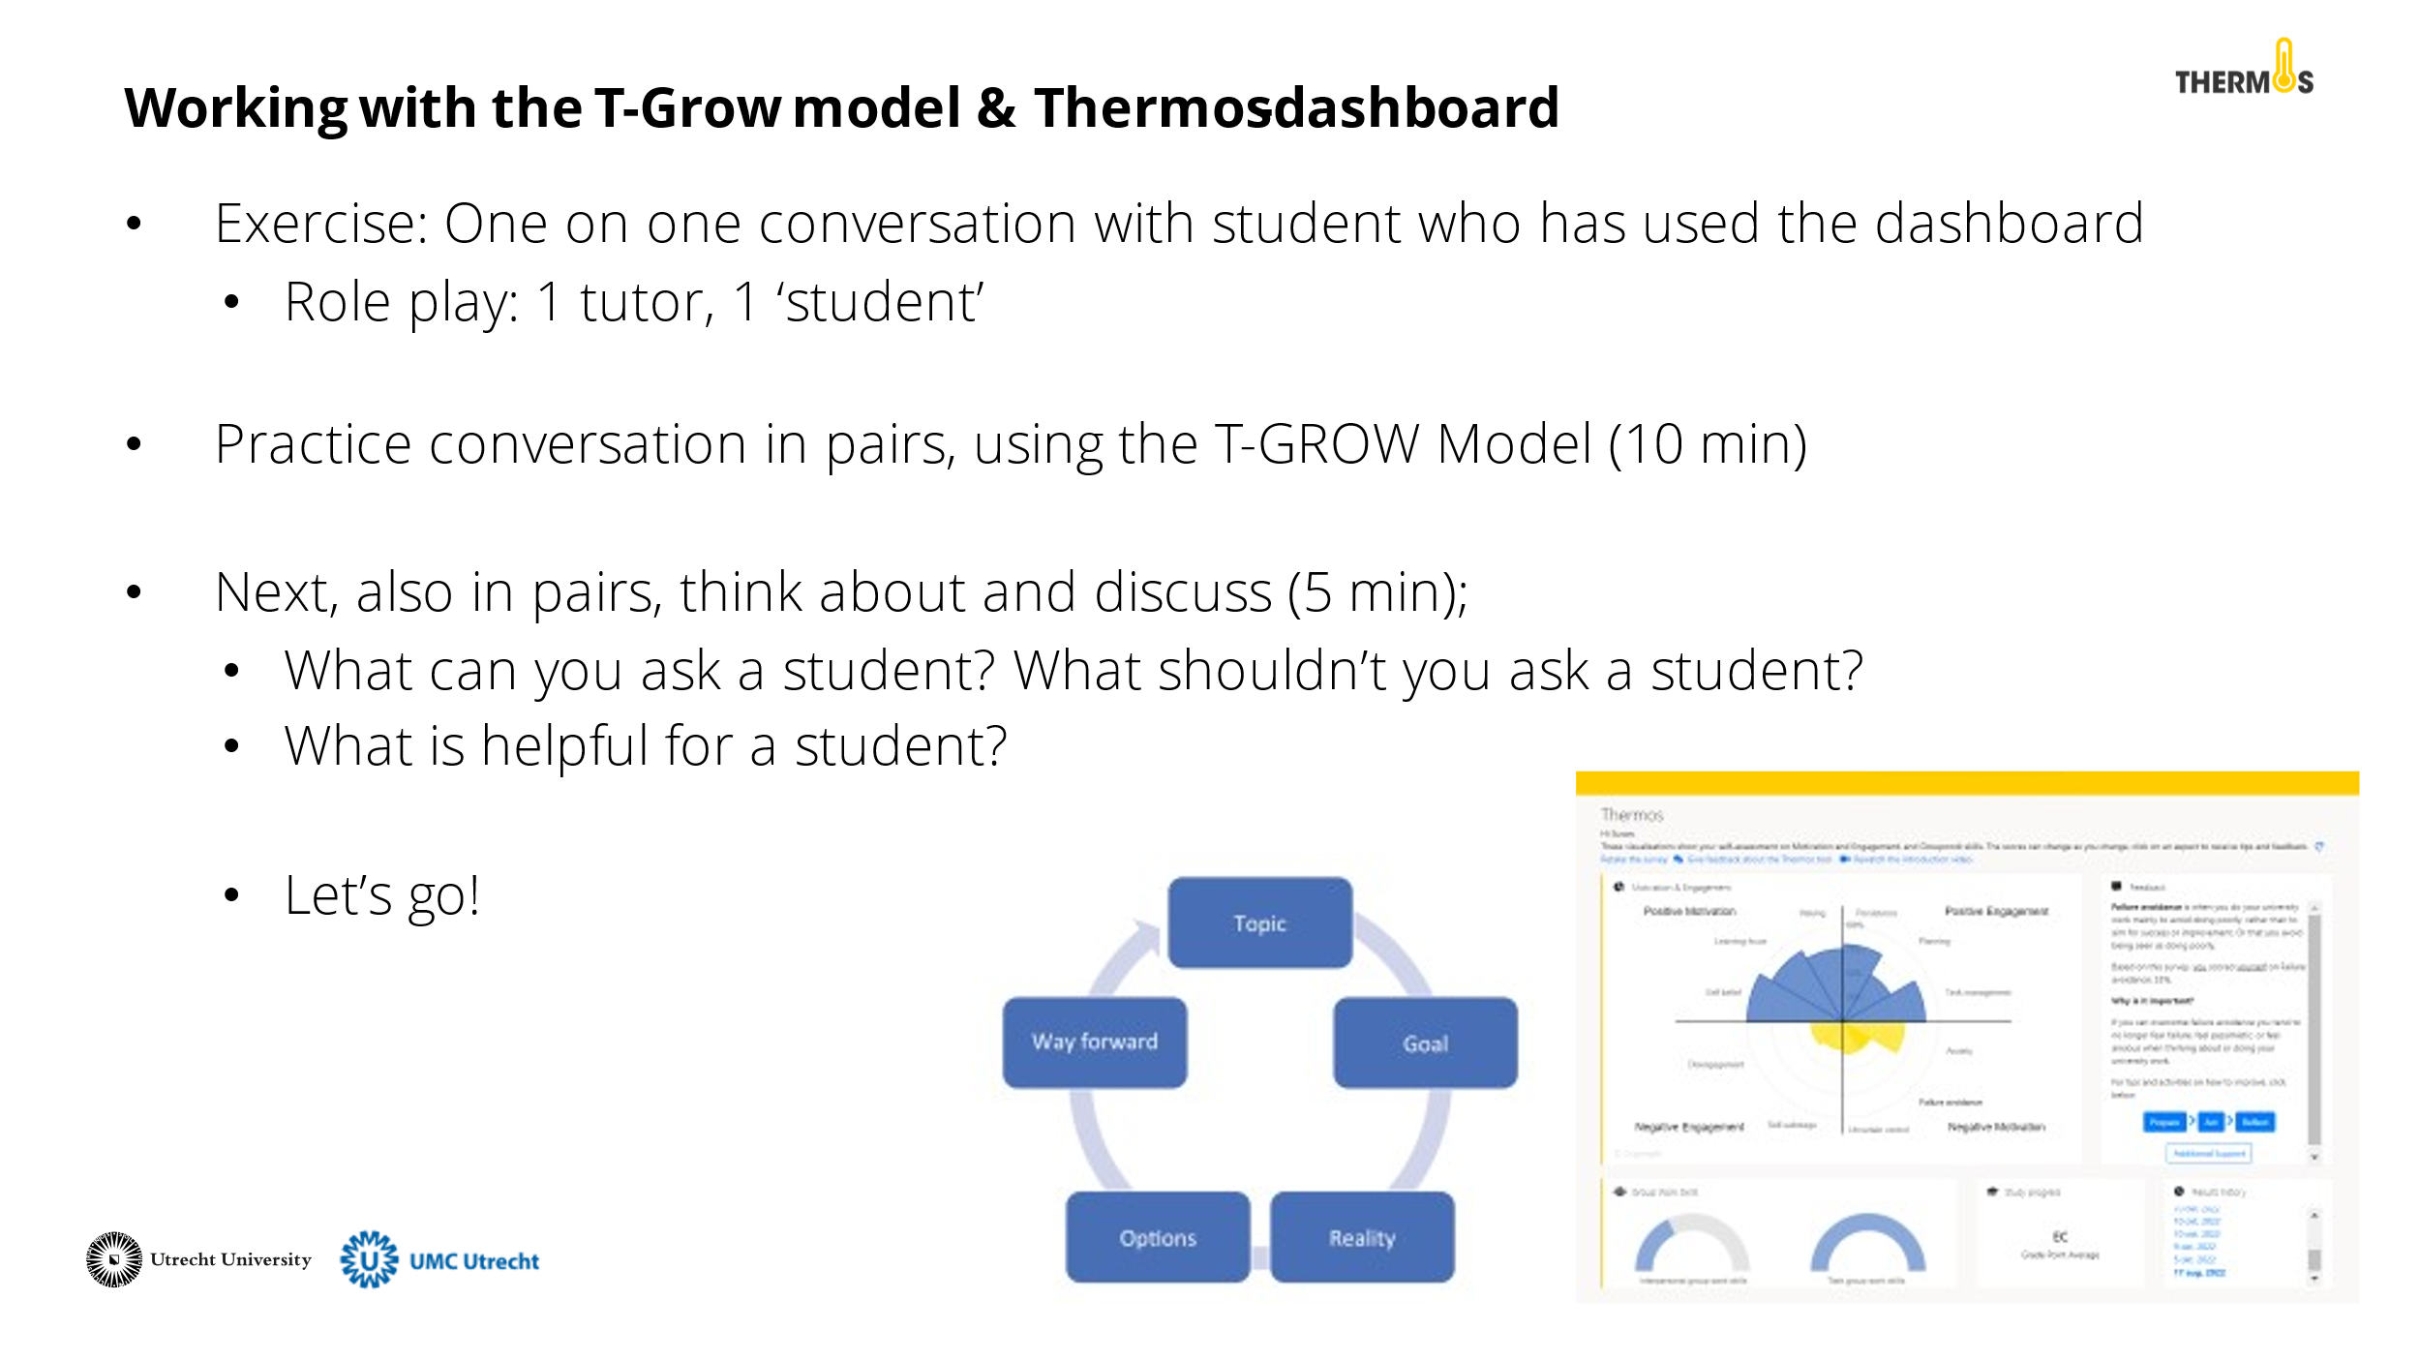 | During the activity, the tutors engage in a practice conversation by role-playing. The tutors do this in pairs. One tutor is the tutor, and one tutor is the 'student'. The 'student' receives a Thermos-dashboard (see appendix). The tutor starts a conversation with the 'student' using the T-GROW model. The 'student' can use the information from the dashboard to think about the topic of this conversation. They have about 10 minutes for this.  Then the pairs discuss the questions on the slide for about 5 minutes.
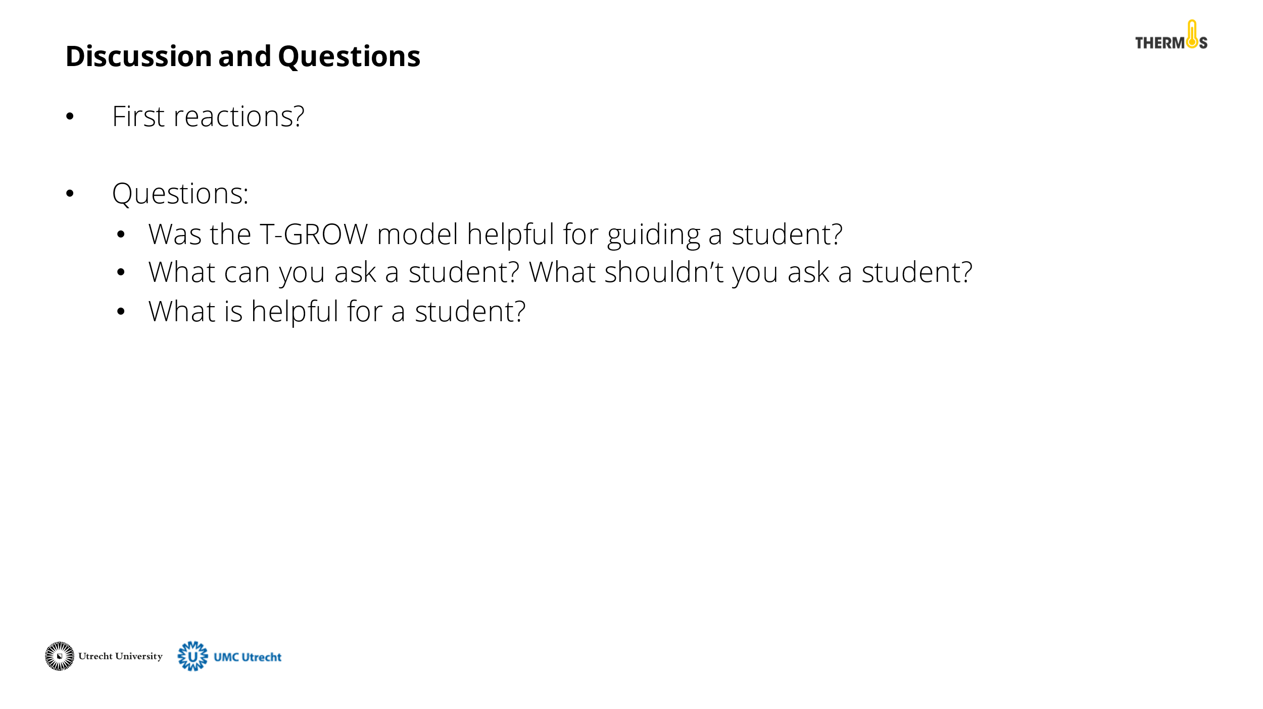 | Discuss with the tutors what their thoughts are about the GROW model and the activity. What insights do they take away from this training?
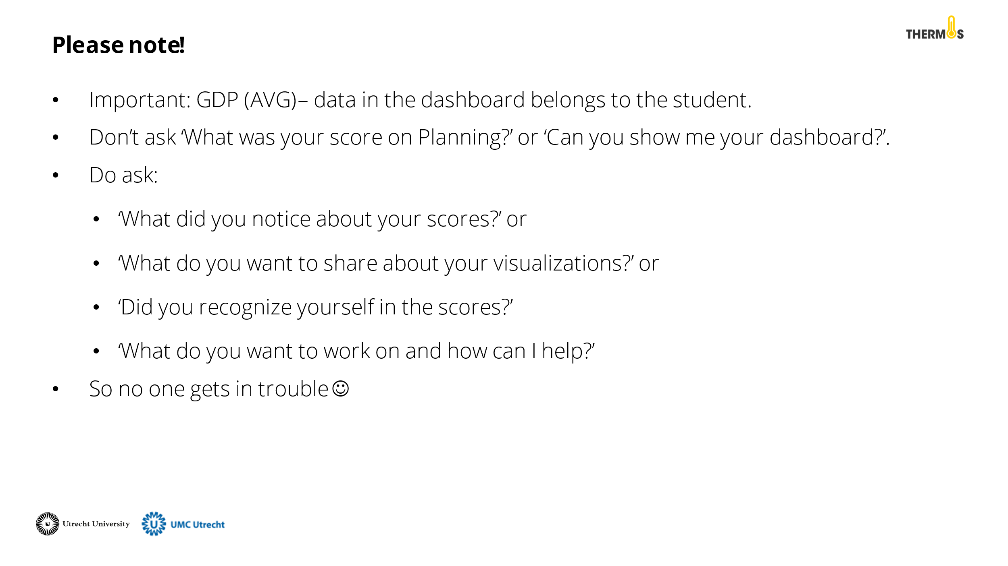 | Discuss with the tutors the AVG rules for working with the Thermos-dashboard. It is important to remember that the data from the dashboard belongs to the student. Therefore, they should not feel pressured to share this information. See the PowerPoint slide for an example of questions you can ask as a tutor.
 | Finally, close the presentation by thanking the tutors for their participation and addressing whom they can contact for questions.

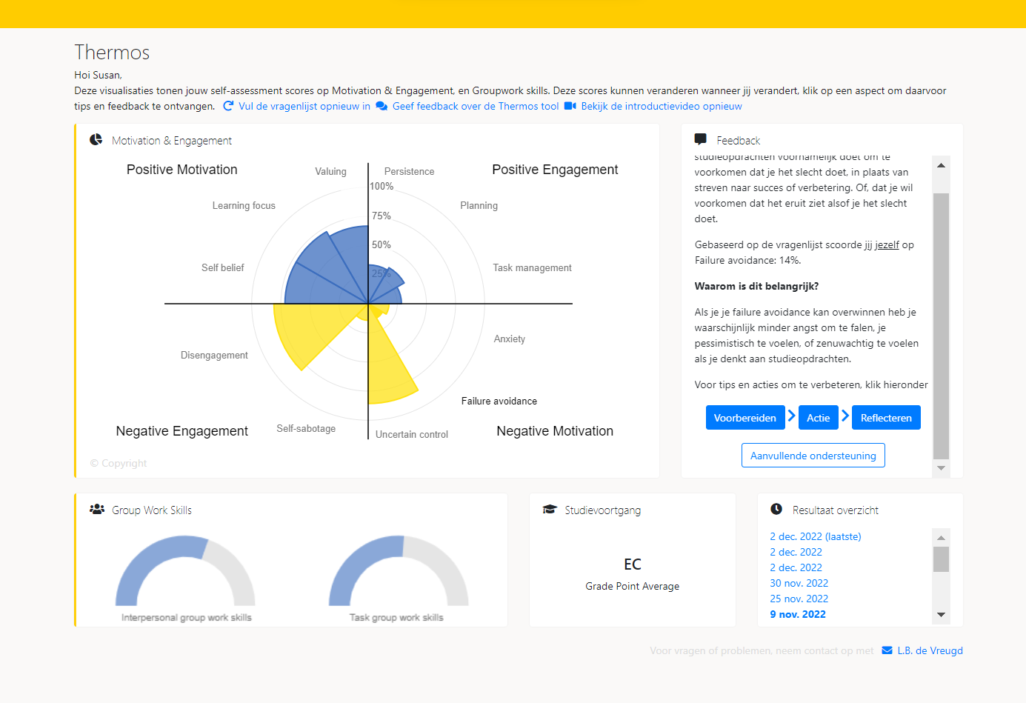
Bijlagen

